CHAPTER FOUR

EXISTING ENVIRONMENT DESCRIPTION

4.1 General
An integral and important part of an EIA study is the establishment of a comprehensive environmental baseline condition of the proposed project area. Such environmental baseline data provide information on the characteristics and features of the proposed project environment. It also provides the background/scientific basis for predicting, evaluating and mitigating the impacts of the planned project activities on the environment, monitoring environmental changes in the area, as well as support the decision making in future project design, operation and management.

This chapter therefore presents the existing environmental baseline milieu of Yoho Field in OML 104, within which MPN plans to carry out drilling/field development activities as described in Chapter 3 of this report. The descriptions presented herein were based on information from literature research, 2 season field sampling/measurements/observation, and results of laboratory analyses of collected seawater column and sediment samples.

4.2 Baseline Data Acquisition Method
Baseline data acquisition involved a multidisciplinary approach and was executed within the framework of Fugro Nigeria Limited (FNL) QHSE management system approach. Elements of this approach include literature research, designing and development of field sampling strategy to meet regulatory requirements; confirmation of the sampling design and locations by MPN; pre-mobilisation activities (job hazard analysis, sampling equipment/materials calibrations and checks) and mobilisation to field; fieldwork implementation, sample collection (including field observations), handling, documentation and storage protocols and procedures, demobilisation from field, transfer of sample custody to the laboratory for analysis.

The following sections presents synopsis of the methodology and procedures employed for the ecological data gathering while detailed documentation of the fieldwork execution including descriptions of the laboratory analytical methods and procedures, the detection limits for the various parameters analysed as well as an overview of the general QHSE plan adopted for field data gathering and laboratory analysis is presented in Appendix 4.1.

    - Literature Research
This was carried out prior to field data gathering campaign in order to obtain relevant background information on the seabed, water and air of the study area. Further research was also conducted at the end of the field data gathering exercise in order to compare literature information with generated field data and for additional information on the study area. Generally, literature research involved consulting relevant textbooks, research publications, articles, reports on previous environmental surveys of proximal / similar environment as well as technical presentations.

4.2.2 Field Sampling / Measurements
Sampling Equipment and Materials
The two season field sampling / measurements were carried out using a certified ocean going vessel MV/Aleutian, owned by Workships Africa Limited. The wet season sampling / measurements were carried out between 10th and 17th October, 2008 while the dry season sampling was carried out between 11th and 18th February 02009. Both season surveys were carried out with oversights by both the Federal Ministry of Environment (FMENV) and Akwa Ibom State Ministry of Environment and Mineral Resources (AKSMEMR) officials.

Sampling Design
The Yoho Field sampling design is in line with Appendix 11 - 4 (General Guidelines for Ecological Seabed Survey, Sampling and Analysis), Environmental Guidelines and Standards for the Petroleum Industry in Nigeria (EGASPIN), issued by the Department of Petroleum Resources (DPR) in 1991 (Revised 2002).
A total of Thirty four (34) (SS0 to SS33) sampling stations were designated for samples collection MPN. These stations were distributed to adequately cover the entire study area.

Project Location
Yoho field lies in Oil Mining Lease (OML) 104, offshore Nigeria in water depths of 200ft – 300ft. The project site is about 38 miles south west of the Qua Iboe Terminal in Akwa Ibom State, Nigeria. The Yoho terminal is located at 40 1’N and 70 28’.

The MPN 2009 – 2011 Yoho development Area is shown in Figure 4.1.while the distribution of sampling points within the field is shown in Figure 4.2. The sampling point’s co-ordinates (including the sample code, water depth at each station and sampling requirement) are documented in Appendix 4.1. Also documented in the Appendix are details on the procedures adopted in the collection of each sampling requirement.

Oso
Qua Iboe Terminal
Oso
Qua Iboe Terminal
Edop
Oso
OML 70
OML 68
Usari
69
Ubit
Oso
OML 67
OML 70
OML 104
OML 68
Qua Iboe Terminal
69
Oil Fields
Gas Fields
0
16
km
0
10
mile
Inim
Enang
Utue
Usari
Edop
Unam
Mfem SE
Ata/Inanga
Asasa
Etim
Awawa
Aran
Yoho
Ufan
Isuo
Okuk
Ekpe / Ekpe WW
Adua
Asabo
Emiang
Enang West
Idoho
Mfem
Isobo
Etoro
Eku
Iyak
Ibot
Abang
Oyot
Itut
Yoho Area
YOHO AREA
Ekpe Area
Edop Area

Figure 4.1: MPN JV 2009 - 2011 Yoho Development Drilling Areas

Figure 4.2: Yoho Field Sample Points Distribution Map

Positioning
During fieldwork activities, the Differential Global Positioning System (DGPS) was used to navigate and position the vessel. Prior to commencement of sampling however, the targeted sampling positions coordinates in WGS 84 format were provided to the vessel party chief. These coordinates were loaded into the vessel Winfrog Software and used to plot the sampling waypoint. Positioning at each sampling station was carried out with the aid of the Global Positioning Systems (GPS) fitted into the survey vessel. At each station, coordinate at which sampling actually took place was recorded electronically and stored in an onboard computer.

Laboratory Analysis
Samples were brought to the FNL laboratory and were analysed using standard analytical methods. The synoptic descriptions of the laboratory analytical methods and procedures employed for the various physical, chemical and biological parameters as well as the detection limits of these parameters in seawater and sediment samples are documented in Appendix 4.1. Also documented are synopsis of the QHSE plan adopted in both field data collection and laboratory analysis.

Description of Environmental Baseline Conditions
The following subsections presents the detailed description of the existing ecological baseline milieu of Yoho Field established during this study.

4.3 Regional Meteorological / Metocean Features
The Yoho Field area is in equatorial West Africa (commonly known as Gulf of Guinea), which comprises the region lying within 5⁰N of the equator on the Atlantic coast of Africa. The overview of meteorological and metocean features (air temperature, humidity, rainfall, winds, waves, currents and water levels, etc.) of the area presented herein was based primarily on information from literature research.

4.3.1 Air Temperature
Air temperature estimates recorded within the project area indicated little variation with a mean of 26^{O}C. The minimum and maximum values recorded were 16^{O}C and 34^{O}C respectively. These values are subject to rapid changes during the passage of thunderstorms (Fugro Geos, 2002).

4.3.2 Relative Humidity
Results of measurements overtime indicate that the relative humidity in the study area is generally high (around 80%) throughout the year while the atmospheric pressure varies on a diurnal basis and ranges between 1010mB in the dry season and 1014mB in the wet season (Fugro Geos, 2002).

4.3.3 Rainfall
The hydrological cycle depends fundamentally on the inter-relationship between the circulation of the ocean and the atmosphere. Water is withdrawn from the oceans into the atmosphere by the process of evaporation which is dependent on factors such as air / sea temperatures, wind strength and humidity (Oguntoyinbo and Hayward, 1987).

There are presently no known existing meteorological stations, offshore Nigeria. Therefore, rainfall data collected from Nigerian meteorological Agency (NIMET) QIT Eket which is the nearest meteorological station to the project area, was used establishing the rainfall characteristics of the area. The information gathered over a period of 15 years (1991 – 2005) and presented in Figure 4.3 showed that the rainfall pattern in the coastal region of Nigeria have two (not very distinct) regimes – wet and dry seasons.

Figure 4.3: Mean Monthly Rainfall in the Study Area

The figure indicates that rainfall in the area is generally high and is experienced almost all year round with highest values ranging between 350mm/month to 360mm/month. Peak periods are generally experienced from June to September while least values were recorded from December to February. The mean annual rainfall in the area is in excess of 2,800mm.

4.3.4 Winds
The two major wind regimes in the study area are the North-East and the South-West Trade Winds and in between them is the Equatorial Trough, also known as the Inter Tropical Convergence Zone (ITCZ). These wind belts and the associated ITCZ are created by the North and South Atlantic Subtropical Highs and Equatorial low pressure system, which controls/regulates the climate of the area.

The North-East Trade Winds generally do not penetrate south of 7°N and therefore does not impact offshore Equatorial Africa. The South-West belt originates in the Southern Hemisphere and crosses the equator throughout the year, extending to about 15°N in the Northern Hemisphere wet season and 7°N in the Northern Hemisphere dry season. As the trade winds cross the equator they are deflected to become south-westerly offshore Cote d’Ivoire and more southerly from offshore Ghana to Nigeria.

The strongest winds (referred to as the South-West Trade Winds), with mean monthly speed of about 5m/s and the weakest Winds (referred to as the North-East Trade Winds), with mean monthly speed of about 2.5m/s, occur in the wet and dry seasons respectively.

Surface wind speed in the area (characterised by small diurnal variation) reaches maximum value during the night, due to radiation cooling leading to instability in the surface layer. The diurnal variation will be most marked during periods of reduced trade wind activity and clear skies. Storms are relatively rare in the area and the major meteorological feature impacting offshore operations is the passage of line squalls. Generally, winds in the study area are fairly consistent and never very strong except during squalls associated with thunderstorms. It is this thunderstorms and the local ‘tornadoes’ accompanying them that are the most impressive features of weather in Nigeria’s coast and offshore environment (Fugro Geos, 2002).

4.3.5 Thunderstorms and Squalls
Thunderstorms are a regular feature of Equatorial West Africa and their high frequency may severely disrupt weather-sensitive operations. The greatest frequency of thunderstorms occurs around the equator, from Cameroon to the Congo, with around 100 to 150 thunderstorms a year.
‘Squalls’ are sudden increases in wind speed that last for several minutes and are associated with the leading edge of multi-cell thunderstorms. Squalls could result from: unstable atmosphere (relatively cold air overlying relatively warm, more buoyant air); moist air; and a trigger mechanism (converging air at low levels e.g. at the ITCZ or terrestrial heating).

The thunderstorms associated with the ITCZ typically develop from Cameroon to Gabon. These storms are steered westwards at about 12.5m/s towards the coast of Nigeria offshore operating areas by upper winds. They are often seen as a line of thunderstorms, commonly referred to as ‘line squalls’. As they travel across the lower plains the warm ground provides a source of heat causing updrafts. Passage across open water enables them to pick up significant volumes of water vapour, increasing the buoyancy of the rising air parcels through the release of latent heat during condensation. This updraft process occurs until the water droplets are too heavy to be sustained and it collapses. With the collapse of the updraft, millions of tons of water start to fall out of the clouds, entraining drier air from the surroundings. Evaporation of water into this dry air cools the falling mass of water, increasing its density and so accelerating its fall.

The rapidly descending air complete with the large amount of water droplets continues to fall below the base of the cloud and, on impinging with the sea surface, the air spreads horizontally in all directions beneath the storm. It is this air that comprises the squall winds (Fugro Geos, 2002).

4.3.6 Waves
The wave in the study area is mild with relatively low significant wave heights. During the wet season months, significant wave heights are generally 1 - 2m while during the dry season months this decreases to 0.5 - 1.5m. The dominant wave process in the area is long-period swell generated in the Southern Ocean and moving towards the north and the north-east to impact the region’s offshore operating areas. Although the swell is relatively infrequent, it is the dominant mechanism controlling metocean design criteria for the region. Typically swell (peak period > 16s) occurs only 6% of the time and predominantly in the wet season (Fugro Geos, 2002).

The major impact of swell is in vessel response, whereby the heave response and hence the riser response become critical to survivability and fatigue.

4.3.7 Currents
The current system in the area is driven by the North-East and South-West Trade Winds. This system is important for both driving and controlling the currents impacting the offshore concessions, which are mainly the Guinea and South Equatorial (Gabon – Congo) undercurrents. The Guinea Current always flows eastwards and is confined to the upper 50m of the water column. The current intensifies at Cape Palmas (8°W), and weakens at Cape Three Points (4°W). It varies seasonally in strength with its greatest intensity occurring in the wet season during which the current extends to Nigeria.

Underlying the Guinea Current is a westward-flow termed the Guinea Undercurrent. Presence of the two currents can lead to strong vertical shear. Also of note are eddies generated by the passage of the Guinea Current past Cape Palmas and Cape Three points. These features may lead to enhanced currents inshore of the Guinea Current and also variable flow directions. The latter could provide operational difficulties for supply vessels servicing the rig as well as other offshore facilities. Facilities and shuttle tankers that shall be utilised for the proposed field development activities in Yoho Field could potentially be affected by the variable current flow directions that characterise the area.

4.3.8 Tides
Tides are the most obvious effect of periodicities in the gravitational potential at any point on the earth’s crust caused by the rotation of the earth in the gravity fields of the moon and sun. The tidal currents around the project site is about 0.05m/s and during the full moon phases of the lunar cycles (every 14 days), tides are more extreme than normal. The time of the tidal cycle is referred to as the “spring tide” and offshore Nigeria; they are only 10cm more severe than the overall mean.

4.4 Air Quality Characteristics / Noise Levels

Air Quality Characteristics
Air pollution is a major environmental health problem affecting developed and developing countries around the world. Increasing amounts of potentially harmful gases and particles are being emitted into the atmosphere on a global scale resulting to human health and the environment. It is therefore important to establish the ambient atmospheric of an area prior to development in order to monitor any changes. Results of in-situ measurements of the ambient air quality characteristics in the Yoho Field area is presented in Table 4.1.

Table 4.1: Ambient Air Quality Characteristics in Yoho Field Area
Sample Code | Parameters
Sample Code | SPM  (μg/m³) |  | CO  (ppm) |  | SO₂  (ppm) |  | NO_{x}  (ppm) |  | H₂S  (ppm) |  | C_{x}H_{y}  (%)
 | Wet | Dry | Wet | Dry | Wet | Dry | Wet | Dry | Wet | Dry | Wet | Dry
STO | 11.0 | 15.0 | 0.80 | 0.20 | 0.20 | 0.10 | <0.10 | <0.10 | 0.16 | 0.10 | <0.01 | <0.01
ST2 | 8.00 | 11.0 | 0.28 | 0.18 | 0.20 | 0.10 | <0.10 | <0.10 | 0.12 | 0.10 | <0.01 | <0.01
ST5 | 7.00 | 6.00 | 0.20 | 0.20 | <0.10 | <0.10 | <0.10 | <0.10 | 0.10 | 0.10 | <0.01 | <0.01
ST6 | 10.0 | 6.20 | <0.10 | <0.10 | 0.11 | 0.11 | <0.10 | <0.10 | <0.10 | <0.10 | <0.01 | <0.01
ST7 | 12.00 | 8.00 | <0.10 | <0.10 | <0.10 | <0.10 | <0.10 | <0.10 | <0.10 | <0.10 | <0.01 | <0.01
ST10 | 7.00 | 7.00 | 0.20 | 0.20 | 0.17 | 0.10 | <0.10 | <0.10 | 0.10 | 0.10 | <0.01 | <0.01
ST21 | 14.0 | 34.0 | 0.18 | 0.18 | 0.10 | 0.10 | <0.10 | <0.10 | 0.10 | 0.10 | <0.01 | <0.01
ST27 | 12.0 | 28.0 | <0.10 | <0.10 | <0.10 | <0.10 | <0.10 | <0.10 | <0.10 | <0.10 | <0.01 | <0.01
ST28 | 12.0 | 23.0 | 0.10 | 0.10 | 0.16 | 0.10 | <0.10 | <0.10 | 0.10 | <0.10 | <0.01 | <0.01
ST31 | 15.0 | 69.0 | 0.12 | 0.10 | <0.10 | <0.10 | <0.10 | <0.10 | <0.10 | <0.10 | <0.01 | <0.01
ST32 | 11.0 | 17.0 | <0.10 | <0.10 | <0.10 | <0.10 | <0.10 | <0.10 | <0.10 | <0.10 | <0.01 | <0.01
ST33 | 10.0 | 8.00 | 0.13 | 0.10 | 0.12 | 0.20 | <0.10 | <0.10 | 0.10 | 0.10 | <0.01 | <0.01
Mean | 10.75 | 19.4 | 0.20 | 0.14 | 0.1 | 0.1 | <0.10 | <0.10 | 0.11 | 0.1 | <0.01 | <0.01
FMENV Daily Average Max Limit | 250 |  | 10 |  | 0.1 |  | 0.04 – 0.06 |  | - |  | -
Source: FNL Field Survey 2008 and 2009

Suspended Particulates
Particles ranging from aggregate of a few molecules to pieces of dust, readily visible to the naked eye are commonly found in the atmosphere. Some of these particles such as sea salt formed by the evaporation of water from droplets of seawater spray are natural and even beneficial atmospheric constituents (S.E. Manahan, 1992). However, high concentrations of suspended particulate matter (SPM) are known to irritate the mucous membranes and may initiate a variety of respiratory diseases. Fine particulates may cause cancer and aggravate morbidity and mortality from respiratory dysfunctions (CCDI, 2001).

The mean SPM levels recorded in the study were 10.8μg/m³ and 19.4μg/m³ in the wet and dry seasons respectively. These values were within the FMENV guideline (daily mean of hourly values) concentration of 250μg/m³ and the DPR guideline (1-hour mean) range of 150 - 230μg/m³. The recorded values would not result in adverse health effects on operational personnel. The proposed FDP implementation (drilling and production phases) would result in exhaust emissions from drilling, MODU and FSO installations and equipment and may lead to increase in SPM levels in the area.
Pollutant Gases
Measurements carried out in proximal areas to the Yoho Field showed that the concentrations of the air pollutants (NO₂, CO, SO₂ and CxHx) were below method detection limits of 1ppm (for NO₂, CO, SO₂) and 0.01% for hydrocarbon gases (C_{x}H_{x}) in both wet and dry seasons respectively. The recorded levels were also found to be within their regulatory limits. Thus, indicating that the ambient levels of these important air quality parameters have not been significantly altered by the ongoing activities in the area. Similar concentrations have also been recorded in other deep water blocks offshore Nigeria.

Noise Levels
Noise a periodic fluctuation of air pressure. The range of sound pressures encountered is very large and to keep numbers in manageable proportion, noise levels are measured in decibels (dB), which has a logarithmic scale.

In addition to causing disturbances, excessive noise can damage health and have physiological effects. Environmental noise concerns in the study area are related to disturbances to personnel and aquatic life. Effects on personnel generally relate to annoyance / nuisance caused by both short and long-term sound levels. Prolonged exposure to noise of frequencies higher than regulatory limits can either cause temporary hearing loss (temporary threshold shift), which disappears in a few hours or days, or permanent loss (permanent threshold shift) (SIEP, 1995). Disturbance of aquatic life by noise may be of significance particularly during breeding season and / or where noise sensitive species are present. The major source of noise observed in the study area during this survey were vessel engines, noise producing work equipment, human noise, ocean waves and noise from other ocean going vessels.

The mean noise level in the study area were 66dB (A) and 78.2dB (A) in the wet and dry seasons respectively. The observed levels are attributable to the ocean wave actions and power generators in the survey vessel. The recorded levels were below the 90dB (A), the Federal Ministry of Environment maximum permissible limit for 8-hour working period (the DPR at present has no noise exposure limit). The result suggests that at the time of study, there were no harmful levels of noise in the vicinity of the study area. Noise levels would however increase during the construction (drilling and pipeline installation) phase of the project.

Regional Geological Synopsis
The Yoho Field area falls within compressional fold of the Niger Delta. The continental margin of West Africa evolved when the African plate separated from the South American plate during the Jurassic period. In a rift-like setting that developed into an “RRR” triple junction, two of the arms developed into collapsed continental margins, while the third, a failed arm (aulacogen), formed the Benue Trough. This rifting was followed by subsidence of the African continental margin (Stacher, 1995).

Immediately after the rifting, marine sedimentation began in the early Delta, depositing thick successions of marine and marginal marine sediments in cycles of transgressions and regressions of the sea. The termination of the Albian rift-fill phase by compressional stress field in the Santonian marked the beginning of the evolution of the true Niger Delta in Tertiary times. This represented the period when sediments began to build out beyond the major troughs towards the Northern flank at the present Delta area (Orheva, 1995). Ever since, the delta has progressed southward towards the oceanic crust while assuming a convex to the sea morphology.

It follows therefore that the Niger Delta Basin was generated as a rift basin (a fault-bounded feature known as a half graben) in the Early Cretaceous and rapidly evolved into a highly subsiding passive margin during the Tertiary when high subsidence rate and thick deepwater terrigenous deposition took place. Presently, in the central and southern part of the delta, the majority of well data pertain to the Tertiary/Quaternary successions. These successions are developed in thick clastic sediments which are slowly moving down slope by gravity sliding on top of a regional unconformity that marks the on set of passive margin deposition. By late Eocene, sediments began to prograde across the existing continental slope into the deep ocean enlarging the continental margin to its present position (NAE, 2004).

Three dominant structural styles control the regional fabric of this area from earliest Oligocene time to present viz: an upper extensional zone dominated by listric growth faults beneath the outer shelf; a transitional zone of shale diapers and ridges beneath the upper slope; and a lower compressional zone of imbricated thrust structures beneath the lower slope rise (NAE, 2004).

Lithostratigraphic units known as the Akata, Agbada and Benin formations typify the geology of the Niger Delta (Wright et al, 1985). The Benin formation (2100m thick) is the most prolific aquifer in the region and constitutes over ninety percent (90%) massive, porous sands with localised clay/shale beds. The Agbada formation underlies the Benin formation and was deposited under transitional environment, with an equi-compositional make up of sands and shales. However, increasing clays may occur with depth. Underlying the Agbada formation is the Akata formation which was deposited in marine environment. It consists of marine clays, silts and shales with occasional turbidite lenses. The formation is rich in organic matter and is thought by geologists to be the source rock of oil in the Niger Delta. It has a relative thickness of 6km (Wright et al, 1985).

The sedimentary process in the Niger Delta Region could be grouped under 5 geologic events viz: Early to late Cretaceous, Paleocene to Eocene, Oligocene, Mio-Pliocene and Plio-Pleistocene (Wright et al, 1985).

4.5 Marine Ecosystem
The marine ecosystem consists of a wide variety of flora and fauna as well as bottom dwelling organisms (benthos), occupying various levels in the marine food web. The basis of life in the oceans is the plant community (phytoplankton). These live in the upper regions of the marine environment, where light penetration is sufficient to enable them synthesize energy and living tissue from raw materials of mineral fertility by photosynthesis. This region of sufficient light penetration is referred to as the euphotic zone. The circulation of the oceans determines those areas where nutrients can reach this zone in which alone there is sufficient light for photosynthesis to precede. Most marine plants are minute, consisting of the smaller elements of floating, drifting plankton. Many of the food chains in the oceans are rather long, in that tiny plants, diatoms and others provide sustenance for small members of the zooplankton, which in turn feed invertebrates and fish (Kings, 1975, Enger and Smith, 2000).

The marine environment represents the largest portion of the biosphere, containing 97% of the earths water (Prescott et al., 1999) and below the large mass of water, at the ocean floor are sediments deposited by near shore and volcanic processes, turbidity currents and related gravity driven processes, by bottom currents and by pelagic sedimentation (Levin and Gooday, 2003).

The quality of seawater and sediment is determined by a number of factors including oceanographic processes, contaminant discharge and parental materials. Also, petroleum exploration and production activities, commercial and recreational vessels, natural hydrocarbon seeps, river run-offs, municipal wastewater outfalls and minor industrial outfalls all contribute to increased nutrients, trace metals, synthetic organic contaminants and pathogens in offshore waters and sediments.

The physical, chemical and biological characteristics of the seawater and sediment of the study area determined from field sampling and measurements are discussed in the following subsections. Also discussed are the fisheries resources that characterise the Nigerian marine waters, based on existing information.
4.5.1 Seawater and Sediment Physical Characteristics
Ocean Water Hydrography
There are two basic ocean circulation systems – the wind driven surface circulation and the deep water density- driven circulation. Only about 10% of the ocean volume is involved in wind-driven surface currents while the other 90% circulates due to density differences in water masses. These differences are primarily caused by differing temperatures and salinities. Denser water masses sink below lighter ones and when water masses run into each other at a convergence zone, the less dense water mass floats on top of the denser one.

The large-scale hydrography of the Atlantic Ocean is dominated by the overall northward movement of warm surface and intermediate water, derived ultimately from the pacific and Indian oceans, through the South Atlantic (where offshore Nigeria is situated) and into the North Atlantic where it becomes more saline through evaporation. On reaching the Greenland-Norwegian Sea, this water is subject to intense winter (dry/cold season) cooling and sinks by vertical convection. The resulting Norwegian Sea deep water spills over the Faroe Bank channel and the Faroe-Iceland Ridge and entrains resident Atlantic water to form Northeast Atlantic Deep Water (NEADW). This water mass finds its way into the Northwest Atlantic basin where it mixes with bottom water flowing through the Denmark Strait and low-salinity water from the Labrador Sea to form a composite water mass termed North Atlantic Deep Water (NADW). North Atlantic Deep Water flows southwards into the South Atlantic and eventually back into the Indian and Pacific Oceans via the Circumpolar Current (Levin and Gooday, 2003).

The deep basins off Northwest Africa are occupied by Antarctic Bottom Water (AABW), which enters the North Atlantic via the Vema Gap. The deep bottom water in the South Atlantic is derived mainly from the Weddell Sea. The deep Weddell Sea Bottom Water is too cold and dense to escape from the Antarctic. The AABW which penetrates northwards into the South Atlantic is lighter and consists of a mixture of three separate water masses dominated by Circumpolar water (CPW). The AABW flows from the Weddell Sea into the Argentine and Brazil Basins via the Scotia Sea and Georgia Basin, and is characterized by low temperature and salinity and relatively high concentrations of oxygen and nutrients. Generally, bottom-water oxygen concentrations in the Atlantic are higher than in the pacific and Indian Oceans, particularly in water of North Atlantic origin and severe oxygen depletion is not as extensive as in marginal regions of the other oceans (Levin and Gooday, 2003).

Yoho Field Seawater Column Hydrography
Hydrographic profiles were obtained for seawater column temperature, salinity, conductivity, and dissolved oxygen at six (6) stations within Yoho Field. This involved continuous measurements from surface to bottom at intervals of 1m. The results are presented in Figures 4.4 – 4.8. Also, in-situ measurements of temperature, pH and redox potential of sediment samples were carried out at all the sediment sampling stations. Further, surface seawater samples were collected at 28 stations for other test parameters in the laboratory.

Temperature
Ocean surface temperatures as well as heat transfer through the oceans varies with latitude, seasons and sea currents as well as the mixing process of large water masses. Temperature is one major affecting the rate of chemical reactions, solubility of gases and density of ocean waters. It is known that the temperature of tropical Surface Ocean waters range between 27⁰C and 28⁰C and values of between 28⁰C and 32⁰C have been recorded in large shallow water area (Ocean Sciences, 1964, Wickstead, 1965).

In open ocean waters, the solubility of gases increases with decreasing temperature and salinity, and increases with pressure, with seasonal variations far less extreme than on land. In the upper 100m of the sea, the water is almost as warm as at the surface. From 100m to approximately 1000m, the temperature drops rapidly to about 5°C, and below this it drops gradually about another 4ºC to barely above freezing (Wickstead, 1965). The seawater column temperature profile in Yoho Field is presented graphically in Figure 4.4.

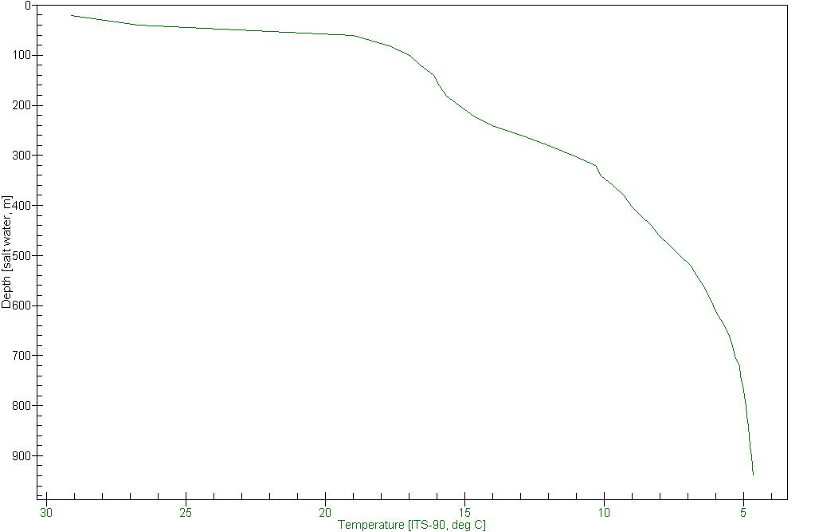

Figure 4.4: Seawater Column Temperature Profile

The profile showed that the surface seawater temperature (within 30m depth) was within 28⁰C and 29⁰C) and consistent with that reported for tropical ocean waters. However, within 30m - 100m depth, the seawater column temperature declined rapidly reaching 16⁰C at about 100m depth. This region of rapid temperature decline is called the thermocline. This is typical of ocean waters and is also responsible for the stratification in the distribution of marine life as it affects the hydrological properties of seawater (Ocean Sciences, 1964; Kings, 1975).

Thereafter (beyond 100m depth), the temperature decreased steadily at a constant rate to about 10⁰C within 300m depth and subsequently at a slower rate towards 4⁰C near the seabed. The trend in seawater column temperature was consistent in the wet and dry seasons across profile stations in the study area.

Salinity
Ocean water salinity gives a measure of the amount of dissolved salt in it and for a sample of ocean water; it is the ratio between the weight of dissolved salts and the weight of the sample being considered. In the surface layers, salinity varies, increasing with increase in the rate of evaporation and vice versa. However, lower salinity is observed at considerable distances from the mouth of rivers where the water remains almost fresh. Ocean salinity has a tendency to decrease slightly in the mixed layer, which is the layer near the free surface subjected to mixing by wind action. Salinity also varies slightly because of tidal effects and the season within the nearshore. The combination of salinity and temperature has profound effect on ocean density and its circulation, though density of seawater depends more on salinity than on temperature. As salinity increases, vapour pressure decreases and osmotic pressure increases (Ocean Sciences, 1964, Kings, 1975).

The importance of salinity in marine ecosystems is seen in the changes that can result in the relative diversity and abundance of marine organisms due to changes in salinity. Such changes may lead to degradation of the food and energy chains in the ecosystem. In the open ocean, salinity normally varies between 33PSU and 37PSU with a mean of 35PSU. The value is lower where large rivers enter the sea, but in areas where the influx from the land is negligible and where surface evaporation is great, it may exceed 40PSU. At depth, salinities range between 34.6PSU and 35PSU (Kings, 1975). The seawater column salinity profile at Yoho Field is presented graphically in Figure 4.5.

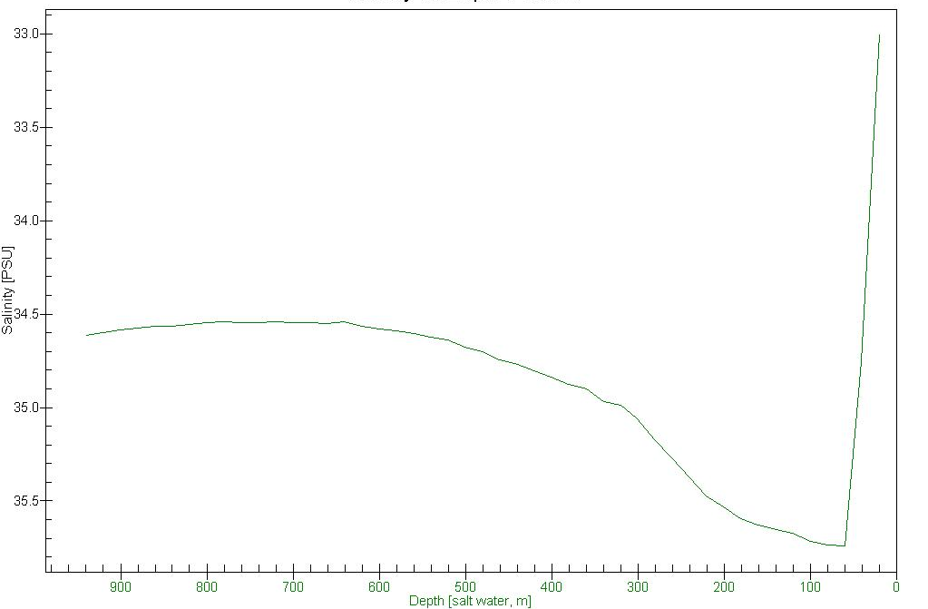

Figure 4.5: Seawater Column Salinity Profile

The profile showed that seawater column salinity increased from about 33PSU (at the surface) to a maximum of about 35.8PSU within 60m depth. Thereafter, salinity decreased steadily to 34.8PSU at about 400m depth and then much more slowly towards 34.6PSU at the maximum depth measured. This trend was consistent in both wet and dry seasons across profiled stations in the area.

Conductivity
Ocean waters, like all aquatic mediums have the ability to carry electric current. This ability is dependent on the presence of ions, on their total concentration, mobility and valence and on the temperature of seawater at points of measurement. Ocean water conductivity is therefore an indication or measure of its ability to carry an electric current. It follows that the degree of conductivity of an aquatic medium is in proportion to the amount of salts in ionised solution in (the salinity). The seawater column conductivity profile is presented graphically in Figure 4.6.

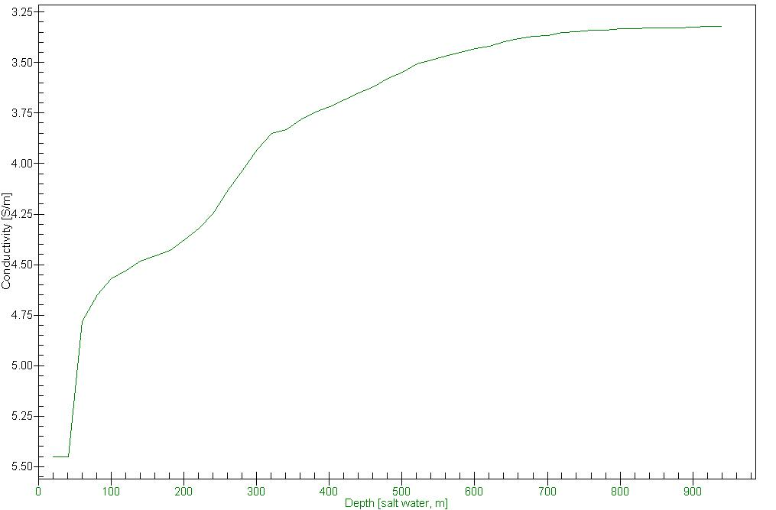

Figure 4.6: Seawater Column Conductivity Profile

The graph above showed that the seawater conductivity decreased gradually from about 54,500µS/cm within the upper 40m depth to about 46,000µS/cm at 100m depth. It further decreased to about 37,500µS/cm at 400m depth and subsequently increases towards 325,000µS/cm at the maximum depth measured. The observed trend was fairly consistent with salinity and temperature trend and also similar in both wet and dry seasons across profiled stations in the study area.

Dissolved Oxygen
The amount of gaseous oxygen dissolved in seawater is referred to as its dissolved oxygen (DO) level. It is an important parameter in aquatic life as it is required for the metabolism of aerobic organisms and also influences inorganic chemical reactions. DO in ocean waters are controlled by a range of processes. Oxygen is produced in the oceanic surface layer by biological production whereas it is removed in the sub-surface waters by the respiration of sinking organic matter. Air-sea gas-exchange rapidly equilibrates near surface waters and the atmosphere, whereas sub-surface oxygen removal is balanced by the transport of oxygen rich surface waters into the interior ocean. The consequence is that sub-surface oxygen concentrations, and the overall partitioning of oxygen between atmosphere and ocean, are sensitive to the rate of surface-to-deep ocean circulation and mixing, biological production as well as temperature and salinity (Emerson et al., 2001; Keller et al., 2002). The DO – depth profile is presented graphically in Figure 4.7.
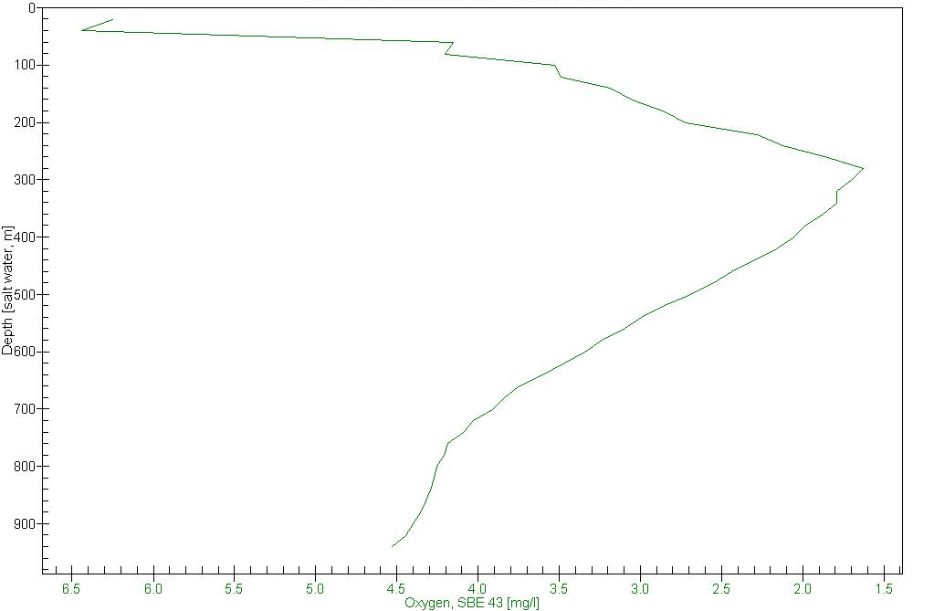

Figure 4.7: Seawater Column Dissolved Oxygen Profile

The DO profile showed that a DO maximum of about 6.5mg/l was attained within the upper 40m depth. Beyond this depth, the concentration declined sharply to 4.5mg/l at about 100m depth. The region between 40m and 100m is termed the euphotic or photic zone, where light penetration is sufficient for photosynthetic activity by sea plants. The bottom of the euphotic zone (also called the “compensation zone”), is defined by the 100m water depth. Here, a balance exists between the oxygen produced photosynthetically and that consumed by respiration. Photosynthesis does not cease below the compensation depth, but there can be no net phytoplankton growth below it. Beyond the 100m depth, the DO concentration continued to decline, reaching 1.6mg/l at about 300m. This continued decline is attributed to consumption of DO due to the respiratory needs of both plants and animals and by the microbial oxidation of settling/sinking organic detritus.

At greater depth however (beyond 300m), the DO level started to increase and continued steadily, towards 4.6mg/l near the seabed. Increase in DO concentrations at greater depth is governed by the observed pattern of surface deep ocean circulation and mixing with resultant formation of various water masses which are cold, dense and rich in DO.

It has also been established that bottom-water oxygen concentrations in the Atlantic are generally higher (>5mg/l) than in the Pacific and Indian Oceans, particularly in water of North Atlantic origin and severe oxygen depletion is not as extensive as in marginal regions of the other oceans. Also, the availability of DO at greater ocean depths assures normal existence of life forms such as the unique benthic/bottom dwelling organisms observed in the area.

pH of Seawater and Sediment
Seawater pH provides insight into its hydrogen ion activity and is used widely to express the intensity of the acid or alkaline condition of the medium (Canter and Hill, 1977). It plays an important role in all chemical reactions associated with formation, alteration and dissolution of minerals and its level is affected by the presence of organic acids as well as biological and physical processes, which can alter concentration of dissolved carbon dioxide. pH is critical to the aquatic ecosystem because it affects the functioning of virtually all enzymes, hormones, and other proteins of the body which control all aspects of metabolism, growth and development. Seawater pH varies between 7.5 and 8.4 with the highest values occurring in the surface during periods of high productivity when carbon dioxide is withdrawn during photosynthesis (Keily, 1998).

The seawater column pH profile indicated very small differences in pH concentration with depth. The pH ranged between 8.05 and 8.6 within a depth of about 950m (Figure 4.8). Also, surface water pH within the 100m depth ranged from 7.2 – 8.8 (wet season) and 7.1 – 7.8 (dry season).

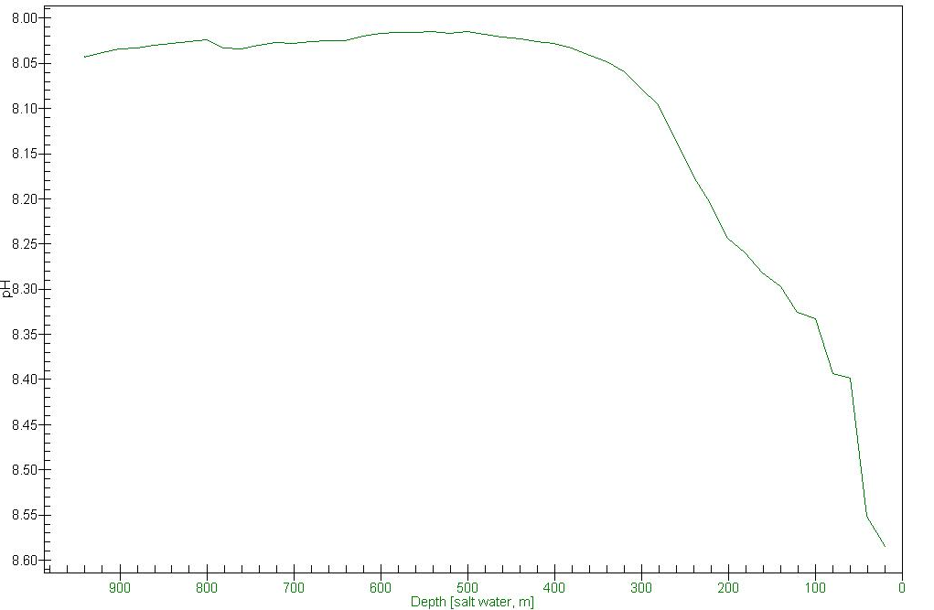

Figure 4.8: Seawater Column pH Profile

However, the pH of surficial sediments in the area were 7.01 – 7.99 (wet season) and 8.04 – 8.5 (dry season). The results for both seasons depicted an alkaline environment, consistent with that reported in similar waters offshore Nigeria (SNEPCO, 2003; STAR, 2004).

Seawater Turbidity
Turbidity provides an expression for the extent to which light passing through water is reduced by scattering which is induced by suspended and colloidal material. It is expressed in the nephelometric turbidity unit (NTU). Turbidity in seawater results from waste discharge, urban run-off, sediment stirring activities of bottom feeders as well as wave and current actions (especially in shallow water regions). Turbidity may impart a brown or other colour in water bodies, depending on the light absorbing properties of the solids and may interfere with light penetration and photosynthetic reactions (Canter and Hill, 1977; Howard, et al, 1985).

The turbidity levels in the seawater column of the study area were below equipment detection limit of 1.00NTU in both wet and dry season. The observed concentrations were consistent with the low TSS levels recorded and indicate that seawater in the area was clear to sight and would permit maximum light penetration for photosynthetic activity in the euphotic zone.

Total Suspended Solids
Total suspended solids (TSS) consist of an inorganic/inert fraction (silts, clays, calcium, potassium, calcium, bicarbonates, chlorides etc.), and an organic fraction (algae, zooplankton, bacteria and detritus) that are within the water column and impart to water the characteristic of turbidity (GEMS, 1992; Canter and Hill, 1977). Excessive suspended solids can be harmful to fish and other aquatic life, by coating gills, blanketing bottom organisms upon settling and reducing solar radiation intensity, thus affecting natural food chain relationships. A positive effect of the presence of suspended solids in water is that toxic chemicals (pesticides and metals) tend to adsorb to them or become complexed with them, thus making the toxics less available to be absorbed by living organisms. A TSS level of 80mg/l appears to have adverse effect on the macro invertebrate population (KWW, 2001).

The TSS levels in the surface seawater of the study area ranged between <1.0 and 16.0mg/l (mean 10.5mg/l) and 5.00 – 11.00mg/l (mean 7.9mg/l) in the wet and dry seasons respectively. These levels were consistent both across sample stations and with previous findings in similar environment, offshore Nigeria (SNEPCO, 2003; STAR, 2004). Also, these concentrations are well below harmful effect levels for macro-invertebrate population and aquatic life generally in the water column of the study area.

4.5.2 Seawater and Sediment Chemical Characteristics
The chemical characteristics (phenol, total petroleum hydrocarbon, polyaromatic and aliphatic hydrocarbons, chlorides, carbonates, nutrients and heavy metals concentrations, etc.), of seawater column and surficial sediments serves as a further indication of the existing status of the marine environment. The links between ocean sediments and the climate include important biological ones, because temperature and other characteristics of the surface water determine the species of creatures that can flourish under those conditions and which form an important element in the sediment that eventually collect on the bottom (Kings, 1975). Environmental contaminants have the tendency to accumulate in the particulates that are deposited on the seafloor over long periods. However, for most elements, low levels of anthropogenic sediment contamination are difficult to detect because natural background concentrations vary with grain size, carbon content and mineralogy (Zenkevitch & Birstein, 1976).

The chemical characteristics of surface seawater and surficial sediments of Yoho Field (from laboratory analysis of collected samples) are summarised in Tables 4.2a and b and detailed in Appendix 4.2. The results obtained from sediment samples analyses were compared with background values as well as that recorded in previous studies in proximal areas offshore Nigeria.
Table 4.2a: Summary of Yoho Field Seawater Samples Characteristics
Parameters (mg/l) | Wet Season |  | Dry season |  | Background Concentrations
Parameters (mg/l) | Range | Mean | Range | Mean
 |  |  |  |  |  | RPI 1985
pH | 7.16 – 8.79 | 8.3 | 7.03 – 7.8 | 7.4 | - | 7.4
Temperature (ºC) | 26.6 - 29.1 | 27.5 | 19 – 29.7 | 28.2 | - | 28
Conductivity (mS/cm) | 45.4 – 51.4 | 48.5 | 42.1 – 52.9 | 44.4 | - | 40,000
Salinity (ppt) | 27.2 – 32.1 | 30.1 | 25 – 29.5 | 26.9 | -
DO (mg/l) | 4.2 - 6.3 | 5.1 | 7.1 – 8.4 | 7.7 | - | 6.7
Turbidity (NTU) | <1.00 | <1.00 | <1.00 | <1.00 | - | -
TSS (mg/l) | <1.00 – 16 | 10.5 | 5 – 11 | 7.9 | - | 45.5
TDS (mg/l) | 28.1 – 33.5 | 31.4 | 25.3 – 31.7 | 28.8 | - | 27464
BOD (mg/l) | <0.5 – 3.4 | 1.2 | <0.5 – 3.5 | 1.2 | - | -
COD (mg/l) | <0.8 – 5.1 | 1.8 | <0.8 – 5.2 | 1.8 | - | -
Phenols (µg/l) | 0.62 – 0.81 | 0.69 | 0.25 – 0.52 | 0.38 | -
TPH (mg/l) | <1.00 | <1.00 | <1.00 | <1.00 | -
Oil & Grease (mg/l) | <1.00 | <1.00 | <1.00 | <1.00 | - | 6.9
Chloride (mg/l) | 15,550 – 18,543 | 17,251 | 13,834 – 16,478 | 16,078 | -
Nitrate (mg/l) | 0.63 – 0.76 | 0.68 | 0.65 – 0.91 | 0.76 | 0.01-0.70*
Phosphate (mg/l) | 0.46 – 0.72 | 0.56 | 0.48 – 0.84 | 0.57 | - | 0.17
Sulphate (mg/l) | 2,180 – 2,615 | 2,419 | 1,451 – 2,514 | 1,622 | - | 1739
Sodium (mg/l) | 10,010 – 17,130 | 13,329 | 5,986 – 16,077 | 10,640 | 10,500*
Calcium (mg/l) | 347 – 387 | 368 | 216 – 400 | 344 | 410* | 1100
Magnesium (mg/l) | 1,623 – 1,926 | 1,728 | 1,048 – 1,875 | 1,546 | 1350* | 5400
Potassium (mg/l) | 357 – 398 | 379 | 201 – 386 | 286 | 390*
Cadmium (mg/l) | <0.02 | <0.02 | <0.02 | <0.02 | 0.001-0.1** | <0.02
Total Chromium (mg/l) | <0.10 | <0.10 | <0.10 | <0.10 | 0.0001-0.00055** | 0.06
Copper (mg/l) | <0.05 | <0.05 | <0.05 | <0.05 | 0.00005-0.00035**
Total Iron (mg/l) | <0.05 | <0.05 | <0.05 | <0.05 | - | <0.05
Lead (mg/l) | <0.20 | <0.20 | <0.20 | <0.20 | 0.002-0.2** | <0.20
Cobalt (mg/l) | <0.10 | <0.10 | <0.10 | <0.10 | -
Silver (mg/l) | <0.10 | <0.10 | <0.10 | <0.10 | -
Nickel (mg/l) | <0.10 | <0.10 | <0.10 | <0.10 | - | <0.10
Zinc (mg/l) | <0.05 | <0.05 | <0.05 | <0.05 | -
Manganese (mg/l) | <0.10 | <0.10 | <0.10 | <0.10 | -
Vanadium (mg/l) | <0.20 | <0.20 | - | - | - | 0.6
* Hem, 1985. ** Neff, 2002. Detailed citations are provided in the in the list of references

Table 4.2b: Summary of Yoho Field Sediment Samples Characteristics
Parameters | Wet season |  | Dry season |  | Background Concentrations*
Parameters | Range | Mean | Range | Mean
 |  |  |  |  |  | RPI 1985
pH (H₂O) | 7.01 – 7.99 | 7.5 | 8.04 – 8.46 | 8.2 | -
Temperature (ºC) | 18.1 – 21.1 | 19.3 | 18.1 – 21.8 | 19.6 | -
Elect Conductivity (mS/cm) | 1.23 – 20.9 | 11.04 | 13.0 – 45.0 | 25.8 | -
TPH (mg/kg) | <10.0 – 83 | 16.9 | <10.0 – 106 | 17.43 | -
TOC (g/kg) | 6.85 – 17.9 | 11.85 | 8.78 – 27.9 | 17.4 | -
Redox Potential (mV) | -130 - -68.5 | -110.13 | -146 – -79.5 | -115.8 | -
Clay (%) | 12 - 31 | 20.1 | 10 - 31 | 19.8 | -
Silt (%) | 21 - 83 | 52.9 | 20 - 80 | 51.29 | -
Sand (%) | 5 - 60 | 26.94 | 5 - 61 | 28.9 | -
Magnesium (mg/kg) | 2,672 – 56,929 | 8,213 | 2,801 – 12,358 | 6,815 | - | 3580
Potassium (mg/kg) | 1,232 – 5,420 | 3,582 | 2,014 – 5,869 | 3,721 | -
Sodium (mg/kg) | 4,069 – 13,110 | 7,502 | 4,240 – 15,350 | 8,515 | -
Calcium (mg/kg) | 8,676 – 27,780 | 13,917 | 9,940 – 28,300 | 14,857 | - | 4.0
Cadmium (mg/kg) | 0.03 – 0.72 | 0.35 | 0.20 – 0.88 | 0.44 | 0.1 - 0.6
Total Chromium (mg/kg) | 7.5 – 30.1 | 19.5 | 12.3 – 35.7 | 22.6 | 50 - 100 | 0.6
Copper ((mg/kg) | 2.3 – 12.6 | 7.4 | 3.73 – 14.5 | 8.15 | 10 - 50
Total Iron (mg/kg) | 8,993 – 25,170 | 16,356 | 10,110 – 26,680 | 17,456 | - | 2180
Lead (mg/kg) | 3.5 – 16.9 | 11.2 | 5.8 – 28.3 | 14.2 | 5 - 30 | 0.6
Cobalt (mg/kg) | 3.0 – 15.5 | 10.7 | 7.6 – 19.4 | 12.1
Silver (mg/kg) | 0.6 – 1.1 | 0.8 | 0.4 – 1.4 | 0.7
Nickel (mg/kg) | 6.2 – 25.9 | 17.0 | 9.1 – 21.7 | 13.9 |  | 1.2
Zinc (mg/kg) | 14.2 – 64.1 | 37.8 | 18.2 – 77.2 | 42.3 |  | 4.6
Manganese (mg/kg) | 106.0 – 515.0 | 330.8 | 196 – 562 | 367.7
Barium (mg/kg) | 29.5 – 186.0 | 73.7 | 32.9 – 232 | 85.8 | 7 – 2,066
Source: FNL Field Survey 2008 and 2009

Total Dissolved Solids in Seawater
Total dissolved solids (TDS) are the aggregate of inorganic salts that are dissolved in water. It is an indication of the quantity of salt and solids dissolved in water. There is a direct relationship between TDS and conductivity as they are both a measure of the dissolved inorganic compounds (EBM, 1994). Excess TDS discharge in water bodies is of concern due to its potential for causing unfavourable physiological reactions in aquatic organisms.

The levels of TDS ranged from 28.1 – 33.5mg/l (mean 31.4mg/l) for the wet season while the dry season recorded a mean of 28.8mg/l. These levels were consistent both across sample stations and with previous findings in similar environment, offshore Nigeria (SNEPCO, 2003; STAR, 2004).

Chemical Oxygen Demand and Biochemical Oxygen Demand in Seawater
Chemical oxygen demand (COD) is the amount of oxygen required to chemically stabilise the organic matter contained in a solution under aerobic conditions. Usually more organics can be oxidised chemically than can be biodegraded (GEMS, 1992).

For the wet season, the COD levels in the seawater samples from the study area ranged from <0.8mg/l to 5.12mg/l with a mean of 1.79mg/l. Dry season results were similar (range = <0.8 to 5.2mg/l, mean = 1.8mg/l). These values suggest a low content of materials requiring chemical oxidation. Disposal of wastes (such as treated sewage, and food waste) offshore, during the implementation of the proposed project, may slightly increase the COD levels of the seawater in local areas, the result of which would be a small reduction in dissolve oxygen value.

Biochemical oxygen demand (BOD) is an indirect measure of the amount of biologically degradable organic materials in water, and is an indicator of the amount of dissolved oxygen that will be depleted from water during natural biological assimilation of organic pollutants (Kiely, 1998; Nebel, 1990). Excess BOD in water therefore could adversely affect aquatic organisms and by extension humans.
The recorded levels of BOD in the study area were <0.5mg/l – 3.42mg/l (mean 1.2mg/l) for the wet season, the recorded dry season levels also has a mean of 1.2mg/l showing no significant difference. The amount of organic contaminant discharged into the seawater during the well development activities is expected to be less compared to the volume of water body which would through dilution render less significant the concentration of the contaminants.

Seawater Phenol
Phenol occurs naturally in low concentrations in the marine environment, being synthesised by a wide variety of plants, animals and microbes. It is also a product of degradation of plant material. It occurs in the environment as phenol, alkyl phenols, and to a lesser extent halogenated phenols. Phenols are present in crude petroleum at low concentrations, and at lower concentrations in refined petroleum products, such as diesel fuel.

Phenol is not persistent in marine and fresh waters. It has a high aqueous solubility (more than 80,000mg/l at 25°C) and vapour pressure. Thus, it is dispersed through water mixing and evaporation. In addition, combined photolysis and microbial degradation remove phenol from the marine water column at a rate as high as 5% per hour. Concerns about phenol stem mainly from its tendency to impart a taste and odour taint to water and aquatic/marine organisms living in phenol-contaminated water. Toxic responses in aquatic organisms are caused by accumulation of phenol in target tissue lipids to a concentration that causes tissue disruption. Such responses occur at relatively high concentrations. The acute marine water quality criterion for phenol is 5,800µg/l. Phenol concentrations rarely reach toxic levels in marine and brackish waters, even near point sources of phenol contamination. Therefore, it is unlikely that phenol represents a quantitatively important toxicant in marine ecosystems.

During the wet season, the concentrations of phenol measured in the seawater samples from the study area ranged from 0.62 - 0.81μg/l, with a mean of 0.68μg/l while in the dry season the concentration range was 0.25 - 0.52μg/l with a mean of 0.37μg/l. These values were well within the acute marine water quality criterion for phenol (Neff, 2002).

Total Petroleum Hydrocarbon in Seawater and Sediment
Petroleum hydrocarbon enters the marine environment through natural sources such as marine seeps and sediment erosion and also from deposits to the seafloor from over time discharges of petroleum products during offshore production, transportation (tanker operations, and dry-docking) and marine terminal operations (bilge and fuel oils, tanker accidents and non-tanker accidents). Other sources include the atmosphere and municipal/industrial waste (municipal wastes, refineries, non-refining industrial waste, urban run-off, river run-off and ocean dumping).

The levels of TPH in the seawater of the study area were below the method detection limit of <10.0mg/l for both seasons while the concentration of TPH in sediment samples collected from the area ranged from <10.0 – 83.0mg/g with a mean of 16.9mg/g for the wet season and <10.0 – 106mg/g with a mean of 17.43mg/g for the dry season.
Total Organic Content in Sediment
Sediment total organic content consists of decomposing plant and animal residues. It is the nitrogen reservoir and furnishes large proportion of sediment phosphorus and sulphur as well as responsible for desirable sediment structure. It also promotes a greater proportion of larger pore sizes and improves water and air retention in sediment.
The TOC levels of sediments in the study area ranged between 6.85g/kg and 17.9g/kg with a mean of 11.85g/kg in the wet season while the level in the dry season was 8.78 – 27.9g/kg with a mean of 17.4g/kg. The levels were consistent across sampling stations in both seasons and indicated no seasonal variation.

Macro Nutrients in Seawater
The macro nutrients (nitrogen, phosphorous, sulphate, etc.), enter the marine environment through urban storm water run-off, irrigation drainage, agricultural run-off, etc. via creeks, rivers and estuaries. Their availability (especially nitrogen and phosphorous), are the limiting factors in primary productivity within the marine environment (Howard, 1985). These essential nutrients are subject to dynamic temporal variability, caused principally by variation in wind driven upwelling. While nitrogen and phosphorus occur in nature and are critical to plant life in the marine environment, too much of the nutrients cause an excessive growth of phytoplankton and other organisms, which deprive marine life including fish and plants of oxygen. The natural concentration of nitrate in seawater is between 0.01mg/l at the surface, to 0.70mg/l at lower depths (Hem, 1985).

The mean concentrations of the nutrients (nitrates, phosphates and sulphates) in the seawater of the study area were 0.68mg/l, 0.56mg/l, 2,419mg/l and 0.76mg/l, 0.57mg/l, 1,622mg/l for wet and dry season respectively. The reported levels were consistent across sampling stations and compared well with ranges recorded in the water column in neighbouring blocks offshore Nigeria (NAE, 2002; 2003; STAR, 2003). There were also no significant variations in both wet and dry seasons.

Exchangeable Cations in Seawater and Sediment
The exchangeable cations determined were magnesium (Mg), potassium (K), sodium (Na), and calcium (Ca). These are abundant natural elements, essential in ensuring optimal primary and secondary productivity of the marine ecosystem. These elements together contribute about 37% to the normal salinity level of the sea, with sodium alone supplying about 31% of this sum (Duxbury, et al, 2002). The natural occurrence levels reported for cations in tropical seawater are as follows: Mg = 1,350mg/l; Ca = 410mg/l; Na = 1,050mg/l; and K = 390mg/l (Hem, 1985).

Generally, the observed ranges and mean concentrations of Mg, Ca, Na, and K in seawater of the study area within natural occurrence levels for tropical seawater. There are no known specific occurrence levels for Mg, Ca, Na, and K in sediment of tropical seas however, their concentration values in the study area were consistent across sample stations (Figure 4.9).
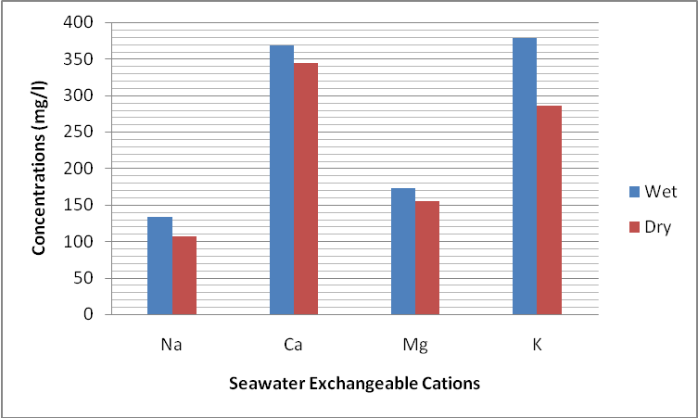
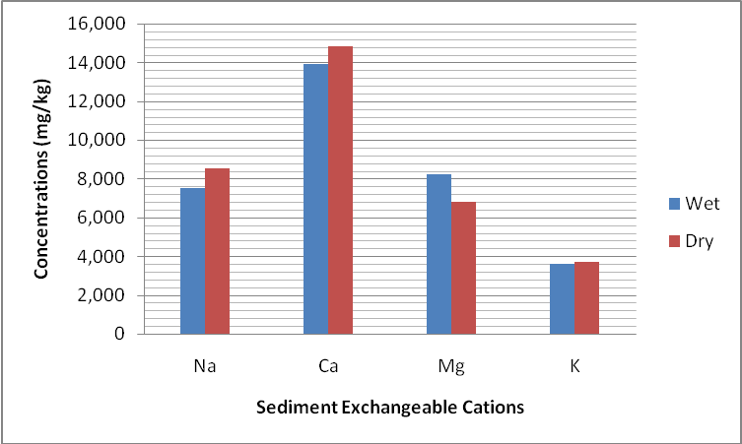

Na x 10²; mg x 10¹

Figure 4.9: Mean Concentrations of Exchangeable Cations in Seawater and Sediment
Sediment Redox Potential
The study area sediment redox potential ranged between -130.0mV and -68.5mV with a mean of -110.13mV for the wet season while the dry season levels were -146.0mV to 79.5mV with a mean of -115.8mV. The recorded values were consistent across sampled stations and depict an anaerobic (reducing) environment which compared well with results obtained on sediments offshore Nigeria (STAR, 2003; ESSO, 2004; Ocean Energy, 2006).

Sediment Particle Size Distribution
The sediments of the study area were generally gray in colour (Hue 7.5Y, 4/1), soft and with lots of visible shell fragments and some sand particles. The particle size distribution (PSD) of sediments show that they were generally silty clay in texture with mean distribution of 52.9% silt, 26.9% sand and 20.1% clay for the wet season while the dry season values were 51.3% silt, 28.9% sand and 19.8% clay. Thus, indicating that there is no significant seasonal variation in sediment PSD distribution in the area. The distribution was also consistent across sampling stations in the area. The graphic description for textural classification of the soil of the study area is illustrated in Figure 4.10.

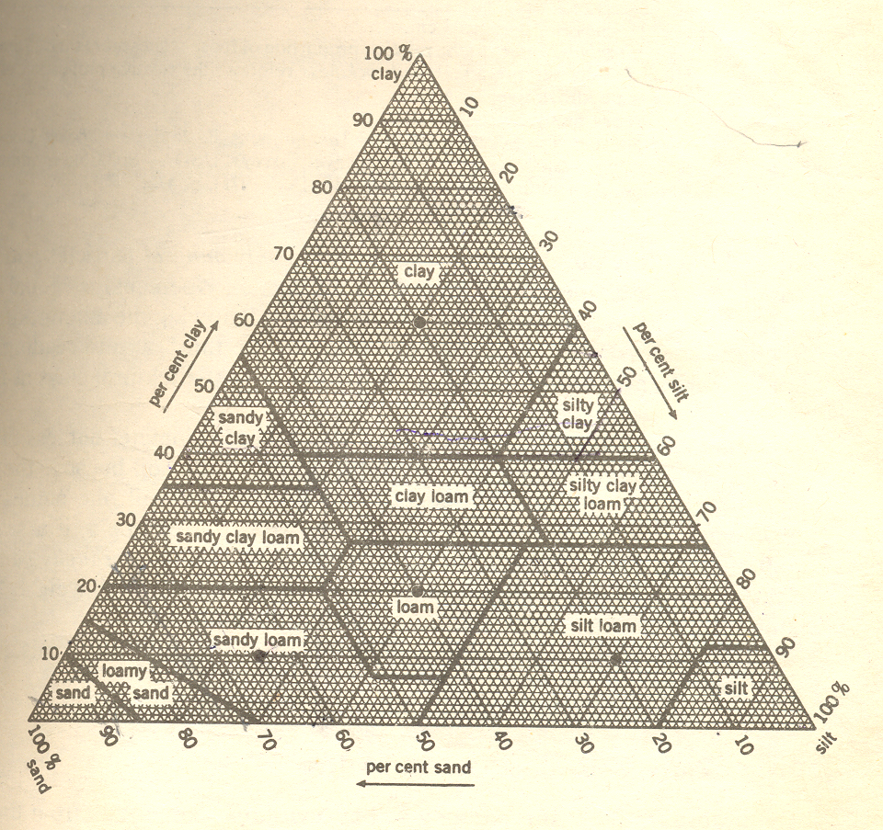
Silty clay
Study area soil description
(Source: Donahue et al, 1990)
Figure 4.10: Graphic Description for Textural Classification of Soil

Heavy Metals in Seawater and Sediment
The heavy metals analysed for in the surface seawater and sediments of Yoho Field were Cadmium (Cd), Chromium (Cr), Copper (Cu), Iron (Fe), Lead (Pb), Cobalt (Co), Silver (Ag), Nickel (Ni), Zinc (Zn), Manganese (Mn) and Barium (Ba). The presences of these metals and others in estuarine and marine sediments originate from several sources and are present in several different forms. More than 25 essential elemental macro- or micro-nutrients have been recognised, some of which may be important toxicants when present in the ambient medium or food at higher than normal concentrations (Neff, 2002). Dissolved metals in seawater tend to form complexes with inorganic and organic ligands and these complexes vary substantially in bioavailability to marine organisms. The availability of trace metals in water are controlled by physical and chemical interactions. These interactions are affected by factors like pH, redox potential, temperature, CO₂ level, the type and concentration of available ligands and chelating agents, as well as type and concentrations of the metals ions. Trace or heavy metals in environmental perspective have potential of bio-accumulation and concentration especially in marine organisms. These may enter the food chain in the process and can affect man (GEMS, 1992).
The chemical species, complexes, adsorbed and solid forms in which different metals occur in sediments have a profound effect on their bioavailability and toxicity to marine organisms. Inorganic detrital particles derived from weathering of crystal rocks may contain a variety of metals, mostly in stable mineral lattice positions. Heavy minerals and many clay minerals are rich in one of more metals. Most of the metals in these solid, stable forms in marine sediments are derived from natural weathering, erosion and surface runoff from land. However, anthropogenic inputs from such sources as mine tailings, dredged material and oil well drilling mud may be important locally. A more important source of metals in sediments is physical and chemical reactions taking place in the water column. Metals introduced in soluble or colloidal forms into the estuarine and coastal marine waters tend to either precipitate or adsorb to suspended particulate and colloidal or dissolved organic matter. These precipitated, adsorbed or complexed metals may be deposited in more or less labile, bioavailable forms in surficial sediments (Neff, 2002).

The following subsections present synoptic discussions on the heavy metals investigated in the surface seawater and sediments of the study area.

Cadmium
Dissolved and particulate forms of cadmium (Cd) enter the marine environment from rivers; atmosphere and other anthropogenic origins while small concentrations could also be present in produced water. In bioavailable form, Cd is one of the more toxic metals to plants and animals and in some forms; it may be mutagenic or carcinogenic in mammals. However, its bioavailability and toxicity decreases as salinity increases, probably due to complexation of Cd ion with chloride in seawater. Marine and estuarine crustaceans are the most sensitive with acute exposure to 300 – 400µg/l dissolved cadmium (as CdCl₂) or chronic exposure to 50 – 100µg/l lead to increased mortalities in some species. Several species of marine animals exhibit decreases in growth, depressed respiration, molt inhibition, shortened life span, altered enzyme activity, abnormal muscular contractions at cadmium concentrations in the range of 0.5 – 10µg/l (Neff, 2002).

Typical concentrations of cadmium in the surface seawaters ranged from 0.001 – 0.1µg/l while concentrations in uncontaminated marine sediments usually are in the range of 0.1 – 0.6mg/kg dry weight. The marine chronic water quality criterion for dissolved ionic cadmium is 9.3µg/l while the effect range low in sediments is 1.2mg/kg (Neff, 2002).

The metal was below method detection limit in seawater (0.02mg/l) while levels detected in sediments of the area (mean values wet and dry seasons 0.35mg/kg and 0.44mg/kg respectively), indicating concentrations which are below toxic levels to life forms in both seawater and sediment of the study area.

Chromium
Chromium enters the marine environment through riverine inflows, deposition from the air and from discharge of produced water. The concentration of total dissolved chromium in open ocean surface waters is in the range of 0.000l – 0.00055mg/l and decreases with depth while its concentrations in uncontaminated marine and estuarine sediments are generally in the range of 50 - 100mg/kg dry weight (Neff, 2002).

Total chromium was below method detection limit of 0.10mg/l in the seawater of study area while the levels in the sediments were 7.5 – 30.1mg/kg with mean 19.5mg/kg and 12.3 – 35.7mg/kg with mean 22.6mg/kg in wet and dry seasons respectively. The recorded concentrations were consistent across sampling stations and within safe levels for uncontaminated marine sediments.

Copper
Copper (Cu) enters the marine environment through river inflows, discharge of produced water, etc and occurs mostly in inorganic complexes. It is an essential element in the nutrition of organisms and is required for the function of several enzymes and in the biosynthesis of chlorophyll. The metal has a strong affinity for complexation with organic ligands such as humic substances and dissolved organic matter and bacterial particles, so little is present in true solution in sea environment as toxic inorganic species. Dissolved reactive copper is toxic to marine plants and animals (GEMS, 1992).

The concentration of copper in clean oceanic water is in the range of about 0.00005 – 0.00035mg/l at the surface and may increase to more than 0.0005mg/l at abyssal depths. In uncontaminated marine and estuarine sediments, copper concentrations usually are in the range of 10 – 50mg/kg dry weight (Neff, 2002). Neff also reported that marine organisms inhabiting sediments containing more than about 200mg/kg copper are likely to be adversely affected (in species diversity) by copper if the copper is in exchangeable, bioavailable forms (Neff, 2002).

Laboratory analysis results showed that copper was below method detection limit of 0.05mg/l in the surface water of the study area while its levels in the sediments ranged from 2.3 – 12.6mg/kg with mean 7.4mg/kg and 3.73 – 14.5mg/kg with mean 8.2mg/kg in wet and dry seasons respectively. The recorded concentrations were well within tolerable limit (200mg/kg) reported for sea bed organisms (Neff, 2002).

Total Iron
Oxides of iron, which are sometimes used as component of water-based drilling mud where it functions as corrosion / scale inhibitors could introduce iron into the water and subsequently, seabed environment. Other sources that may increase the iron level in the seabed environment include metal scraps from construction of offshore facilities, corroding parts of platforms, drilling rigs and other offshore facilities as well as natural sources. The metal occurs in the +2 and +3 oxidation states and the form and solubility of each ion is dependent upon the pH and the oxidation-reduction potential (GEMS, 1992).

The total Fe concentration in the seawater of the study area was below method detection limit of 0.05mg/l. Its concentrations in the sediments ranged from 8,993 – 25,170mg/kg and 10,110 – 26,680mg/kg in wet and dry seasons respectively. The recorded concentrations were consistent with reported values for similar sediments offshore Nigeria (SNEPCO, 2003; STAR, 2004).

Lead
A small fraction of the total lead in open ocean waters is associated with suspended particulate matter and from other anthropogenic sources such as burning leaded gasoline and from metal smelters and discharge of produced water. As a natural component of marine ecosystem, lead is present at low concentrations (0.002 – 0.2µg/l) in clean seawater and in the tissues of marine plants and animals. Dissolved lead is not readily bioavailable or toxic to marine animals (Neff, 2002).

Total lead levels in uncontaminated estuarine and near shore marine sediments generally fall in the range of 5 – 30 mg/kg dry weight. It is also known that background concentrations of lead are inversely related to sediment grain size hence uncontaminated silt/clay sediments contain an average of 15.8mg/kg lead. Although marine invertebrates and fish bioaccumulate lead from seawater in proportion to its concentrations in solution, which in most cases is very small. However, high concentrations of lead (46 – 218mg/kg) in bioavailable forms, could harm local benthic organisms, preventing their colonization of the sediments. Such lead induced effect in marine invertebrates and fish include neurological dysfunction in both the central and peripheral nervous system, altered behaviour and immune suppression (Neff, 2002).

Analysis results indicated that Pb was below method detection limit of 0.20mg/l in the surface seawater. Also the concentrations of Pb in the sediments ranged from 3.5 – 16.9mg/kg with mean 11.2mg/kg and 5.8 – 28.3mg/kg with mean 14.2mg/kg in the wet and dry seasons respectively. The recorded levels in both seasons were consistent across sampling stations and within background as well as tolerable limit for local benthic organisms.

Cobalt
Cobalt is an important micronutrient for marine phytoplankton, (Morel et al., 1994), in particular the photosynthetic Cyanobacteria, yet its surface-water concentrations are very low based on limited available data. Cobalt in its oxidized state forms Co (ll) and Co (lll), like Iron (Fe) its low solubility when oxidized to inorganic Co³⁺ seems to prevent its accumulation in deep water. The world estimated cobalt concentration in open waters was calculated to be 17ppm. This is based on a prediction that used Mn:Co ratios in coastal water, cobalt abundance in pelagic clays and estimates of sedimentation rates while the crustal composition of cobalt was put at 0.0012% (Taylor and McLennen 1985 and Knauer et al. 1982).

Cobalt concentration was below the method detection limit of 0.10mg/l in the surface seawater for both seasons. In sediment samples Cobalt concentration ranged between 3.0 and 15.5mg/kg with a mean of 10.7mg/kg and 7.6 - 19.4mg/kg with a mean of 12.1mg/kg in wet and dry seasons respectively. These concentrations are within the range reported for tropical oceans (Portman et al, 1989).

Silver
Estuarine sediments that receive metals or sewage usually have higher silver concentrations (>0.1 mg/kg dry weight) than do non-contaminated sediments (http://www.inchem.org/documents/cicads).

Analysis result for the seawater samples showed that Silver (Ag) concentration was below the method detection limit of 0.10mg/kg for both seasons. The sediment concentrations for the wet season ranged from 0.6 – 1.1mg/kg with a mean of 0.8mg/kg while the dry season concentration ranged between 0.4 and 1.4mg/kg with a mean of 0.7mg/kg. Previous reports on offshore Nigerian waters have shown that higher concentrations of Ag were recorded in nearshore than in deep offshore areas (ExxonMobil, 2007).

Nickel
Nickel (Ni) enters the marine environment through weathering of minerals and rocks and a wide range of anthropogenic activities. It is an abundant element in the earth crust and occurs naturally in combination with sulphur, arsenic and antimony. It enters the environment mainly through the weathering of minerals and rocks and as a result of anthropogenic activities (GEMS, 1992).

The metal was below method detection limit in the seawater of the area while its concentration in the sediments of the area ranged from 6.2 – 25.9mg/kg with mean 17.0mg/kg and 9.1 – 21.7mg/kg with mean 13.9mg/kg in the wet and dry seasons respectively. The reported concentrations are within the range recorded in previous seabed surveys offshore Nigeria (SNEPCO, 2003; STAR, 2004).

Zinc
Zinc is a naturally occurring element found in rock-forming minerals. Its concentrations in marine and estuarine sediments vary widely and may be high in uncontaminated sediments remote from human activities (Neff, 2002). Other sources of Zinc in the marine environment include aerial depositions and industrial discharges.

Zinc concentrations above about 600mg/kg decreases total abundance and diversity of benthic macrofauna in sediments. Also, several families of polychaetes, harpacticoid copepods, and ostracods are sensitive to Zinc, while some species of gastopods and bivalve molluscs are tolerant and their abundance increase in Zinc contaminated sediments regardless of the Zinc concentrations higher than 8,000mg/kg (Raman and Ganapati, 1983).

The concentration of Zinc in seawater of the study area is below the method detection limit of 0.05mg/l. In sediments Zinc concentrations ranged from 14.2 to 64.1mg/kg (mean of 37.8mg/kg) and 18.2 to 77.2mg/kg (mean of 42.3mg/kg) for wet and dry seasons respectively. These concentrations are consistent with previous studies offshore Nigeria and also below the tolerant level of zinc for aquatic macro fauna.

Manganese
Manganese (Mn) is a relatively common element in rocks, soils and sediments where it exists in the (II), (III), (IV) oxidation state as oxides or hydroxides. These compounds strongly absorb other metallic cations and, along with iron oxides, are of great importance in controlling the concentrations of various trace metals present in natural water systems. In relatively anoxic systems of near neutral pH, considerable concentrations of dissolved manganese may develop, but oxidation and precipitation may result from slight shifts in pH and redox potential (GEMS, 1992).

The concentration of Manganese in seawater of the study area is below the method detection limit of 0.10mg/l. The recorded concentration of manganese in sediment of study area ranged from 160 to 515mg/kg (mean of 330.8mg/kg) and 196 to 562mg/kg (mean of 367.7mg/kg) for wet and dry seasons respectively. The observed concentrations were generally within the natural range for manganese in uncontaminated marine sediment.

Vanadium
Vanadium (V) is present in plants, coal and petroleum and is involved in biochemical processes in living matter. It occurs in three stable oxidation states (V³⁺, V⁴⁺ and V⁵⁺) in aqueous systems, but the dominant forms probably are V⁵⁺ anionic complexes with oxygen and hydroxide. Vanadium’s tendency to form anions often results in a fairly high solubility in oxidising alkaline environment.

Analytical results showed that concentration of vanadium in seawater of the study area during the wet seasons is below the method detection limit of 0.20mg/l. This implies that the level of vanadium in the seawater of the study area is within natural occurring limit.

Barium
Barium (Ba) is an inert yellowish-white alkaline earth metal which combines with water to produce barium hydroxides, thus found in nature as barite. It is the fourteenth most abundant element in the continental crust of the earth with an average concentration in soils and sediment of about 400mg/kg dry weight and a range from <1mg/kg to at least 2,000mg/kg (Trefry, 1982). Barium may be introduced into the environment during oil and gas drilling activities as it is an important component in drilling mud.

The barium concentration in sediment of study area ranged from 29.5mg/kg to 186mg/kg with a mean of 73.7mg/kg for wet season and 196mg/kg to 562mg/kg (mean of 367.7mg/kg) for the dry season. Similar values have been previously reported for uncontaminated sediment in baseline studies offshore Nigeria (SNEPCO, 2003; STAR, 2004).

Polyaromatic Hydrocarbons
Polycyclic aromatic hydrocarbons (PAHs), also called polynuclear aromatic hydrocarbons, are composed of two or more fused benzene rings. Aromatic rings are fused when they share two carbon atoms. Naphthalene (C₁₀H₈), consisting of two fused aromatic rings, is the lowest molecular weight PAH. PAHs with nine or more aromatic rings have been identified in the resin-asphaltene fractions of petroleum.

PAHs may be formed by a variety of mechanisms:
- very rapid, high temperature (e.g., 700°C) incomplete combustion or pyrolysis of organic materials (pyrogenic PAHs);
- very slow (e.g., millions of years) rearrangement and transformation of biogenic organic materials at moderate temperatures of 100-300°C to form fossil fuels (petrogenic PAHs);
- relatively rapid (days to years) transformation of certain classes of organic compounds in soils and sediments (diagenic PAHs); and
- direct biosynthesis by organisms (biogenic PAHs).

PAHs enter the marine environment from natural oil seeps, erosion of coal, peat, and oil shale deposits, oil and coal spills, discharges of treated and untreated ballast and bilge water from oil tankers and other ships, and effluents from oil refineries, oil/water separators on production platforms, coal-fired power plants, and municipal sewage treatment plants. An estimated 3.5 million metric tons of crude oil and refined petroleum products enter the oceans each year from these sources (Neff, 2002). If 5% by weight of all petroleum products released to the ocean is PAHs, then the total annual input of PAHs to the ocean from petroleum is approximately 175,000 metric tons (Neff, 2002).

PAHs in water and sediments are not persistent. They are degraded by various natural processes to various polar organic chemicals, and ultimately to carbon dioxide and water. The quantitatively most important degradative processes for PAHs in the marine environment are photooxidation and biodegradation. Photooxidation involves the exposure of complex mixtures containing PAHs,such as petroleum or coal tar to solar radiation, leading to several reactions that produce a variety of mostly more polar organic compounds. Photooxidation substantially changes the physical and chemical properties of petroleum and its toxicity to marine organisms. Biodegradation is carried out by bacteria and fungi. Nearly all marine water bodies and sediments contain populations of bacteria and fungi that are capable of biodegrading at least some petroleum hydrocarbons. Water column and sediment bacteria and fungi show a tremendous diversity and adaptability in utilizing different types of organic molecules as a sole or supplemental carbon source. Many groups of microorganisms are able to oxidize some aromatic hydrocarbons and heterocyclic compounds completely to carbon dioxide and water and use them as a source of carbon for growth (Neff, 2002).

Effects-range low (ERL) and effects range-median (ERM) concentrations have been estimated for several PAHs in marine sediments. ERLs for individual PAHs range from 0.016 µg/g dry wt for acenaphthene to 0.665 µg/g for pyrene. ERM values range from 0.5 µg/g for acenaphthene to 5.1 µg/g for fluoranthene. The ERL and ERM values for low molecular weight PAHs are 0.55 µg/g and 3.16 µg/g, respectively. The values for total high molecular weight PAHs are 1.7 µg/g and 9.6 µg/g, respectively. ERL and ERM values for total PAHs in sediments are 4.02 µg/g and 44.79 µg/g, respectively. ERMs are useful for identifying sediments that are likely to be non-toxic (all concentrations below ERLs) and sediments likely to be toxic to benthic organisms (several contaminant concentrations above ERMs). However, sediments containing contaminants at concentrations between the ERL and ERM cannot be categorized accurately (Neff, 2002).

The PAH concentrations in the sediments of the area (<0.50mg/kg or <0.50µg/g) were well below the ERL (4.02µg/g) for total PAH in sediments, indicating that the sediments of the area are likely to be non-toxic to the bottom dwelling organisms observed in the study area.

Aliphatic Hydrocarbons
These are the different fractions of total petroleum hydrocarbon (TPH) in marine sediments. Like the polyaromatics, these enters the marine environment from natural oil seeps, erosion of coal, peat, and oil shale deposits, oil and coal spills, discharges of treated and untreated ballast and bilge water from oil tankers and other ships, and effluents from oil refineries, oil/water separators on production platforms, coal-fired power plants, and municipal sewage treatment plants, etc.

The aliphatic hydrocarbon fractions (C₁₀ – C₄₀) were not detected in the sediments of the area and agree with the TPH results in both water and sediments of the area.

4.5.3 Seawater and Sediment Microbiological Characteristics
Micro-organisms are essential components of the marine ecosystem and are involved in the synthesis of new organic matter from carbon dioxide and other inorganic compounds during primary production as well as the decomposition of this accumulated organic matter. They are constantly in competition for available nutrients hence their presence in the marine environment is limited by factors such as energy in the form of light and chemical compounds, temperature, nutrients, pressure, pH and salinity. In response to oligotrophic environments (low nutrient level) and intense competition, many microorganisms become more competitive in nutrient capture and exploitation of available resources (Prescott, et al., 1999).

Many microorganisms can change the physical characteristics of metals and metalloids. Recently, microbes have been found that oxidize Fe2+ using nitrate as an electron acceptor. This process occurs in sediments with depressed levels of oxygen and maybe another route by which large zones of oxidized iron have accumulated in environments with lower oxygen level (Prescott, et al., 1999).

Bacteria are single cell organisms, which are generally considered as organic degraders. Coliforms, including Escherichia coli, are members of the family Enterobacteriocea and these make up approximately 10% of the intestinal microorganisms of humans and other animals. They aid in the digestion of food. The presence of the sub-group, faecal coliform bacteria, in aquatic environments indicates that the water is contaminated with faecal material of man or other animals (KWW, 1994; Prescott, et al., 1999). Synopsis on the microbial composition of the seawater and sediments of Yoho Field are presented hereunder (detailed data is in Appendix 4.3).

Table 4.3: Summary of Seawater and Sediment Characteristics
Parameter | Microbial Counts (cfu/ml)  Seawater |  | Microbial Counts (cfu/g)  Sediment
Parameter | Wet Season | Dry Season | Wet Season | Dry Season
Total Heterotrophic Bacteria (THB) | 3.3 x 10³ – 6.4 x 10⁴  Pseudomonas Sp., Bacillus  Occurrence – 100% | 7.8 x 10³ – 2.15 x 10⁴  Pseudomonas Sp., Bacillus, Micrococcus  Occurrence – 100% | 1.0 x 10⁴ – 2.84 x 10⁶  Pseudomonas Sp., Bacillus, Micrococcus  Occurrence – 100% | 2.0 x 10³ – 1.95 x 10⁶  Pseudomonas Sp., Bacillus, Micrococcus  Occurrence – 100%
Hydrocarbon Utilising Bacteria (HUB) | 0.0 – 5.0 x 10²  Pseudomonas Sp.  Occurrence – 42% | 0.0 – 2.88 x 10²  Pseudomonas Sp.  Occurrence – 97% | 0.0 – 8.1 x 10³  Pseudomonas Sp.,  Occurrence – 65% | 0.0 – 2.48 x 10³  Pseudomonas Sp.,  Occurrence – 50%
Total Heterotrophic Fungi (THF) | 0.0 – 3.3 x 10²  Penicillum, Mucor, Candida, Rhodotorula  Occurrence – 32% | 0.0 – 6.0 x 10¹  Mucor, Candida  Occurrence – 42% | 0.0 – 2.9 x 10²  Mucor, Candida, Rhodotorula  Occurrence – 41% | 0.0 – 1.0 x 10¹  Mucor  Occurrence – 3%
Hydrocarbon Utilising Fungi (HUF) | 0.0 – 2.9 x 10²  Candida, Mucor  Occurrence – 16% | 0.0 – 1.9 x 10¹  Mucor, Candida  Occurrence – 42% | 0.0 – 2.9 x 10²  Mucor, Candida, Rhodotorula  Occurrence – 14.7% | 0.0  -  Occurrence – 0%
Coliform | 0.0 - 3.0 x10¹  Occurrence – 10% | 0.0 - 1.2 x10¹  Occurrence – 3% | 0.0 - 8.9 x10²  Occurrence – 6% | 0.0 - 2.0 x10¹  Occurrence – 12%
Source: FNL Field Survey 2008 and 2009

The predominant heterotrophic bacteria (HB) observed within the study area were Bacillus, Pseudomonas, and Micrococcus with Pseudomonas as the only hydrocarbon utilising bacteria (HUB) species present. Similarly, the encountered fungi genera include Candida, Penicillum, Mucor and Rhodotorula. Result of seawater sample analysis showed that heterotrophic bacteria with counts ranging from 3.3 x 10³ – 6.4 x 10⁴cfu/ml for the wet season and 7.8 x 10³ – 2.15 x 10⁴ for the dry season were present in all the stations visited (Table 4.3). The result also revealed that the percentage occurrence for Coliform bacteria in the area were 10% and 3% for wet and dry season respectively. The analysis result of sediment in the area also recorded similar microbial counts with heterotrophic bacteria with counts ranging from 1.0 x 10⁴ – 2.84 x 10⁶ cfu/g for the wet season and 2.0 x 10³ – 1.95 x 10⁶ cfu/g for the dry season. No sulphate reducing bacteria was found in the sediment wet season sample which a low count of 1cfu/g was recorded during the dry season. However, the percentage hydrocarbon degraders (bacteria and fungi) to the total heterotrophic bacteria and fungi load in the seawater and sediment samples were less than 1, thus corroborate the recorded TPH level and suggest an environment that was free of hydrocarbon pollution at the time of survey.

Accidental release of oil from well blowouts, pipeline leakages / seeps is likely to introduce hydrocarbon feeders thereby increasing the population of the HUBs and HUFs in the seawater and sediment of the study area.

4.5.4 Seawater and Sediment Hydrobiological Characteristics
This section discuses the plankton (phytoplankton and zooplankton) and benthic macrofauna composition in the Yoho Field from the result of field sampling and laboratory analysis. Detailed data is in Appendix 4.4.

Phytoplankton
The phytoplankton community (earlier noted as the basis of life in the oceans and aquatic ecosystems generally) includes small sized to microscopic photosynthetic marine plants, which float freely in the mid-water / surface layer of both marine and freshwater. Usually, these plants are usually single celled and autotrophic. As primary producers, they contribute appreciably to total production within aquatic systems (Canter and Hill, 1977). Their proliferation during a particular season depends on water temperature, light penetration and the supply of nutrient salts to the surface layer. However, biomass of plankta decreases with depth and distance from the coast (Butman, 1987). A summary of the phytoplankton abundance and diversity is presented in Table 4.4.

Table 4.4: Phytoplankton Abundance and Diversity
Division | Abundance |  | % Count
 | Wet | Dry | Wet | Dry
Blue green algae | 22 | - | 1.2 | -
Diatoms | 1,459 | 1,260 | 80.3 | 65.5
Dinoflagellates | 330 | 654 | 18.2 | 34.0
Marine flagellates | 1 | 10 | 0.1 | 0.5
Tintinnid | 4 | - | 0.2 | -
Total | 1,816 | 1,924 | 100 | 100
Source: FNL Field Survey 2008 and 2009

The major divisions of phytoplankton observed in the area were Diatoms which accounts for 80.3% and 65.5% for the wet and dry seasons respectively. This is followed by the Dinoflagellates with 18.2% in the wet season and 34.0% in the dry season. Other encountered divisions include Blue green algae, Marine flagellates and Tintinnid (Table 4.4). Statistical analysis indicated no significant difference in species abundance across sampling stations. Generally among the phytoplankton species, high fidelity of a particular species seemed to be as a result of low abundance and was likely to be a product of chance.

The dominance of Diatoms in the two seasons is in conformity with previous findings, which indicate that Diatoms dominate the phytoplankton population in marine ecosystem (Nwankwo, 1993 and 2003). An outstanding feature of Diatoms is that their food storage takes the form of oil droplets. It is thought that petroleum deposits may represent the pre-historic accumulation of an incredible number of such droplets from Diatoms and other plankta.

Zooplantkton
Zooplankton occupies the lower depths, below the phytoplankton in the marine ecosystem and comprise small animals of weak swimming ability or without swimming ability that are free flowing or drifting biota. They include the holoplankter (e.g. copepods) and the meroplankton (such as the larval stages of invertebrates and the eggs and larvae of most fish species). In the aquatic food web, zooplankton is the initial consumer of energy fixed by the phytoplankton and by themselves provides a link between primary production and higher trophic levels (Canter and Hill, 1977). Increase in primary production following fertilization usually result in greater zooplankton abundance (Boyd, 1982). A summary of the zooplankton abundance and diversity is presented in Table 4.5.

Table 4.5: Zooplankton Abundance and Diversity
Division | Abundance |  | % Count
 | Wet | Dry | Wet | Dry
Annelida/Polychaeta | 2 | 31 | 0.2 | 2.7
Copepoda larvae | 90 | 34 | 11.0 | 2.9
Copepoda/Calanoida | 535 | 851 | 65.6 | 73.5
Copepoda cyclopoida | 64 | 85 | 7.8 | 7.3
Copepoda/Harpacticoida | 27 | 29 | 3.3 | 2.5
Malacostraca | 2 | - | 0.2 | -
Chaetognatha | 19 | 23 | 2.3 | 2.0
Copepoda/Cladocera | 1 | 14 | 0.1 | 1.2
Chordata | 47 | 39 | 5.8 | 3.4
Echinoderm larvae | 11 | 23 | 1.3 | 2.0
Mollusca larvae | 18 | 29 | 2.2 | 2.5
Total | 816 | 1158 | 100 | 100
Source: FNL Field Survey 2008 and 2009

A total number of 816 and 1158 species were counted for Yoho Field during the wet and dry seasons respectively. Out of these, the Copepoda/Calanoida was the most abundant with a percentage of 65.5% and 73.5% for the wet and dry seasons respectively. The Copepoda larvae also have a percentage count of 11.0% and 2.9% for the wet and dry season respectively. Copepods are known to constitute three-quarter of the zooplankton population of tropical marine ecosystem (Wiaffe & Frid, 2001). Most Copepods within offshore region are carnivorous in habit and form significant component in the food chain of any marine ecosystem (Hallegraff, 1995; Nwankwo, 2003). Other divisions of zooplankton observed in the study area include Annelida/Polychaeta, Chaetognatha, Chordata, Echinoderm larvae and Mollusca larvae (Table 4.5). There was no significant variation in the abundance of protozoa across sample stations.

Detailed analysis result for plankton (Appendix 4.4) indicated low plankton diversity and moderate abundance in all the sampled stations. Species observed in this study are similar to that reported in previous studies by marine ecologists who, noted that size of phytoplankton species, diversity and abundance decreases from inshore to offshore and that carnivorous micro zooplankton dominates the population of zooplankton species within the offshore region due to the difficulty encountered in filtering small sized phytoplankton (UNEP, 1990; Marten, 1985; Wyatt 1998 & Nwankwo, 2003).

Overall comparison of the total plankton population for the Yoho field area shows that a total number of 2,632 and 3,082 for wet and dry seasons respectively were recorded. The analysis result showed that the number of phytoplankton recorded for the wet season was 1,816 (68.99%), while the dry season result showed that phytoplankton also recorded a high percentage of 62.4% (1,924). The results also revealed that zooplankton recorded 31.0% and 37.6% for wet and dry seasons respectively. This trend is however, in agreement with previous findings, which indicated that phytoplankton (as primary producers), not only serve as inevitable food source for the zooplankton and other herbivores, but, also have initial higher regeneration rate (Wiaffe & Frid, 2001). Also, it has been reported that more herbivorous micro-zooplankton within inshore waters change to carnivorous habit within offshore waters, due to difficulty in filtering small sized phytoplankton within this zone (Hallegraff, 1995; Wiaffe & Frid, 2001).

Benthic Macrofauna
Benthic macro invertebrate fauna (the bottom dwelling components of the aquatic environment) include the large marine molluscs and crustaceans. They consist of animals that live on or in bottom sediments, which mix up the soil and incorporate organic matter and may impair the exchange capacity and content of some nutrients. Their distribution is effected by such environmental variables as the physical, chemical and biological characteristics of both sediment and the overlaying water medium. A great number of these diverse assemblages of plants and animals are decomposers contributing in the turnover of energy and materials and playing vital roles in the ecosystem (Sanders & Hessler, 1969).

The character of the bottom (sediment type) and the depth influence the type of animal or benthic community found in each habitat. Sand tends to shift and move, making it difficult for large plants or algae to become established, although some clams, burrowing worms, and small crustaceans find sand to be a suitable habitat. Clams filter water for plankton and detritus, or burrow through sand, feeding on other inhabitants. Muds may provide suitable habitats for some kind of rooted plants. Muds generally have little oxygen in them but still may be inhabited by a variety of burrowing organisms that feed by filtering water above them or feed on other animals in the mud. However, the variety of creatures is greatest on the continental shelves, in the zones where light penetration can reach to the bottom and the benthos can feed on living phytoplankton as well as zooplankton and other food. Generally, species diversity of benthos increases up to a certain depth in the marine environment, after which it starts to decrease (Sanders & Hessler, 1969; Kings, 1975).

The detailed data on the benthos abundance and diversity in Yoho Field is presented in Appendix 4.4. In the wet season, a total of 1,693 species of benthic macrofauna were encountered of which 430 belonged to Annelida/Polychaeta, 839 were members of the Mollusca family and Arthropoda were 253. Others were Echinodermata, Sipunculida, Chordata, Nermetea and Hemichodata.

Similarly, during the dry season, about 1,805 species were encountered. Annelida, Arthropoda, Mollusca, and Echinodermata were also identified. The most abundant phylum in terms of total number of organisms was the mollusca having 49.6% and 56.2% for the wet and dry season respectively. Two bivalves, Nacula sp and Mytilus sp, were predominant. The next important phylum was Annelida, here solely represented by the polychaetes. These made up 25.4% and 27.1% of the total number of organisms for the wet and dry seasons respectively. The polychaetes were a mixture of tube-dwellers in parchment-like tubes (e.g Chaetopterus), tube-dwellers in sandy tubes (e.g sabellaria) and burrowers in sand and mud (e.g Dasybanchus). Other phylum that also made a good number of the total number of benthic organisms present includes the Arthropoda and Echinodermata. A summary of the benthic macrofauna abundance and diversity is presented in Table 4.6.

Table 4.6: Benthic Macrofauna Abundance and Diversity
Division/Phylum | Abundance |  | % Count
 | Wet | Dry | Wet | Dry
Annelida/Polychaeta | 430 | 492 | 25.4 | 27.1
Arthropoda | 253 | 120 | 14.9 | 6.6
Chordata | 5 | 4 | 0.3 | 0.2
Mollusca | 839 | 1017 | 49.6 | 56.2
Sipuncula | 17 | 12 | 1.1 | 0.7
Echinodermata | 129 | 161 | 7.6 | 8.9
Nermetea | 10 | 2 | 0.7 | 0.1
Hemichodata | 6 | 1 | 0.4 | 0.1
Total | 1,693 | 1,805 | 100 | 100
Source: FNL Field Survey 2008 and 2009

The high dominance of phylum Annelida/Polychaeta could be due to the muddy nature of the sediments which favours more the abundance and distribution of marine burrowing and tube-dwelling deposit feeders within this group (Snelgrove, 1999; Raman & Ganapati, 1983). However, some of these organisms especially Polychaetes, Mollusca and Arthropoda contain enzyme system capable of oxidizing the toxin by literally adding oxygen atoms, making it more hydrophilic and thus, more easily metabolised. This phenomenon is also accountable for the recorded abundance in Annelida and Mollusca respectively.

The study showed that species diversity has been considered in two main components, namely, species richness and equitability. While species richness refers to the number of species in the sample, community or habitat, the term equitability refers to the evenness with which individual are distributed numerically among species. From the analyses it can be generally inferred that both species were remarkably low in Yoho Field.

Thus the low abundance may be largely due to low biological productivity in the area. The low level of biodiversity is a combination of several factors such as low biological productivity, depth of sea water, relative uniformity of benthic sediments and subsequent small range of ecological niches (Cushing, 1975).

4.5.5 Fisheries Resources, Seabirds and Marine Mammals of Project Area

Fisheries Resources
The study area supports a substantial artisanal and trawl fishery. The common fisheries resources within the study area include fin fishery (pelagic and demersal), and shellfishes (shrimps, crabs, lobsters, and molluscs). Detailed description of the fisheries resources of the study area is presented in Appendix 4.5.

Seabirds
More than 30,000 seabirds belonging to 13 species breed along the coast of West Africa. However the only recorded large concentrations of seabirds on the coast of West Africa are in Mauritania and Senegambia to the north of the Gulf of Guinea (Cooper et al, 1984). There may be breeding areas along the Nigerian coast, but no full-scale survey of seabird population has been undertaken.

The most commonly identified Nigerian coastal/nearshore birds include pelicans (Pelecanus rufescens), egret (Egretta gularis), purple heron (Ardea purpurea), greater flamingo (Phoenicopterns ruber), pintail duck (Anas acuta), white-fronted plover (Charadrius marginatus) and curlew (Numenius arquata) (Esso, 1998). Several of these are shorebirds, which tend to have low sensitivity to oil spill due to their life habits. However, those species that spend a large proportion of time on the water surface, and certain diving species in particular, tend to be more sensitive to oil pollution.

Two “near threatened” (per IUCN) bird species occur in Nigeria but do not breed there. These are the Damara tern, which feeds offshore as well as in estuaries and lagoons, and the African skimmer, which occurs on the coast and along rivers.

Marine Mammals
About 27 species of marine mammals, all of which are either dolphins or whales, are commonly known to inhabit or migrate through Nigerian offshore waters. These marine mammals and their known conservation status according to the International Union for Conservation of Nature (IUCN) are listed in Table 4.7. For those species listed as conservation status “insufficiently known”, there is insufficient information on population levels and distribution within Nigerian waters to determine local status.
Table 4.7: Marine Mammals Known to Exist in Nigerian Offshore Waters
Common Name | Biological Name | Conservation Status
Rough toothed dolphin | Steno bredanensis | Insufficiently known
Atlantic hump-backed dolphin | Sousa teuzii | Insufficiently known
Risso’s dolphin | Grampus griseus | Insufficiently known
Bottle-nose dolphin | Tursiops truncatus | Insufficiently known
Atlantic spotted dolphin | Stenella frontalis | Insufficiently known
Pantropical spotted dolphin | Stenella attenuata | Insufficiently known
Spiner dolphin | Stenella longirostris | Insufficiently known
Clymene dolphin | Stenella clymene | Insufficiently known
Striped dolphin | Stenella coeruleoalba | Insufficiently known
Common dolphin | Delphinus delphis | Insufficiently known
Fraser dolphin | Lagenodelphis hosei | Insufficiently known
Melon-headed dolphin | Peponocephala electra | Insufficiently known
Pygmy killer whale | Feresa attenuata | Insufficiently known
False killer whale | Pseudorca crassidens | Insufficiently known
Killer whale | Orcinus orca | Insufficiently known
Short-finned pilot whale | Globicephala macrorhynchus | Insufficiently known
Blainville’s beaked whale | Mesoplodon densirotris | Insufficiently known
Cuvier’s beaked whale | Ziphius cavirostris | Insufficiently known
Sperm whale | Physeter macrocephalus | Insufficiently known
Pygmy sperm whale | Kogia breviscep | Insufficiently known
Dwarf sperm whale | Kogia simus | Insufficiently known
Minke whale | Balaenoptera acutorostrata | Insufficiently known
Sei whale | Balaenoptera borealis | Vulnerable
Byde whale | Balaenoptera edeni | Insufficiently known
Blue whale | Balaenoptera musculus | Endangered
Fin whale | Balaenoptera physalus | Vulnerable
Humpback whale | Megaptera noveagliae | Vulnerable
Source: Marine Mammals of the World

An unidentified species of whale was observed during the marine sampling survey conducted for this EIA. The Atlantic humpbacked dolphin (Sousa teuzii) has also been sighted in coastal nearshore waters (Esso, 1998). This species prefers coastal and estuarine waters less than 20m deep. There are no reports of its presence in offshore water. Preferred habitats for this species appear to be sandbank and mangrove areas. These dolphins often form small schools (up to 25 dolphins).

Sea Turtles
Five species of turtle have been reported off the West African coast and may inhabit the study area. These are the leatherback turtle (Dermochelys coriacea), olive ridley turtle (Lepidochelys olivacea), green turtle (Chelonia mydas), loggerhead turtle (Caretta caretta), and hawksbill turtle (Eremochelys imbricata) (Esso, 1998). Although these creatures will occur in offshore waters, their abundance will be greater nearshore. While observed elsewhere along the West African coast, the occurrence of the endangered (per IUCN) green turtle and critically endangered (per IUCN) hawksbill turtle is questionable in Nigeria.
4.6 Socio Economics and Health Survey
As directed by the Akwa Ibom State Ministry of Environment and Mineral Resources (AKSMEMR). The study covered sixteen (16) LGAs in Akwa Ibom State, namely; Eket, Esit Eket, Onna, Nsit Ubium. Ikot Abasi, Mkpat Enin, Eastern Obolo, Ukanafun, Oruk Anam, Mbo, Oron, Okobo, Ibiono Ibom, Itu, Uruan and Ibeno. These LGAs are the coastal towns and are proximal to the three major rivers, namely; Qua Iboe River, Imo River and Cross River or their tributaries, and all of which empty into the Atlantic Ocean.

4.6.1 Study Methodology
Two major activities were conducted, viz; Consultations and Socio-economics survey.

Consultations
Consultations is a major feature of the socio-economic component of the Environmental Impact Assessment (EIA) process for any intended project, which in this case incorporates all individuals and communities that may be directly or indirectly affected by the proposed project. Consultations aim to inform relevant stakeholders about the intentions / plans of project proponents. It also attempts to record the concerns and views of the generality of stakeholders and helps to ensure general acceptability of research results with a view to ensuring that minimal dissensions and conflicts arise during project implementation.

The consultation programme for the socio-economic impact assessment of the SFDP consisted of a two-tier process.

- Reconnaissance visits to key LGA stakeholders (political leaders / traditional rulers / civic leaders). This was done for legitimating purposes, as to secure permission and cooperation for the study.

- Direct Consultation with Identified Stakeholders. This phase was conducted by the EIA consultants through visits to the various communities which were identified by each Local Government Council after due consultations at the Local Government secretariat (Tier 1 consultation). The Tier I consultations involved the utilization of participatory tools to elicit information from stakeholders on community baseline data, expected impacts (direct/indirect, adverse/beneficial, short/long term etc). Attempts were also made to ascertain stakeholders’ concerns as well as identify areas by which affected communities may be assisted by the Project Proponent alone, or in conjunction with relevant NGOs and Government Agencies at various levels. This phase of the study was conducted between June 22, 2009 and July 2, 2009 by a combined team of representatives of MPNU and the EIA consultants (Fugro Nigeria Limited). Additional study was conducted from May 20, 2009 to June 1, 2009 with representatives of sixteen (16) LGAs at their respective headquarters. The proceedings from the various meetings as well as the attendance sheets were well documented. The schedule of meeting with the various LGAs is presented in Table 4.8 (see Appendix 4.6a for details).

Table 4.8: Schedule of Consultations with Key Stakeholders
Date | LGA | Purpose | Remarks
20/05/11 | Eket | Visit to Eket LGA Traditional Rulers Council (TRC) to establish contact with the Paramount Ruler/ Village Head of Atibe village | -
20/05/11 | Eket | Consultation visit to Idung Udo | FGD Session scheduled for the Village Council
23/05/11 | Itu | Consultation visit to establish contact with contact persons submitted by the LGA during July 2009 Consultation meetings | Contact established with Mr. Mfon Eton, Personal Assistant to Itu Chairman. IDI scheduled with Community representatives for Ntak Inyang and Atai Ibiaku Itam
23/05/11 | Ibiono Ibom | Visit to establish contact with community representatives and set up meetings | IDI scheduled with Legislative Leader and Supervisory Councilor from Ntan Ekere
24/05/11 | Oruk Anam | Consultation visit to Ibesit Anwa Udo | FGD session scheduled for key stakeholders
24/05/11 | Oruk Anam | Consultation visit to LGA council to establish contact with Councilor representing Ikot Inyang | IDI meeting scheduled
24/05/11 | Ukanafun | Consultation visit to establish contact and schedule meetings | Community leader for Ikot Ikpe / Leader of Legislative Council contacted. Interview meeting scheduled.
24/05/11 | Mkpat Enin | Consultation visit to establish contact with the councilor representing Odoro Ikot Communities | Contact established with Hon (Elder) Inyang Umoh and IDI scheduled
25/05/11 | Esit Eket | Consultation visit to establish contact with Dr. Isangedighi Imossan, contact person forwarded during July 2009 consultation session at the council | Contact person reached on phone but claimed he wouldn’t be available. Direction to Etebi Mbak - Uyo obtained
25/05/11 | Oron | Consultation visit to establish contact | Interview session scheduled with the Clan Heads of Eyo Abasi and Idua
26/05/11 | Ikot Abasi | Consultation visit to Uta Ewa | Village Council Secretary contacted and Interview session scheduled with Village Head
26/05/11 | Onna | Consultation visit to the LGA area to establish contact with community representatives and set up interview meetings | Interview meetings scheduled for Mkpok and Ikwe villages
27/06/11 | Onna | Collect additional information | Meeting with Rev. Akpan Inyang Ata, Community Representative/ Local Government Supervisory Councilor for Education
28/06/11 | Eket (Idung Udo) | Collect additional information | IDI with Village Head, Eteidung John Tom Udoette
01/07/11 | Mkpat Enin (Ikot Ekpang) | Meeting with the Odoro Ikot Group of Villages Stakeholders’ forum at the instance of Hon. (Elder) Inyang Umoh, Councilor representing Ikpa Ibom Ward 3 | The community representatives were further clarified on the purpose of the exercise and reason for interview with Hon. (Elder) Inyang Umoh. Information gotten during the IDI authenticated.

Table 4.8: Schedule of Consultations with Key Stakeholders – cont’d
Date | LGA | Community | Contact Persons | Remarks
27/05/11 | Mkpat Enin | Odoro Ikot community | Hon. (Elder) Inyang Umoh- Councilor representing Ikpa Ibom Ward 3 | IDI Conducted
27/05/11 | Eastern Obolo | Iko town | Chief J. M. Ugama – Acting Village Head | IDI conducted
27/05/11 | Eastern Obolo | Elekpon | Hon. Ikan Felix Aganin - Councilor representing the ward | -do-
28/05/11 | Onna | Mkpok | Hon. (Prince) Dominic Offong - Councilor representing ward | -do-
28/05/11 | Onna | Ikwe | Rev. Akpan Inyang Ata – Supv. For Education in Onna/ Community leader | -do-
28/05/11 | Eket | Idung Udo | Chief John Tom Udoette and Village council members | IDI and FGD conducted
-do- | Nsit Ubium | Ikot Okwot | Chief Nathan Willie Akpan – Village Head | IDI conducted
30/05/11 | Nsit Ubium | Ibiomin | Pastor Friday Noah Village Council Sect. and others | IDI conducted
-do- | Oruk Anam | Ikot Inyang | Hon. Kingsley O. Frank- councilor Representing the ward | IDI conducted
-do- | Oron | Idua group of villages | His Highness Chief E. N. Ekeng – Clan Head of Idua Clan | -do-
-do- | Oron | Esin Offot – Eyo Abasi clan | Chief Etim Edet Ata – Esin Uffot Village Head/ clan Head Elect | -do-
-do- | Okobo | Edebe Enen - Ekeya | Chief Michael Asuqwo Anyin – Village Head | -do-
-do- | Esit Eket | Etebi Mbak Uyo | Chief Etim Johnson – Village Head and others | FGD conducted
-do- | Esit Eket | Ebighi Assang - Uquo | Chief Eteudo Ikot – Village Head and others | -do-
31/05/11 | Ukanafun | Idung Udomisor | Hon. Emmanuel Wison Udomisor – Supervisory Councilor/ Community leader | IDI conducted
31/05/11 | Ukanafun | Ikot Ikpe | Hon. (Elder) Elijah Akpan – Leader Ukanafun legislative council | -do-
-do- | Ibiono Ibom | Ntan Ekere | Hon. Nkereuwem Umoh – Supv. Cllr | -do-
-do- | Ibiono Ibom | Mbiakpan Atan | Hon. (Engr.) Dominic Udoatan - Leader Ibiono Ibom legislative council | -do-
-do- | Itu | Ntak Inyang | Prince Aniefiok Okon Ekong – Community leader | -do-
-do- | Itu | Atai Ibiaku Itam | Chief Daniel Udo Efe – Village Council Chairman | -do-
-do- | Uruan | Anakpa | Chief Asukwo Ekpeyong – Village Head and others | FGD conducted
01/06/11 | Eket | Atibe | Prince U. F. Akpan- Village council Chairman | IDI conducted
01/06/11 | Ikot Abasi | Ikpetim | Pastor Augustine Robert – Community leader | IDI conducted
01/06/11 | Ikot Abasi | Uta Ewa | Eteidung Akpan Akpan Uwa Uniong – Village Head | IDI conducted
01/06/11 | Oruk Anam | Ibesit Anwa Udo | Chief Sam King Akpabio – Village Head and others | FGD conducted
01/06/11 | Ibeno | Upenekang | Mr. O. H. Okutinyang – Sect. Ibeno Clan council | IDI conducted

Socio-economics Survey
This phase of study consisted of data collation on the existing social and economic indices of the study area. Relevant data were presented under various subheadings, including:

- Social Environment (Socio-cultural/psychological environment, demography, education and literacy, quality of life);
- Poverty and inequality, (human development indices); and
- Economic Survey and production factors, labour force participation, employment / unemployment and market survey.

4.6.2 Sampling Procedure
Choice of respondents (groups / individuals) for the consultation activity was by purposive sampling techniques based on the perceptions of the LGA Chairman- in-Council with regard to community stakeholders who can provide relevant informed opinion on the issues at stake.

Data Collection Techniques
The study utilised both primary and secondary data. Primary data collection was through Focus Group Discussions (FGDs) with community representatives (Figure 4.11). Non-participatory observation techniques and visual photography sessions were utilised as complementary data collection tools. Stakeholder communication technique used is presented in Table 4.9

Table 4.9: Stakeholder Communication Technique
Public Communication Techniques | Inform/ Educate | Identify Problems& Values | Get Ideas/ Solve Problems | Get Feedback | Evaluate | Resolve Conflict/Obtain Consensus
Informal small group meetings
General public information
meetings
Local planning visits
Field trips and site visits
Letter requests for comments
Community interest advocates
Public review of assessment decisions
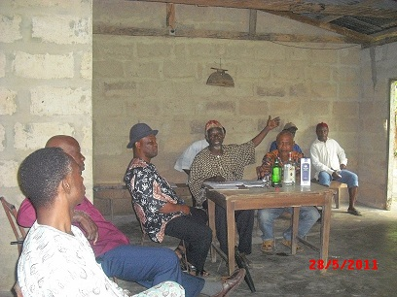


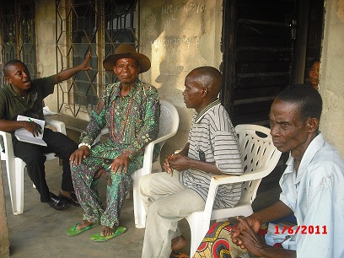
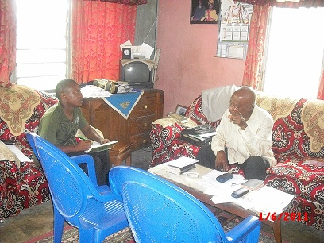

Figure 4.11: Cross section of Discussions with Key Stakeholders

Analytical Techniques
Descriptive statistics were utilised to analyse collated data. These included means, percentages, frequency tables and charts.

4.7 Basic Demographic, Political and Physical Profile
Akwa Ibom State is one of the 36 states making up the Nigeria Federation and was created on September 23, 1987. The state occupies the South-South fringe of Nigeria lying between latitude 4⁰33’ and 5⁰33’ North and longitudes 7⁰35” and 8⁰25” East. The state is bounded on the North by Abia and Cross River States and on the South, by the Atlantic Ocean. On the East, the State shares its boundary with Cross River State along Okpokong River and on the West, by Rivers
and Abia States. The state, which is divided into 31 Local Government Areas, covers a total land area of 7,081 sq.km, representing about 0.87 percent of the country’s total land area and an ocean front, which spans a distance of about 129 kilometres (Akwa Ibom State Government (AKSG,2001). It is the 15th most populous state in Nigeria with a high population density, ranging between 466 persons per square kilometer. Akwa Ibom State is a haven of wealth and potentials in agriculture and mining. Its weather is clement and holds splendid opportunities for leisure, investment and wealth creation and the people are hospitable. The state has a young, educated and vibrant population (45% in the 0-14 year’s age group and 52.1% in the 15-64 years age groups (Iwok, 1994) who is dynamic, forward looking and self assertive; and because of a shared common ancestry, are largely homogenous in socio-psychological characteristics like language, beliefs, norms and behavioural patterns.

In fact the state has been described (Umanah, 1987) as “primus inter pares” in political organization and political clout development in Nigeria; as the first socio-political organization in the country, the “Ibibio State Union” was founded in 1928. Community self help programmes in Nigeria also originated in Akwa Ibom State with the Ibibio State Union scholarship scheme, which sent six sons overseas for studies.

4.7.1 Socio-Cultural and Psychological Characteristics
Socio-Historical Environment
The people of Akwa Ibom State are believed to have originated from one ancestral Ibibio stock. There is a consensus that the Ibibio is a semi-Bantu tribe, that they traveled through Cameroun, possibly from Central or south-Western Africa, and crossed into the South-Eastern portion of Nigeria settling first in the district now known as Aro-Chukwu. Talbot (1926) estimated that between 1300 and 1400 A.D., the Ibo tribe invaded the Aro-Chukwu district and a portion of them combined with some Ekoi tribes to drive away the Ibibio aborigines who had earlier on occupied the area. The Ibibio people, following this combined invasion, moved southwards and occupied the area beyond the Cross River where they have since maintained their hold.
Ford and Jones (1950) classified the Ibibios’ into six main sub-groups or sub-tribes, including:
- Eastern or Proper Ibibio (Uyo, Etinan, parts of Eket and Ikot Abasi).
- Western Ibibio or Annang (Abak and Ikot Ekpene axes).
- Northern Ibibio or Eniong (Parts of Itu and Ikot Ekpene Division).
- Southern Ibibio (Oron and Parts of Eket Division).
- Delta Ibibio or Andoni-Ibeno [Parts of Eket (Ibeno) and Ikot Abasi (Eastern Obolo) Divisions].
- Riverine Ibibio or Efik (Calabar and parts of Itu Division).

Present day Akwa-Ibom is made up of three distinct ethnic groups of Ibibio, Annang and Oron. Ibibio is however spoken and understood among all linguistic groups.In essence, there is a similarity and mutual intelligibility of each other dialects among the various sub-groups mentioned above because language is a crucial element in a people’s culture. The prominent minor ethnic dialects include: Ekid, Andoni, Ibeno, Effiat and Enwang,etc.

4.7.2 Ethnography/Culture and Belief Systems
The people are very rich in a cultural heritage that generates their thoughts, design, appreciation, protection and external contact. The people adopt and cherish the environment that gives them a similar major cultural affinity (Udoh, 2000). The culture of the people involves daily events geared towards authority, traditional governance and good strata for social aspirations and targets for emulation. Many rites of passage, ceremonies and performance and even relaxation; are tailored towards social integration, and the people have tremendous value for hard work and integrity.

Marriage and religion are important social institutions in the study area. Marriage involves sex and reproduction, and the main concern is the biological perpetuation of lineage and culture through proper nurture and training of new generations. Monogamous and polygamous forms of marriage exist in the study area and average number of children per family may range between 5 and 12; depending on the number of wives/husband; a male/female marries or had married over time. The social life of the people revolves around families and groups (social clubs, church groups, cooperatives, etc) and while age is revered, considered and preferred in the choice of traditional leadership roles (family heads and sectional heads) the aged perform mainly advisory roles in economic or politically oriented institutions. The Village Head-in-Council intermediates and resolves all civil and traditional cases. Flouting the directives aimed at conflict resolution at the traditional level may however result in recourse to formal law enforcement agencies for solution. Leadership tussles may at times occur in the general study area. The tussles arise out of the conflict between tradition, based on respected values; and modernity, based on acquisition of economic power. In essence, people with economic power and with urban bias may attempt to dislocate people with local moral authority, who may be economically poor. This brings rancour between opposing parties, which are however resolved over time. Crisis resolutions normally occur when issues of perceived mutual political or economic advantages arise and the conflicting parties “sheath their swords” and come to a consensus in order to gain from perceived advantages. This scenario obviously does not engender the development of a strong leadership as leaders arise to suit particular situations.

The chiefs/advisors serve the purpose of legitimation as people respect constituted authority. Once the chief and his advisors are in favour of a particular candidate for any elective or selective position, and once they (chiefs/advisors) also back a particular programme; chances of success and lessening of dissenting views/opinions are very high. The chief’s authority is however pronounced when he is seen as highly favoured or regarded by the higher political authority in the area.

Belief Systems
The people of Akwa Ibom State, like most other African people, are a religious people. In religious terms the people have a strong and sometimes inexplicable but enduring recognition of a living being, in form of deities; and they are viewed as objects of worship and promotion of social integration, interaction and group solidarity They recognize the existence of Abasi Enyong (Sky god or god of the Heaven) and Abasi Isong (god of the earth). While the sky god is regarded as a single entity, the earth has many gods responsible for the various aspects and features of the physical environment. Functionally, the nearest entity to the sky god is the spirit of the ancestors who act as intermediaries between the living and the god of heavens. The earth gods are divided into the benevolent ones called Ndem, and the malevolent ones called Ibok. While these earth gods could be reached and are regarded as taking active interests in the activities of men, the sky god is regarded as only distantly interested in the affairs of the living. The Ibibio do not therefore have shrines for the sky god; neither do they offer specific sacrifice to him. However, they regard the sky god as the supreme god who created everything and so must be acknowledged at anytime that sacrifices are offered to the earth gods. A typical incantation or libation therefore starts with the invocation of the sky god before the earth god thus “Abasi Enyong, Abasi Isong” Also, while the earth gods are worshipped through symbols, forms or as fetish, the sky god has no image but is believed to be omnipresent and omniscient. His power is indeterminate since he does not seem to interfere with the activities of the earth gods and evil men.

The earth gods have specific abodes. For instances, certain Ndem live in water and are known as Ndem mmong while others live on land and are known as Ndem Obot or Ndem isong. Ndem obot may be symbolized by a large stone, a large tree, an ant hill, a sacred grove, etc. Generally Ndem mmong is regarded to be more powerful than Ndem obot. Thus the Ibibio recognize a sky god who is the creator of all things, as well as the earth gods and the spirits of the ancestors who are all regarded as mere administrators and defenders of creation.

The Ibibios believe that to carry their duties effectively for the welfare of man, the earth gods must be continuously rewarded by way of sacrifices. In fact, the whole act of worship in the Ibibio religion consists in the offering of sacrifices during the planting and harvesting seasons. It may also be performed at any time else by an expectant mother, the parents of a sick child or by anyone who is in any form of difficulty.

Among the Efik sub-group, sacrifices are often offered in a pit whereas among the mainland Ibibio sub-groups, sacrifices are offered at road junctions, by a hill, river side or at the foot of a tree. Sacrifice offered on land is regarded as having been accepted if vultures (the messenger bird of the gods) come around to eat up the offering

The Christian religion came into the former South Eastern state of Nigeria in 1846, when the Reverend Hope Waddell and the Presbyterian Mission came to Calabar. In 1887, Revd Samuel Bill came into present day Akwa Ibom state and opened the Qua Iboe Mission in 1890. Since the advent of Christianity, it has gained prominence in all the communities. Despite strong but waning adherence to the deities, the people have embraced Christianity with its attendant Western civilization. This is evident in the presence of a lot and variety of orthodox, Pentecostal and spiritual churches dotted all over the state. The church is regarded as loyalty index and effectively impacts on peoples’ psychological attitude to envisaged projects. The church is also an effective information dissemination organ and may replace the need for separate seminars and workshops because people willingly meet on a regular basis. The influence of Christianity is felt in every area, especially in naming of schools and newborn babies. More than 90% indigenes are outwardly Christians On this premise, core traditionalists and animists are almost absent. Islamic adherents are absent among natives except among the stranger elements. Even with the overwhelming influence of Christianity, the culture and tradition of the people is still recognized, but scarcely practiced. There is a relatively high awareness of the functions of different deities peculiar to each family or communities, even among the professing Christians. All the communities have deities, and shrines which the people believe as having some control over the general existence and effective functioning of the communities. However, strict adherence to these deities is not common and even some of the deities have been either destroyed and/or abandoned, becoming obsolete. Some major cultural festivals are periodically observed in the communities besides the modern Christian originated festivals. Some of the important and common ones include ‘Nkuho’, Ekpe masquerade and Ekong masquerade. These festivals are mostly observed after the planting season. However, the level of observance is gradually reducing, for instance ‘Nkuho’ festival is quite becoming obsolete because of the campaign against female genital mutilation.

Ethnic Relations
The people of the study area are generally God fearing, peaceful, accommodating and receptive to change. The people are also warm, very friendly and are much desirous and feverishly expectant of any proposed development activity that will liven up their rather dull environment and transform their abundant human and physical resources into a cohesive force for statewide and ultimate national development.

In essence, stranger elements are very much welcome, accommodated and encouraged to succeed in their chosen endeavour. There is no restriction to property acquisition and ownership by stranger elements. Natives sell their landholdings to non-natives for erection of housing structures, culminating in a situation where non-indigenes may even inhabit more imposing housing structures than the natives.

In essence there is a generally peaceful and cordial co-habiting nature of both indigenous and stranger elements in the study area. However, the traditional leadership complains of the passive nature of the stranger elements, with reference to community development activities. Strangers are perceived as not ready to deploy their wealth in aid of overall community benefit and may hardly attend community events or meetings even when officially notified/ invited.

The rare minor infractions that occur between natives and stranger elements may arise over surreptitious sales of already purchased land or over perceived unfulfilled pledges by the management of the ubiquitous private/public concerns that have almost appropriated the entire communal landscape from the natives. Many infractions by natives and stranger elements are resolved by law enforcement agencies, where Clan Council is unable to effectively adjudicate.

Migration
Emigration, from the rural/riverine communities into the urban/ upland communities, especially into the capital cities of the LGAs, commercial and industrialized towns and the state capital; is a common phenomenon in the study area. The lure is as a result to avoid the drudgery of farm/fishing work and to seek for less strenuous means of income generation. The youth (male and female) are the most affected. Youth emigration is aided by a generally positive attitude on the part of elders and other family members. Factors, which predispose the youth to emigration include: Higher educational attainment, relatively older youth age, family affluence, level of urban contacts and proximity of youth’s community of origin to a major highway. It is important to note that emigrating youths do not lose contact with their native roots as they are always eager to affiliate with their kith and kin abroad, so as to keep abreast with happenings in their homes of origin. They also send money home to their parents and siblings and are always eager to come home for cultural festivities and to contribute to development purposes. A trend has occurred of recent, of long-emigrated youths seeking to re-establish or cement relationship with their communities of origin. This is more so in the present political dispensation and the reason is to assume political relevance especially where the feeling is rife that much political clout and affluence accrues to the youth involved in political pursuits.

4.7.3 Traditional/Political Governance and Community Organisation
There are two levels of political organisations in the study area; (i) the formal government and (ii) the local/traditional administration. At the formal governmental level, study area communities/settlements fall under the administrative authority of the Local Government Areas (LGA) presently constituted by elected representatives of all constituent parts of each LGA.

Traditional Organisation
The local traditional political organisation consists of five tiers of authority (Figure 4.12), consisting of the Nuclear Family Heads; extended (lineage) Family Heads (Obong Ekpuk) and Village Heads (Ete Idung) who superintend over various families. They are aided by the Village Council, constituted by representatives of various families in the village and may include the youth and women representatives. A collection of villages (Oduk or Ikpa Isong) sharing some traditional bonds (deity, food prohibition etc) come under the leadership of a Clan Head – who is chosen from the rank of Village Heads. The highest office in the traditional LGA setting is that of the Paramount Ruler, who is chosen from the rank of Clan Heads. There are also traditional rulers councils at both the LGA and State level.

Paramount Ruler

Clan Head

Village Head

Extended Family Head

Nuclear Family Head

Figure 4.12: Traditional Tiers of Authority

Traditional Governance
In terms of traditional administrative duties and with reference to the family or lineage level, the family head presides over family meetings, which are held on a particular market day. During such meetings, land boundary disputes and other minor disputes between family members are resolved. At the village level, the Village Head presides over Village Council meetings. The Village Council is composed of mainly the different Family Heads and other co-opted members, representing the different families, youth and (a times) women groups. Above the Village level, the Clan Head exercises administrative and judicial authority over his clan through the Clan Council (Esop Ikpa Isong). This council has authority to settle all forms of conflict. The family council (Esop Ekpuk) and village council (Esop Isong) are linked to the clan council by representatives of each village.

The economic base of the chieftaincy in the study area consists of tributes, gifts, fees, fines, compensations and money accruing from settlement of cases. The Clan Council is summoned occasionally to hear inter village cases, which contravene clan laws like murder through alleged witchcraft, physical assault, arson and armed robbery. Other intra-village and minor cases like petty theft, land dispute, matrimonial and debts settlements are adjudicated at the family or village councils. However cases that cannot be amicably settled at the lower tiers of authority are referred to the progressively higher authorities, for possible solutions.

Community Organization
With regard to community organization, communities in the study area exhibit a high level of cooperative tendency. The people also speak with one voice and bear allegiance to their groupings of affiliation. There is the powerful Ibeno Clan Council. At the local intra-communal level exists the village council, youth and women councils. The youth are usually incorporated into the executive arm of each village council. The village councils handle traditional and non-criminal issues. Also important are the age-grades, church based societies and ubiquitous credit and thrift groups (etibe). The pre-cooperatives and etibe groups provide a lot of financial assistance to needy members, at little or no interest, and group members generally offer material, social and financial assistance to needy members and also render moral support during the celebration of members’ joyous occasions. Leadership of various traditional, civic and political settings may be through inheritance, nomination/consensus and/or elective means.
Social Groupings
The youth group remains the most active pressure group in the study area. This is not different from what obtains in other parts of the State and the Niger Delta, in general. The community has a youth executive, at the apex of who is a youth leader. Choice of youth leadership is either by consensus (village/youth councils) or by fiat (appointment) by the Village Head. The youth are an active, vocal group and (at times) volatile pressure group. Their primary functions pertain to provision of security, apprehension of culprits and environmental sanitation. The youth group has become an indispensable part of traditional governance in the study area, most especially since the advent of the present political dispensation, and based on examples from other areas of the Niger Delta. The youth have the ability and power to initiate action. They are also primed for energetic action and are always at the forefront of actions targeted at sustained development. A report on the state of youth employment (2004) however reveals that between 47.51 % and 64.61% of Nigerian youths were unemployed in 2003. This was expected to worsen by the year 2010. Unemployment level was however revealed to be highest (83.3 %) for male/female of the 20-24 years age group. The World Youth Report (2003) also revealed that 17.3 million of the estimated 24.7 million Nigerian youth of the 15 - 24 years age range, were living below the poverty line of less than 1 dollar (N130) per day. The situation is far worse now as Nigeria has been classified as the third country in the world with the highest concentration of youths living below poverty line (UNO, 2005). The problem is more pervasive in Akwa Ibom State which the UNECA (2002) regards as one of the poorest states in the country, with more than 70% income expenditure on food, a situation which has led to a number of unrests and crises situation. The present level of deprivation and general underdevelopment of their communities in the face of inestimable natural resources and perceived looting of common heritage by a few elites has brought an ominous side of the youth to the fore. Complaints from the youth often arise from employment issues with oil exploration/servicing companies operating within the community shores. The various complaints are channeled through the youth leader to the village council or to the youth council in the Clan and Local Government Areas. Various steps to resolve the complaints have always been undermined by the companies due to lack of a binding MOU with the communities. Problems faced by the youths include: Unemployment, lack of credit facilities for empowerment purposes, and lack of scholarship and vocational skills.

The youth are therefore very suspicious and may be very hostile and violent, depending on the situation. These pressure groups in the various communities are therefore handled with care and attempts are always made to at least seek their views or incorporate them in village councils and in committees’ set-up to either initiate or implement proposed development activities. It is most pertinent to note that under normal circumstances, when the youths do not feel their rights are being infringed or when their desires are met, the youth are a submissive and loyal group, who defer to the formal traditional authority and are a strong force of communal mobilization for development activities

A critical challenge for sustainable agricultural fisheries and community development is the mobilization of the large number of youth as active participants in the development process. Effective youth mobilization will increase the adoption level of agricultural and fisheries innovations and will also provide career opportunities for them within their neighbourhood and thereby curb migration to urban areas and other social crimes like restiveness, juvenile delinquency armed robbery and obtaining by tricks (419). The youth will also become more interested in developing their communities. The youth have special characteristics which they can utilize in agricultural and fishery production. This is because they have the ability and power to initiate action, they are skilful and energetic for action, especially in enterprises that need heavy and sustained physical effort, and they also have the ability to engage in high risk enterprises that offer high and or quick returns.

The youths can be assisted through: creation of employment to create wealth, provision of skill acquisition to retrain them on various trades to earn a living, scholarship/sponsorship into secondary, post secondary and tertiary institutions for those who have flair for education, and assistance to those involved in fishing activities, in form of provision of accessories, boats and outboard engines etc
In the study area, the youth play functions relating to labour work in agricultural production, fish capture and community security. They are also involved in transportation, sand dredging and artisanal businesses. A larger proportion of these youth have however migrated to urban areas to seek perceived decent means of livelihood because of their industrious and adventurous nature.

Female Gender Issues
The contributions of the female gender to socio-economic development of the community and cooperation are very tremendous and spoken of in glowing terms. They are said to be very industrious and utilise all available land to cultivate, even down to swampy terrains. They are also reported to utilise their husband’s name to engage in worthwhile economic pursuits, especially in areas of endeavour where gender bias exists and persists. In terms of agricultural production, the women engage in more tasks than the male and know much more about the fertility status of different farm land portions than the male.

In the household, the contribution of women to family survival and sustenance is well applauded by the male and children. Women provide the bulk of food eaten and are the driving force behind the children’s (especially the girl-child) education. Investigations reveal that the female as a body are fairly organised and may engage in any remarkable cohesive interaction. Some of the females are also selected and given token positions in the community even though they may virtually be kept in the dark about official matters and actions. A lot of efforts still have to be expended in the communities, to wield the women together into a formidable and cohesive front for integrated action, in aid of rural development.

In essence, the female gender has to be more effectively mobilised to form cohesive action oriented groups. Incidentally, this may even be easier to achieve than trying to moblise the male gender. The women are more gregarious and socially oriented than the male as can be inferred by their propensity to adorn identical apparels during festive occasions. Women are more involved in church-oriented groups and pre-cooperatives than the male. There is however a lot of mutual distrust and lack of confidence among the women folk and this may be attributed to their relatively lower educational and economic statuses. A lot of psychological and socio-economic re-orientation is necessary to readdress this trend and which can be implemented through capacity building activities.

Children
The children basically assist the parents in domestic chores and livelihood earning activities (cooking, trading, fishing, collection of NTFPs and especially hawking). They also provide a sense of psychological fulfillment and a source of joy to parents. School enrolment figures may be high (on paper) but information reveals that attendance may be low – as the children become independent at quite an early age and commence to cater for themselves. In this situation, schooling may be seen as a distraction, more especially with the general complaints of absenteeism by teachers and lack of classrooms.
FGDs reveal that cases of child trafficking /labour which used to be quite rampant have suddenly dwindled due to recent government policies and pronouncements on free and compulsory education and prescribed punishment regimes for those involved in such acts. Respondents asserted that fishing is a gregarious activity and which needs many hands to succeed. Hence, parents would prefer to keep their children with them in order to assist them. This is also the reason for polygamous marriages – with the prospect of the wives bearing more children to render assistance. With respect to farming communities, it was revealed that it was common in times past to give out children freely as house helps, on the understanding that such children will be availed of educational training opportunities. This practice has however waned considerably due to rampant cases of social and psychological trauma encountered by the children, and the present government policy of free and compulsory education. The children may however be given out to close relatives residing in the relatively urbanised communities. Indigenes of island settlements asserted that giving out children to strangers is against cultural norms and that even the issue of giving out children to close relatives will be considerably reduced if primary schools are located within the communities.
4.7.4 Contentious Issues and Conflict Management
Contentious issues may arise in the study area due to perceived neglect, marginalization and/or appropriation of family, sub-group and/or communal benefits. Contentions may also arise out of perceived lopsided sharing of political patronage (positions, money, scholarship awards, development activities etc), ceding or usurpation of communal rights to (by) stranger elements (in terms of job placements and contracts awards); usurpation of authority /infringement of rights/perpetuation of injustice (insults, thuggery/ battery/ or political opponent/bodily violation/forced abduction, and the likes. Infact any intentional or unintentional misdemeanour may become contentious if not properly handled and quietly disposed of. The youth are always at the forefront of contentious issues and agitations for restoration of infringed benefits / rights.

Intra communal tension may arise between the youth and community elders, when the youth perceive the elders as trying to infringe on their rights, while the elders may feel that the youth are attempting to undermine their constituted authority. When instances of this occur, the youth would mobilize themselves and traverse the whole community, while chanting songs of protest. When the youth are done, a higher authority – Clan council or Paramount Ruler-in-Council, as the case may be – would embark on fence-mending measure, in order to douse raised tensions. This it does, by inviting the leadership of the two parties to the negotiating table. Valiant attempts are made to ensure amicable solutions of the crisis. If the restored rights bordered on income generating activities, the relevant group (invariably the youth group) are expected to mobilize available resources within a 2-3 weeks span and procure yams, goat and spirit drinks, for onward presentation to the elders, who in the prevailing spirit of forgiveness also accept such gifts and go further to pour libation and/or offer prayers to ward off or revert whatever curses that may have been uttered against the youth, when the imbroglio persisted. Only in very few cases do the youth embark on violent or destructive action and these arise when the elders remain recalcitrant, even after third party involvement, or as reprisal attacks for earlier unpremeditated attacks.

It is also pertinent to note that formal law enforcement agencies are rarely contacted to adjudicate on contentious communal issues. They are only called in when traditional conflict resolution mechanisms do not achieve desired effects. It may also be mentioned that law enforcement officials would rarely storm a community to arrest alleged offence perpetrators, without at least, informing the Community Head, either before or after an arrest is effected.

4.8 Demography
4.8.1 Population Size
Akwa Ibom State has landmass of 7,081 sq. Kilometres. (AKSG, 2007).The area is inhabited by a total population of 3,902,051 people (1,983,202 males and 1,918,849 females), giving the state a population density of 333.2 persons/sq. kilometres. The population characteristics of Akwa-Ibom State are presented in Table 4.10.

Table 4.10: Population Characteristics of Akwa Ibom State
S/N |  | LGA | Total | Male | Female | Dependency Ratio | Sex Ratio | Literacy level (%)
1 |  | Ibeno | 74,840 | 40,006 | 34,834 | 66.47% | 113.6 | 70.3
 |  | Upenekang | 6,892 | 3,362 | 3,350
 |  | Opolom | 1,844 | 896 | 948
2 |  | Eastern Obolo | 59,970 | 30,229 | 29,741 | 43.40% | 98.2 | 75.6
 |  | Elile | 755 | 392 | 363
 |  | Amadaka | 740 | 355 | 385
3 |  | Ikot Abasi | 132,023 | 70,192 | 61,831 | 49.29% | 113.5 | 83.9
 |  | Uta Ewa | 507 | 261 | 246
 |  | Ikot Obong | 3,645 | 1,913 | 1,732
4 |  | Mbo | 102,173 | 52,351 | 49,822 | 53.53% | 113.9 | 70.3
 |  | Ewang | 1,730 | 926 | 804
 |  | Akwa Obio Effiat | 3,450 | 1,904 | 1,546
5 |  | Oron | 87,209 | 44,545 | 42,664 | .92% | 113 | 77.3
 |  | Eyo Abasi | 13,892 | 6,573 | 7,319
 |  | Idua | 15,280 | 7,815 | 7,465
6 |  | Ibiono Ibom | 188,605 | 96,406, | 92,499 | 57.66% | 113.6 | 72.5
 |  | Mbiakpan | 817 | 384 | 433
 |  | Ntan Ekere | 306 | 154 | 152
7 |  | Itu | 127,856 | 65,410 | 62,446 | 54.61% | 113.6 | 76.4
 |  | Atai Ibiaku Itam | NA | NA | NA
 |  | Ntak Inyang Itam | 1,217 | 629 | 588
8 |  | Uruan | 117,469 | 54,254 | 57,915 | 73.30% | 113.5 | 68.9
 |  | Anakpa | 478 | 283 | 195
 |  | Esuk Odu | 927 | 474 | 453
9 |  | Ukanafun | 125,473 | 63,308 | 62,165 | 47.02% | 95.5 | 76.9
 |  | Ikot Ikpe | 574 | 268 | 306
 |  | Idung Uso Iso | NA | NA | NA
10 |  | Oruk Anam | 179,831 | 86,863 | 84,976 | 53.48% | 99.8 | 74.5
 |  | Ibesit Anwa Udo | 1,555 | 708 | 847
 |  | Ikot Inyang 1&2 | 3,204 | 1,484 | 1,720
11 |  | Mkpat Enin | 177,293 | 89,283 | 88,010 | 53.82% | 111.7 | 80
 |  | Ikot Ekpang | 745 | 360 | 385
 |  | Ibioete | 669 | 328 | 314
12 |  | Okobo | 102,753 | 52,395 | 50,358 | 58.26% | 114 | 73.9
 |  | Atabong | NA | NA | NA
 |  | Ekaye Okobo | 8,678 | 4,520 | 4,158
13 |  | Esit Eket | 63,358 | 32,189 | 31,169 | 60.51% | 114 | 67.8
 |  | Akaputong | 4,258 | 1,986 | 2,272
 |  | Etebi Idung Ita | 389 | 184 | 205
14 | Nsit Ubium |  | 127,083 | 66,674 | 62,406, | 39.95% | 113.5 | 78.1
 | Ikot Okwot |  | 847 | 442 | 405
 | Ibiomin |  | 818 | 438 | 380
15 | Eket |  | 172,856 | 89,006 | 83,850 | 51.23% | 105.6 | 73.7
 | Idung Udo |  | 1,166 | 554 | 612
 | Atibe |  | NA | NA | NA
16 | Onna |  | 123,193 | 61,413 | 61,783 | 40.02% | 93.5 | 80.8
 | Oniong East |  | NA | NA | NA
 | Oniong West |  | NA | NA | NA
17 | Akwa Ibom |  | 3,920,208 | 2,044,510 | 1,875,698 | 53.80% | 109 | 75.8
Sources: (i) Federal Republic of Nigeria Official Gazzet-No 2, 2nd February 2009 Vol. 96, (ii) NPC, 1991 and 1996, (iii) Akwa Ibom State Baseline Socio-Economic Study (AK-BASES) 2005. N/B: Figures for Communities are 2006 Population figures

4.8.2 Population Structure
Population structure affects age and sex composition of any study area. In terms of age structure and distribution, the general study area exhibits the typical pyramidal structure characteristic of Akwa Ibom and Nigeria, in general. Population is rather loaded for the lower range cohorts. With reference to Table 4.11 the bulk of the population (58.6%) is made up of persons below 25years old. Those of the 25 – 44 years age group make up 26.67% of the population, while the 44 – 64 years bracket constitutes 13.14% of the population. The Centre for Population and Environmental Development, extrapolated the population of Akwa Ibom State for 2003, as made up of 62.1% in the below 30 years age category and 35.8% in the 30 – 69 years category (CPED, 2005). This implies a young and growing population with heavy burden on the adult population, and a high dependency ratio, as well as a high unemployment ratio.

Table 4.11: Age and Sex Structure of Akwa Ibom State
Age Categories (yrs) | Male (%) | Female (%) | Total
less than 15 | 32.22 | 33.34 | 32.77
15 – 24 | 26.12 | 25.42 | 25.78
1 – 24 | 58.34 | 58.76 | 58.55
25 – 34 | 14.52 | 15.80 | 15.15
35 – 44 | 9.88 | 13.21 | 11.52
25 – 44 | 24.40 | 29.01 | 26.67
45 – 54 | 9.71 | 9.02 | 9.37
55 – 64 | 5.22 | 2.27 | 3.77
45 – 64 | 14.93 | 11.29 | 13.14
65 years and above | 2.32 | 0.94 | 1.64
Source: AK-BASES (2005)

With regard to sex structure, gender statistics for Akwa Ibom State indicates a sex (male: female) ratio of 103.3 (NPC, 2006). This figure is quite close to the national ratio of 103, meaning that the male population is slightly higher than the female population. This trend is similar for a majority of the LGAs under focus. However the female population is relatively higher in Onna LGA.

Focus Group Discussions with community indigenes reveal that population structure is similar for both incident and control zones where the children (less than 21 years old) and the young (21 – 40 years) may constitute about 3/4th of study areas’ population. The middle aged (41 – 60 years) and the elderly (more than 60 years) constitute about 34% of the survey population (Figure 4.13).

The mean household size was revealed to range from 13 – 15 for all surveyed communities while with regard to conjugal liaison (marriage mode) polygamy (at least two wives/husband) and monogamy were almost equally practiced in the study area. Polygamy is very common with mainly elderly/illiterate fisher folks, while monogamy is becoming very popular among various segments of the educated populace.

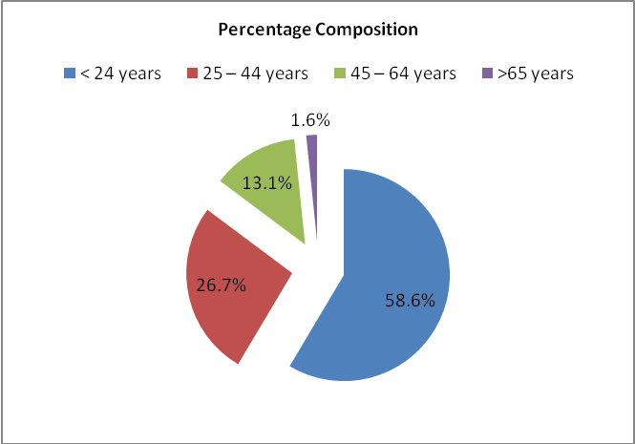

Figure 4.13: Age Structure of the Study Area

The dependency ratio is the ratio of the working population (those between 15 and 64 years) to the dependent (those under 15 years and those 65 years and above) population. The dependency ratio for Akwa Ibom State stood at 95.21% for the 2000 analytical year (NISER, 2000). There has been an improvement, to 53.8% in 2005 (AKBASES, 2005). This is relatively lower than the national dependency ratio of above 55%.

4.9 Education and Literacy
Education
Education is a major socio-economic variable which influences nearly every aspect of human life. Education is generally a thriving industry in the study area, alike other parts of the state, where parents/guardians (and children alike) are constantly in a struggle to ensure that their wards attain, at least, the minimal level of educational requirement. According to the National Bureau of Statistics (2004), primary and secondary schools enrolment figures for the State peaked at 96.31% and 99.07% respectively in 2004. This is an obvious improvement over the NPC (1992) literacy levels of 52.4%, 91.3% and 18.9% for the 6 – 11, 12 – 17 and 18 – 24 years age groups, respectively. Above improved figures have been attributed to the introduction of free and compulsory primary education and proliferation of educational institutions and scholarship foundations floated by the NGOs, socio-political and faith based organisations, political elites, various levels of governance and multinational corporations.

Some of the basic educational statistics of the study areas is presented in Table 4.12 including students and pupils’ enrolment figures.

Table 4.12: Primary and Secondary School Statistics for Study Area
LGAs | PRIMARY SCHOOLS |  |  |  |  |  | SECONDARY SCHOOLS
LGAs | No. of Schools |  | No. of Teachers |  | Pupils Enrolment |  | No. of Schools |  | No. of Teachers |  | Students Enrolment
LGAs | 2008 | 2009 | 2008 | 2009 | 2008 | 2009 | 2008 | 2009 | 2008 | 2009 | 2008 | 2009
Eastern Obolo | 10 | 10 | 56 | 49 | 15,436 | 15,936 | 3 | 3 | 44 | 39 | 1,074 | 1,553
Eket | 29 | 31 | 486 | 464 | 30,496 | 30,952 | 9 | 9 | 327 | 318 | 9,685 | 10,186
Esit Eket | 16 | 21 | 233 | 205 | 12,370 | 13,370 | 3 | 3 | 44 | 62 | 1,257 | 3,179
Ibeno | 12 | 12 | 107 | 102 | 11,803 | 12,303 | 1 | 1 | 35 | 35 | 1,485 | 1,716
Ibiono Ibom | 62 | 59 | 867 | 788 | 32,433 | 33,312 | 11 | 11 | 244 | 252 | 5,944 | 8,704
Ikot Abasi | 35 | 34 | 246 | 310 | 27,341 | 28,849 | 6 | 6 | 67 | 83 | 3,213 | 5,205
Itu | 38 | 38 | 728 | 705 | 25,683 | 26,010 | 8 | 8 | 479 | 517 | 6,474 | 12,700
Mbo | 28 | 28 | 399 | 418 | 18,007 | 19,007 | 3 | 3 | 41 | 43 | 1,669 | 1,862
Mkpat Enin | 49 | 49 | 446 | 457 | 29,950 | 30,950 | 15 | 15 | 190 | 176 | 5,647 | 7,852
Nsit Ubium | 38 | 38 | 443 | 398 | 19,835 | 21,355 | 12 | 12 | 191 | 181 | 4,985 | 7,336
Okobo | 31 | 32 | 366 | 332 | 21,990 | 22,490 | 8 | 8 | 123 | 116 | 4,027 | 8,518
Onna | 26 | 26 | 317 | 287 | 20,380 | 21,380 | 9 | 9 | 141 | 140 | 4,263 | 6,614
Oron | 13 | 13 | 222 | 348 | 12,488 | 13,094 | 4 | 4 | 70 | 81 | 1,393 | 3,005
Oruk Anam | 71 | 71 | 670 | 597 | 36,386 | 37,394 | 14 | 14 | 218 | 229 | 5,652 | 11,430
Ukanafun | 64 | 62 | 756 | 715 | 35,435 | 36,838 | 5 | 5 | 110 | 100 | 3,430 | 5,450
Uruan | 45 | 45 | 425 | 396 | 26,956 | 28,781 | 9 | 9 | 327 | 350 | 6,075 | 11,257
Source: Akwa Ibom State Universal Basic Education Board

Oruk Anam has the highest number of schools (71) while Eastern Obolo (10) has the lowest number. With regard to the number of teachers, Ibiono Ibom (738) has the highest number while Eastern Obolo (49) has the lowest. The table also shows that Oruk Anam (37,394) has the highest number of pupils, while Ibeno (12,303) has the lowest number of pupils.

With regard to secondary schools, Ibeno has only one public secondary school with 35 teachers and a students’ enrolment figure of 1716. Enrolment figures were found to increase between 2008 and 2009, basically due to the new government policy of free and compulsory primary and secondary education. The highest increases were recorded for Itu and Oruk Anam. The increase in students’ population has not however met with a corresponding increase in the teaching strength. Many LGAs even recorded decreases in the number of teachers at both the primary and secondary levels. Mkpat Enin (15) however has the highest number of secondary schools; Uruan (350) has the highest number of teachers, while Itu (12,700) has the highest number of students.

It is however important to observe that high enrolment figures as depicted on Table 5.3 do not automatically translate into, even minimal school attendance. The National Population Commission (2000) released figures indicating the problem of non-attendance, with a higher proportion among girls/and in rural areas than urban areas (31% to 14% for males and 43% to 25% for females). The Statistical Year Book (2001) of the Akwa Ibom State Government recorded only 24.7% school attendance for the state in 2001. More recently, The Nation newspaper reported a statement credited to a former Minister of Education, to the effect that 1n 2005, 19.8million pupils of primary school age were not in school while only 6.4 million of the 33.9 million of secondary school aged Nigerian children were in school. (Louis Odion, The Nation newspaper, Saturday, July 5, 2008). A recent study (Akpabio, 2008) revealed that secondary schools recorded higher dropout rates than primary schools. Major reasons for this trend was found to include: long distance to school, inability to pay fees and lack of facilities - for secondary schools; and lack/absenteeism of teachers and lack of class rooms - for primary schools.

It has also been revealed that apart from the primary schools where the number of females surpassed that of the male, in general the number of educated females’ vis-à-vis the males, decreases with higher educational qualification.

Literacy Level
Literacy level (ability to read and write with understanding in any language) is generally regarded as one of the indicators of level of socio-economic development of any society. Table 1 shows the literacy rate in Akwa Ibom State as 75.77%, which is quite higher than the estimated national rate of 68% (AK-BASES 2005; UNDP 2006), with regard to the specific study area, Table 5.1, above shows that no LGA has a literacy level of less than 67%. The highest literacy level of 83.9% is recorded for Ikot Abasi LGA.

4.10 Quality of Life
This attribute encompasses many indices, all aimed at ascertaining the level of well being of the people inhabiting a particular community/area. These are as detailed below.

4.10.1 Settlement Pattern/Housing Structure and Tenure
Settlement Pattern
The study environment exhibits both the linear (along road arteries and the banks of waterways) and nucleated (clustered) settlement patterns. A relatively higher proportion of the houses in the towns may be multi-tenement with shared facilities, while owner occupied family houses are more prevalent in the more rural settings.

Housing structure
With regard to housing structure the Nigeria Bureau of Statistics (NBS, 2005) has given statistical data (Figure 4.14) showing that 49.44% of dwelling houses in Akwa Ibom state are made of cement/concrete mixture while 32.96% are made up of mud materials.
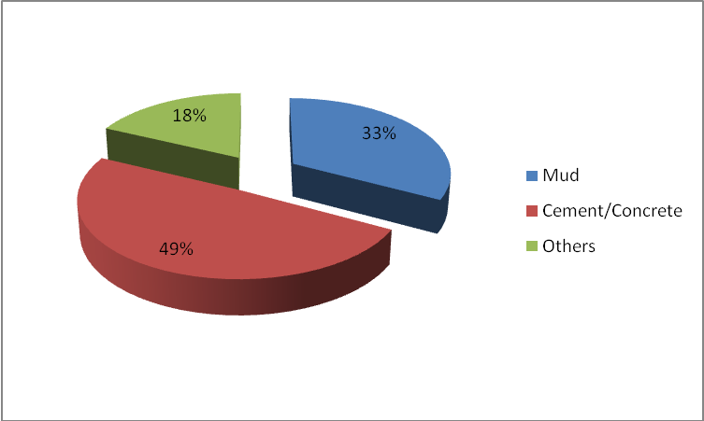

Figure 4.14: Housing Structure - Upland Areas

These figures may also hold true for the urban/upland areas of the LGAs under focus. However with particular reference to the riverine/rural areas of the study area Akpabio (2007) reveals data (Figure 4.15) to the effect that a majority (71.4%) of such dwelling places is made of thatched walls and roofs.

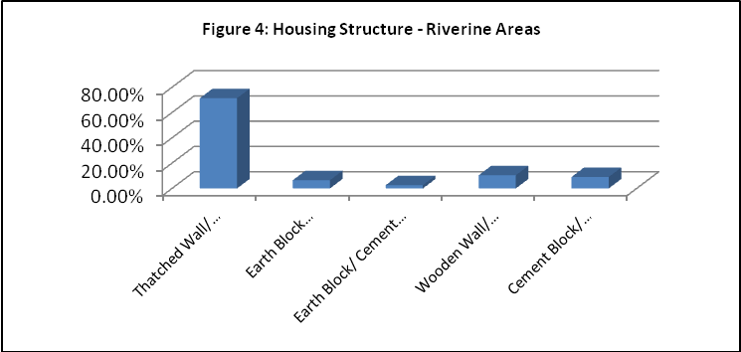

Figure 4.15: Housing Structure – Riverine Area

NBS (2005) also reveals data to the effect that 48.0% flooring materials in urban/upland based households are made of cement materials while Akpabio (2003) reported that for riverine areas earth/mud may constitute 72.5 of household flooring materials.

With regard to tenure of dwelling houses it is revealed in figure 5 that on a general basis, about 35% dwelling houses were of a permanent nature, 25% were made up of semi-permanent structures, while about 40% were of temporary (Figure 4.16), makeshift nature.
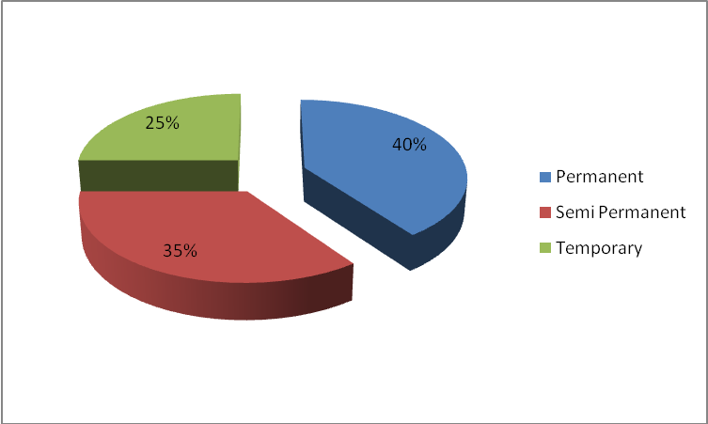

Figure 4.16: Tenure of Dwelling Houses

4.10.2 Monthly Family Expenditure Pattern
Food and education take the lion share in the expenditure on various necessities in the sample population (Table 4.13).
Table 4.13: Monthly Expenditure Pattern Per Family (%)
S/N | LGA | Necessities
S/N | LGA | Food | Water | Health Care | Transportation | Education | Rent | Electricity | Clothing | Mean salary/Income (N)
1 | Eastern Obolo | 28.7 | 5.6 | 12.8 | 8.7 | 20.1 | 8.6 | 4.1 | 11.6 | 15,651
2 | Eket | 31.4 | 2.9 | 11.5 | 8.5 | 21.9 | 8.9 | 3 | 12 | 18,743
3 | Esit Eket | 27.4 | 3.4 | 11.7 | 7 | 24.6 | 12.5 | 3.6 | 9.9 | 22,196
4 | Ibeno | 25.2 | 5 | 8.2 | 12.4 | 18.9 | 10.9 | 4.1 | 15.3 | 13,507
5 | Ibiono Ibom | 28.1 | 3 | 10.7 | 10.2 | 20.4 | 8.4 | 5.3 | 13.9 | 15,303
6 | Ikot Abasi | 31.8 | 3.1 | 10.7 | 10.2 | 18.9 | 7.6 | 3.9 | 13.8 | 16,999
7 | Itu | 25 | 2.7 | 9.1 | 9.4 | 20.1 | 14.1 | 3.8 | 15.6 | 21,506
8 | Mbo | 33.1 | 4.7 | 10.5 | 10.3 | 15.7 | 8.5 | 4.9 | 12.3 | 16,156
9 | Mkpat Enin | 35.2 | 2.1 | 8.6 | 8.7 | 20 | 7.6 | 5.4 | 12.4 | 13,202
10 | Nsit Ubium | 33.1 | 3.1 | 11.1 | 10 | 17.8 | 7.1 | 3.7 | 14.2 | 13,068
11 | Okobo | 33.1 | 3.2 | 10.3 | 7.7 | 20.1 | 7.2 | 5.2 | 13.2 | 12,291
12 | Onna | 27.6 | 4 | 11.2 | 8.6 | 19.1 | 13.2 | 14.1 | 12.1 | 14,198
13 | Oron | 30.6 | 3.3 | 8.5 | 8.7 | 25 | 8.1 | 2.8 | 13.1 | 27,601
14 | Oruk Anam | 29 | 2.8 | 10.5 | 7.2 | 16.8 | 18.5 | 3.5 | 11.8 | 13,182
15 | Ukanafun | 32.7 | 3.1 | 10 | 8.9 | 16.7 | 6.7 | 4.4 | 14.6 | 15,698
16 | Uruan | 26.8 | 4.7 | 10 | 8.3 | 20.6 | 10.3 | 5.1 | 14.2 | 14,716
Akwa Ibom State |  | 29.6 | 3.5 | 10.2 | 8.9 | 21.1 | 10.7 | 3.9 | 12.7 | 15,067
Source: AKBASES (2005)

The two items account for over 50% of the mean monthly household expenditure. One is not surprised that education is taken seriously in the State as this has resulted in the high literacy rate (75%) in the State which is higher than the national rate of 68%. The trend is similar for individual LGAs under survey. Other items of basic expenditure allocation in a decreasing order of priority include clothing (12.72%), health care (10.20%) and rent (10.03%).

4.10.3 Availability and Access to Household Conveniences
With regard to availability and general access to household conveniences AKBASES (2005) reveals that clocks/watches (90% households) and radio sets (87% households) as the most common and generally easily accessible household conveniences.

4.10.4 Energy Sources
Firewood, charcoal and kerosene remain the most popular materials utilized as energy sources in Akwa Ibom households for cooking food. Other sources include gas and electricity which is majorly used in towns like Uyo, Eket and Onna LGAs. The energy sources for lighting include PHCN, kerosene lamps, petrol and diesel generators.

4.10.5 Refuse Disposal System
The most common refuse disposal system in the general study area of Akwa Ibom State is through disposal pits dug within the compound of each house hold, followed by unauthorized refuse dumps. There are however variations within specific LGAs (Table 4.14). For example in Ibeno (64.29%), Mbo (56.35%) and Oron (37.18%) the norm is to dispose refuse in unauthorized places while outright burning of refuse is prevalent in Eastern Obolo (56.82%).

Table 4.14: Common Waste Disposal System in Survey Area
S/N | LGA | Disposal Systems
S/N | LGA | Refuse Bin | Disposal Pit | Unauthorized | Outright
S/N | LGA | (Govt. / Private) | within Compound | Refuse Dump | Burning
1 | Eastern Obolo | 4.5 | 29.6 | 9.1 | 56.8
2 | Eket | 9.2 | 40.7 | 26.6 | 23.5
3 | Esit Eket | 0.7 | 53.2 | 10.8 | 35.3
4 | Ibeno | 0 | 33.3 | 64.3 | 0
5 | Ibiono Ibom | 2.2 | 80 | 14.7 | 3.1
6 | Ikot Abasi | 5.4 | 64.9 | 9.6 | 20.1
7 | Itu | 3.1 | 63.4 | 17.5 | 16
8 | Mbo | 0 | 42.5 | 56.4 | 1.1
9 | Mkpat Enin | 2.6 | 64.9 | 25.1 | 7.4
10 | Nsit Ubium | 1.4 | 75.3 | 14.5 | 8.8
11 | Okobo | 0 | 72.4 | 9 | 18.6
12 | Onna | 2.3 | 49.5 | 39.4 | 9
13 | Oron | 0 | 34.6 | 37.2 | 25.6
14 | Oruk Anam | 1.2 | 71.9 | 19.7 | 7.2
15 | Ukanafun | 1 | 57.4 | 24.5 | 17.1
16 | Uruan | 5.6 | 68.2 | 14.6 | 11.6
Akwa Ibom State |  | 4.3 | 61 | 21.4 | 13.3
Source: AKBASES (2005)

The most common type of toilet facility in about 89.0% households in Akwa Ibom State is the traditional pit latrine (covered or uncovered). It must be noted however that this situation is peculiar to urban communities. Toilet facilities may not be available in riverine rural terrains as residence may defecate into stagnant or running water sources. These are popular in Ibeno (60.47%), Eastern Obolo (44.4%) and Mbo (34.25%). Presented in Table 4.15 are the common toilet facilities used around the study areas.

Table 4.15: Common Types of Toilet Facility in Study Area
S/N | LGA | Toilet Systems
S/N | LGA | Sewage System | Septic Tank | VIP  Latrine | Latrine with  Sanplat | Pit  Latrine (Covered) | Pit  Latrine (Uncovered) | No
 |  |  |  |  |  |  |  | Facility
1 | Eastern Obolo | 2.2 | 4.4 | 29 | 2.2 | 6.7 | 11.1 | 44.4
2 | Eket | 9.2 | 10.5 | 1.8 | 3.1 | 55.5 | 18.4 | 1.5
3 | Esit Eket | 1.4 | 0 | 0 | 0 | 84.2 | 13 | 1.4
4 | Ibeno | 7 | 0 | 0 | 0 | 25.6 | 7 | 60.5
5 | Ibiono Ibom | 1.8 | 4.2 | 1.3 | 2.1 | 79.5 | 10.8 | 0.3
6 | Ikot Abasi | 3.8 | 3.8 | 2.5 | 2.9 | 74.5 | 6.3 | 6.3
7 | Itu | 2.3 | 10.1 | 0.4 | 0.8 | 72 | 9.7 | 4.7
8 | Mbo | 0.6 | 1.1 | 3.9 | 1.1 | 33.2 | 25.9 | 34.3
9 | Mkpat Enin | 0 | 2 | 0.2 | 2.7 | 74.6 | 20.1 | 0.4
10 | Nsit Ubium | 1.4 | 3.9 | 1.1 | 4.2 | 78.8 | 10.6 | 0
11 | Okobo | 0 | 0 | 0.6 | 0.6 | 79.8 | 17.9 | 1.2
12 | Onna | 2.3 | 2.5 | 0.5 | 3.4 | 73.6 | 17.2 | 0.5
13 | Oron | 8.9 | 3.9 | 2.6 | 0 | 66.7 | 10.3 | 7.7
14 | Oruk Anam | 1.2 | 1.7 | 0.5 | 0.5 | 81.7 | 13 | 1.4
15 | Ukanafun | 2.4 | 1.3 | 0.6 | 2.9 | 69.5 | 21.8 | 1.6
16 | Uruan | 3 | 6.4 | 0 | 1.3 | 75.2 | 13.3 | 0.9
Akwa Ibom State |  | 3.2 | 3.5 | 1.3 | 2.2 | 68.9 | 18.4 | 2.5
Source: AKBASES (2005)

Majority of the people in the study area source their drinking water from untreated water sources like river, streams, and ponds. This is shown on Table 4.16.

Table 4.16: Drinking Water Sources In The Study Area
S/N | LGA | Sources of Drinking Water
S/N | LGA | Piped in  Dwelling | Public  Tap | Hand Pump  & Borehole | Dug  Well | Spring/River/  Stream/Pond | Others | Total
1 | Eastern Obolo | 0 | 0 | 20 | 28.9 | 51.1 | 0 | 100
2 | Eket | 10 | 10.8 | 44.6 | 0.5 | 33.8 | 0.3 | 100
3 | Esit Eket | 11.5 | 1.4 | 2.2 | 0.7 | 84.2 | 0 | 100
4 | Ibeno | 0 | 4.7 | 32.5 | 44.2 | 18.6 | 0 | 100
5 | Ibiono Ibom | 0.3 | 0.8 | 22.1 | 1 | 75.1 | 0.7 | 100
6 | Ikot Abasi | 0 | 6.3 | 8.8 | 5.3 | 78.8 | 0.8 | 100
7 | Itu | 2.7 | 6.2 | 20.2 | 0.8 | 70.1 | 0 | 100
8 | Mbo | 0 | 1.7 | 3.9 | 0 | 87.3 | 7.1 | 100
9 | Mkpat Enin | 0 | 2.9 | 10.2 | 8.4 | 78.5 | 0 | 100
10 | Nsit Ubium | 1.1 | 1.8 | 19.4 | 0.4 | 76.8 | 0.5 | 100
11 | Okobo | 0.6 | 0 | 16.2 | 1.2 | 82 | 0 | 100
12 | Onna | 0.5 | 7.8 | 15.6 | 2.8 | 71.6 | 1.7 | 100
13 | Oron | 1.3 | 15.4 | 57.7 | 1.3 | 23.1 | 1.2 | 100
14 | Oruk Anam | 0 | 0.2 | 14.2 | 8.4 | 77.2 | 0 | 100
15 | Ukanafun | 0.4 | 6.4 | 51.8 | 1.6 | 38.7 | 1.1 | 100
16 | Uruan | 2.6 | 14 | 25.1 | 1.7 | 56.2 | 0.4 | 100
Akwa Ibom State |  | 1.6 | 4.4 | 32.5 | 3 | 56.3 | 2.2 | 100
Source: AKBASES (2005)

In essence the people may be prone to water borne diseases like cholera, typhoid fever etc. About 33% households source their drinking water from mainly untreated boreholes. Only 4% households obtain drinking water from public tap system. A related finding reveals that more than 70% respondents access drinking water from a distance of less than 1km.
4.10.6 Poverty and Inequality
Available literature and series of interviews and focus group discussions with members of the community, council of chiefs and local government chairman reveal an increasing incidence of poverty (defined as deprivation in well being - reflected in the inability to attain a minimum standard of living) in Nigeria and Akwa Ibom State. For Nigeria, poverty was revealed as ranging from 27.2% (18 million) to 66% (67 million people) in 1996. For 2004, it was estimated that about 70% (90 million) people lived below the poverty line of 1 Dollar/day (USAID, 2005).

The FOS (2004) revealed that poverty level in Akwa Ibom State decreased from 72.3% in 1996 to 40 % in 2004. This contradicts AK-BASES (2005) report of an estimated 74 % indigenes that were living below the poverty line in 2005.

With regard to food poverty, it was revealed that 63% Akwa Ibom people are unable to meet the cost of the recommended 2100 calories/day. It was also revealed that an average poor household needs an additional monthly expenditure/adult equivalent of N38.48 to escape food poverty. With regard to inequality, defined as distribution of income/expenditure across the entire population, the USAID (2005) declared that from 1980 – 1996, consumption expenditure of the poorest half of the Nigerian population declined by half in real terms. The report also declared that by 2001, the richest (top) 10% of the Nigerian population controlled 31.4% income, compared to 1.3% for the poorest decile.

AK-BASES (2005) also revealed the disparity in household expenditure between the poorest and richest deciles in Akwa Ibom State. Total expenditure per capita for the lowest 10% was revealed as N726 as against N6, 000 for the highest 10%. It was generally observed that the poorest population segment spent more on food than on non-food items, while the reverse held for the highest segment of households. A wide disparity in food poverty level (measured by 2100 calories food intake) was also reported for Akwa Ibom State, where 68 % of the population exists below the minimal food security level. In absolute terms it was revealed that an average poor needs extra N1, 809.62 per month in order to reach the poverty line and thus escape poverty.

Overall headcount poverty in the study area varies between 35.5% (for Oron) and 80.3% (for Oruk Anam) as shown in Table 4.17.

Table 4.17: Income and Food Poverty Indices for the Study Area
S/No. | LGA | Income (%) | Food (%)
1 | Eastern Obolo | 79.07 | 23.26
2 | Eket | 58.61 | 19.44
3 | Esit Eket | 63.42 | 21.97
4 | Ibeno | 78.95 | 44.74
5 | Ibiono Ibom | 76.53 | 35.20
6 | Ikot Abasi | 65.74 | 29.63
7 | Itu | 69.08 | 30.52
8 | Mbo | 77.33 | 34.30
9 | Mkpat Enin | 72.51 | 33.58
10 | Nsit Ubium | 77.01 | 37.59
11 | Okobo | 78.26 | 30.43
12 | Onna | 73.41 | 40.24
13 | Oron | 35.53 | 11.84
14 | Oruk Anam | 80.32 | 43.59
15 | Ukanafun | 78.14 | 35.17
16 | Uruan | 70.04 | 36.56
17 | Akwa Ibom State | 73.73 | 37.02
Source: AKBASES (2005)

In essence, while only 36% of Oron people are found to be poor, more than 80% of Oruk Anam people are regarded as poor. With regard to food poverty indices, the range is between 11.84 (Oron) to 44.74 (Ibeno). In essence, about 45% of Ibeno residents cannot access adequate food for a functional life.

With regard to spatial poverty, statistics indicate that 76% of the poor in Akwa Ibom State live in rural areas and contribute 91% to overall poverty level in the state, compared to the 24% /9% respective population/poverty contributions of the urban areas. It was also revealed that an average rural/urban dweller needs approximately N1891.80/N1, 190, respectively, to escape poverty. Also, in tandem with national based records, poverty level is higher for the dependent population (80%), widows (70%), non-formally educated (85%), the female poor (76%) and for those involved in extractive occupations like fishing and agriculture etc. Table 4.18 shows at a glance, various highlights of the poverty/inequality indices in Akwa Ibom State.

Table 4.18: Poverty/Inequality Highlights (Akwa Ibom State)
1 | Income poverty level | 74%
2 | Food poverty level | 63%
3 | Inequalities Indicators | Richest decile | Lowest decile
a | Income | 31.4% | 1.3%
b | Expenditure/capita | N6,000 | N726.00
c | Expenditure on non-food | N2,500 | N313.00
d | Expenditure on food | N3,677 | N250.00
4 | Requirements to escape Income poverty
a | Statewide | N1,809.62
b | Urban areas | N1,190.00
c | Rural areas | N1,891.80
5 | Requirements to escape food poverty | N3,848/month
6 | Most poverty stressed sub-groups (
a | Dependent population (less than 15 years/above 64 years)
b | Widows
c | Female group
d | Those not exposed to formal education
e | Those involved in extractive occupations (fishing crop farming, forestry etc)
7 | Others
a | Crude birth rate | 47.5/1000 people
b | Crude death rate | 14.7/1000 people
c | Average annual growth rate | 3.2%
d | Average life expectancy | 46.8 years
e | Child mortality rate | 178/1000
f | Infant mortality rate | 105/1000 live births
g | Maternal death rate | 704 – 100,000 live births
Sources: (AKBASES 2005; FOS 2004; USAID 2005; UNDP 2006; NBS, 2006)

4.10.7 Human Development Indices
The UNDP (2006) reported that the human development situation in Nigeria, as a whole is deplorable, in comparison to other petroleum producing/exporting countries (Table 4.19).

Table 4.19: Human Development Indices for Study Area (States)
State / Nation | HDI | GDI | HPI | GDP*
Akwa Ibom | 0.576(H) | 0.391(M) | 30.659(L) | 0.540(M)
Cross River | 0.584(H) | 0.481(M) | 29.300(L) | 0.565(M)
Rivers | 0.591(H) | 0.454(M) | 26.53(M) | 0.620(H)
Bayelsa | 0.499(H) | 0.443(M) | 33.82(L) | 0.520(M)
Niger Delta | 0.564(H)
Nigeria | 0.453(H)
Saudi Arabia | 0.800(H)
Indonesia | 0.658(H)
Key: H-high (0.463 – 0.579); M-medium (0.462 – 0.347); L-low (0.346 – 0.229);
Source: Environmental Resources Managers Limited (ERML, 2005)

The human development index, which is a measure of well being- encompassing longevity of life, knowledge and decent standard of living, remains low (0.453) for Nigeria. Reasons for the poor human development situation have been attributed to poverty, poor governance, poor quality education, unsustainable livelihood and unemployment, oil company activities and environmental degradation, conflict and lack of security and exclusion of particular social groups etc (USAID, 2005, UNDP, 2006).

In comparison with surrounding Niger Delta States, Akwa Ibom State has a high HDI (0.576), its GDP (0.540) is in the median range. Rivers State scores highest in all the indices under consideration. The UNDP (2006) however cautions that while the HDI may seem high for surveyed states, it does not capture data on physical infrastructure like road, water source, availability of electricity supplies etc.

In an attempt to compare human development indices of the study area, Table 4.20 shows that the HDI for the surveyed LGAs range between a low 0.261 (for Eastern Obolo) and a high of 0.505 (for Ikot Abasi).

Table 4.20: HDI for Surveyed LGAs
S/No. | LGA | HDI | Rate
1 | Eastern Obolo | 0.261 | Low
2 | Eket | 0.440 | Medium
3 | Esit Eket | 0.346 | Low
4 | Ibeno | 0.355 | Medium
5 | Ibiono Ibom | 0.372 | Medium
6 | Ikot Abasi | 0.505 | High
7 | Itu | 0.391 | Medium
8 | Mbo | 0.320 | Low
9 | Mkpat Enin | 0.276 | Low
10 | Nsit Ubium | 0.354 | Low
11 | Okobo | 0.354 | Medium
12 | Onna | 0.254 | Low
13 | Oron | 0.369 | Medium
14 | Oruk Anam | 0.257 | Low
15 | Ukanafun | 0.337 | Low
16 | Uruan | 0.313 | Low

On general note, nine of the LGAs have low HDI scores; six have median HDI scores, while only one LGA is rated to have a high HDI.

4.11 Economic Survey
4.11.1 Natural Endowment
The UNDP (2006) reported that the informal sector accounts for as much as 85% employment in the Niger Delta but yields only about 25% income (Cour, 2000). The USAID (2005) reported that Nigeria’s agricultural sector (including farming, fisheries and forestry activities etc) contributes about 40% to the national GDP and over half employment. According to the same source the manufacturing sector does not create jobs, while the oil industry contributes only 13% GDP, generates only 1% employment and directly benefits not more than 5% Nigerians. All the above depicted indices also affect the study area. There is a very high level of dependence on land and natural water resources for livelihood sustenance. The natural water bodies are inhabited by fishes, crayfishes, oysters and periwinkles. The rich mangrove is a reservoir of logs and fuel woods, stakes for fish traps, fishing platform and scaffold pole; and piling and construction materials, including wood for furniture and thatch materials for roofing. The mangrove serves as habitat for crabs and molluscs and as nesting sites for sea and shore birds. This is apart from its reservoir of vegetables, dyes fruits and nuts, medicinal plants, bark, roots and spices; snails and wild game.

All the above enumerated natural endowment gives rise to a multiplicity of income sources which people cobble together to survive.

4.11.2 Production Factors
Agricultural Production
The people of Akwa Ibom State are very industrious, enterprising and resourceful and hence they identify themselves with many aspects of economic endeavour. They are predominantly farmers and fishermen although other traditional occupations include trading, hunting, wood carving, arts and craft, raffia works, etc.

Agricultural production is a very important activity in the study area as the state falls within the tropical zone with a dominant vegetation of green foliage of trees, shrubs and oil palm tree belt, which holds the highest density of the cash crop in the world (AKSG, 2001). Cassava is the main food crop planted although it is fast becoming a commercial endeavour. Other commonly grown crops include: yam, cocoyam, plaintain/banana, vegetable crops (especially fluted pumpkin) and some perennial tree crops like oil palm, bush mango (uyo) star-apple (udara) pear (eben), raffia palm tree, etc.

Land in the study area is the joint property of the extended family system, leading to fragmentation and small sizes of non-contiguous farm holdings. Land acquisition in Akwa Ibom State, is by either of four means: outright purchase; leasing (oto-owo); inheritance (Ikot ufok/ekpuk); and pledging (Ubiong ikot) in lieu of loan acquisition, and which is returned to original owners after loan payment to creditors. Some conditions may be attached to land acquisition (especially leased or pledged land). For example, length of time of acquisition may be for a single or more planting seasons on leased land; and in cases where oil palm trees are planted on pledged or leased land, the temporary owner may be forbidden from harvesting produce thereof. In terms of family land, family members may be barred from outright sale of their portion to non-family members.

Soil in the study area is replenished through rudimentary bush fallows which may last between 5 and 7 years. Population pressure may however lead to reduction of fallow period. Average family farm size may range between 0.2 – 2 hectares.

In the study area, farm labour is manual and requires physical energy exertion with the matchet and hoe as the main capital items; and while bulk of labour on compound farms is supplied by the family, the case is different on communal or cooperative land. On these farmlands labour is mainly hired, at exorbitant rates, as children are mainly in school during peak farming seasons, while older children may have migrated to towns in search of greener pastures. Work on the farm therefore devolves mainly on the husbands and wife/wives who may be too old for any effective energy output. Labour, in this area is generally regarded as a very restrictive factor of production, based on its high cost. Of all forms of labour, weeding cost is most restrictive and attracts highest cost of labour, because it may be performed a number of times before crop maturity.

On farm tasks performed by different gender and generation, it is a known fact that the female gender is more involved in most aspects of farm work than the male gender. The children perform assigned tasks especially in planting and weeding, but their active participation may be constrained by school activities. Most household chores are also performed by the female gender (mothers and female children) and sometimes assisted by the male children. Generally, in the study area, the bulk of farm tasks devolve on the female gender, the male’s major activity is in the ownership of farm lands utilised by the female for farming activities. Use of child labour for farming activities is common in the study area. Child labour is generally not aimed at economic motive nor gain. In essence, the “child-on-the –farm” syndrome does not connote child abuse, but is rather regarded as a skill transfer mechanism where the adults encourage their children/wards to accompany them to the farm, in order to acquire farming skills for future sustenance. This is more important in areas where there are no other avenues for vocational training/skill acquisition. The fact that farming is no more regarded as a lucrative economic venture has led to the increasing trend of child-labour trafficking, mainly to urban areas. This trend however portends deleterious consequences.

Fish Production
The continental shelf is widest in Akwa Ibom State, which possesses about 129 kilometres of coastline and is reputed to have the highest concentration of fisheries in Nigeria. The total land area of the state encompasses the entire Qua Iboe River basin, the western part of the lower Cross River basin and the eastern part of the Imo River basin. These three major rivers and their tributaries water the study area. Essentially, the coastal fisheries cover the area between Longitude 7⁰ 35¹E to Longitude 8⁰ 25¹E and Latitude 4⁰ 32¹ to Latitude 3⁰ 55¹N.

Typical commercial fish species harvested in this area include: croakers, bonga, barracuda, soles, shinynose, sharks, snappers, catfish, grunter, prawn, shrimps, crabs and oysters etc. Akwa Ibom coastal waters have been described as the largest shrimp, bonga and prawn area in West Africa. The commercial fishes are not evenly distributed throughout the area. The specific rich areas for individual species are confidential to various fishermen and trawler captains, and these secrets are often times jealously guarded.

The Cross River fisheries particularly the section between Itu and Oron are reputed as richest of the three major rivers in the state. The water in these rivers is fresh (except in the estuaries) and so fresh water fishes abound. The common commercial species include Catfish, Heterobranchus, Tilapia, African Pike, Moonfish, African Carp and Niger Perch etc. Catfish harvest peaks during the months of May to July. Oysters and periwinkles also abound in these rivers. One particular phenomenon occurs in these fisheries – the outbreak of Ghost-Shrimps (Callichurus turneranus) during the months of August and September of alternate years. During such outbreaks, catch rates of fish (particularly catfish) are quadrupled.

Fishing activities also occurs in the lakes, swamps and brackish waters which occur at the banks of the main rivers and those of big streams. These kinds of fisheries occur in all the local government areas of the state. Catfish (particularly Mud Catfish) tilapia, mullet, feather back and electric fish are regularly harvested from these fisheries with the aid of hooks, long-lines, traps, poisons, nets and drain. The coast of Akwa Ibom State is characterised by extensive stretches of swamps and shallow waters, which are not utilised for any profitable form of agriculture. Bonga fish, catfish and mullet are regularly harvested from these areas.

Private fish ponds exist all over the State. The pond sizes, stock and yields do vary, but generally cultivated species include carp, tilapia, catfish, heterobranchus clarias (mud catfish) and Niger perch. The pond generally consists of nursery, transition and production ponds. Only very few have hatcheries.

Constraints affecting fishery development in Akwa Ibom State include: mangrove ecosystem destruction by oil production, mangrove colonisation by nipa palm (Nypa fruticans) and lack of motorized equipment for deep sea fishing (capture fisheries). Others are, lack of finance, shortage of frys, fingerlings and feed supplements, etc.

4.11.3 Employment/ Labour Force Participation /Unemployment
AK-BASES (2005) reported that over one third (36.3%) of the employed people in Akwa Ibom State are involved in extractive occupations (fishing/farming/logging/sand excavation/collection of timber/non timber forest products etc) while 20.3% of employed are traders. Both the Nigerian Bureau of Statistics (NBS, 2005) and the Akwa Ibom Baseline Socio-Economic Survey (AK-BASES, 2005) have depicted the 25 – 54 years age category as making up more than 81% of the working population in the study area.

The average monthly income for Akwa Ibom State has been revealed as N11, 349.00 (AK-BASES, 2005). This is above the national minimum wage of N7, 500.00. It was also revealed that all self employed workers earn less than those employed in the public and private sector. Table 12 shows that operatives in fishery activities earn relatively higher income (63.9% earn more than N7, 500/month) in comparison with crop farming practitioners (only 34.5% earn more than N7, 500/month). This finding corroborates with previous reports (Akpabio, 2000, 2004 and 2006).

Table 4.21: Mean Monthly Salary Distribution
Trade | Income Distribution (%)
 | < 7,500 | 7,500 | > 7,500
Agriculture (n=8819) | 64.8 | 0.7 | 34.5
Forestry (n=94) | 34.0 | 1.1 | 64.9
Fishing (n=548) | 35.9 | 0.2 | 63.9
Source: AK-BASES (2005)

Labour Force Participation
The labour force of a study area is comprised of the sum total of employed, underemployed and unemployed persons. The labour force participation (LFP) is the labour force expressed as a percentage of working age population (15-64 years) while the labour force participation rate (LFPR) shows the percentage of the labour force in a given working age. The overall LFPR comprising of 63.5% males and 57.3% females is presented in Figure 4.17. It is obvious that male participation rate exceeds that of the females. AKBASES (2005) reported a high (59.49%) economically inactive rate for Akwa Ibom State, meaning that unemployment rate is high in the state. Figure 8 also shows that LFPR rises with age, peaks at age groups 45 - 54 years and starts to decline thereafter.

Source: AKBASES (2005)
Figure 4.17: Labour Force Participation Rate

Unemployment Rate
Unemployment (non-utilization of human resources, especially among the 15 – 64 years age group) in the study area is in tandem with international human capital profile. The unemployment situation among persons aged 15 – 24 years is presented in Figure 4.18.

Source: AKBASES (2005)
Figure 4.18: Unemployment Rate

Unemployment is also relatively high (26.86%) in the 25 - 34 years age group. It is important to note that the most economically active productive age group (15 – 34 years) has the highest unemployment burden of about 80%. This is indicative of the wastes in man power through unemployment that is facing the state. Also note that the unemployment rate of the males exceeds the corresponding rate for the female counterparts at every age group except the 45 - 54 years group. Related data reveals that unemployment rate is highest among the unmarried females and young school leavers/ graduates (87.94%).In the same vein, The Sunday Punch newspaper of July 20, 2008 reported a statement credited to the Minister of youth affairs, to the effect that 80% of the estimated 80 million Nigerian youths are unemployed, while 1.6 million of the estimated 16 million employed Nigerian youths are underemployed.

4.12 Market Survey
Market surveys (see Appendix 4.6b) were conducted in each LGA of the survey area. Results were presented in terms of 5 axes as follows: Eket axis (Eket, Esit Eket, Ibeno and Onna LGAs), Oron axis (Mbo, Okobo, and Oron LGAs), Ikot Abasi axis (Eastern Obolo, Ikot Abasi and Mkpat Enen LGAs), Ukanafun axis (Ukanafun and Oruk Anam) and Itu axis (Itu, Ibiono, Nsit Ubium and Uruan LGAs). A list of the major markets in each LGA is as presented below:

- Offiong Etuk and Urua Udo Inyang (Eket LGA) (daily markets are Ikot Odiong and Urua Nka)
- Uquo and Etebi (Esit Eket)
- Iwuoachang market (Ibeno)
- Urua Ekpo, Edere Obo, Urua Abat and Ikot Edo / Mkpaeto (Onna)
- Ibaka market (Mbo)
- Oron main market, Udua Aba, Beach market and Idua (Oron LGA)
- Atabong beach market, Odobo, Okopedi and Ekeya markets (Okobo)
- Okoroete and Iko markets (Eastern Obolo)
- Ete and Ikot Abasi urban markets (Ikot Abasi)
- Ukam, Okpoudo and Obo markets (Mkpat Enin)
- Urua Anwan Ekparakwa and Offiong Eshiett (Oruk Anam)
- Akpan Eshiet, Awan Uyio and Adatifang markets (Ukanafun)
- Itam and Ekim markets (Itu)
- Ikot Ambang market (Ibiono)
- Ikot Eyo, Timber market, Ndukpoise (Nsit Ubium)
- Ekpene Ukim market (Uruan)
Price Trend
Price trends of tradable goods in the surveyed markets indicate the relatively higher cost of items (especially food) in the Eket axis, in comparison to other axes of the survey. Reasons attributed for this trend include, among others: small sizes of available market space (resulting in intense competition for stalls), lack of market infrastructure (resulting in the renting of private properties at exorbitant rates (supermarkets) or sub-letting of stalls / stores by third parties. Other reasons include poor yield of food crops, arising from poor soils allegedly occasioned by oil exploration activities and concomitant lack of interest in agricultural production; and food stuffs importation from other areas (within and outside the State) and the high transportation and handling costs accruing thereof. Marketers attempt to reduce these high overheads by transferring the costs to the consumers. There is also the erroneous impression that inhabitants of the survey axis are all oil companies workers / or contractors – hence “they are swimming in money”. It is however important to note that prices of food items are cheaper at the weekly markets.

The high variation in prices of some food items across the different axes of the study area may be linked to non-utilisation of a standardised scale of measurement and size and grouping variations. This is especially for yam (sold in single tubers / groups (Iso-udia) and fish (single items, stake or baskets). For an item like crayfish, price variations reflect the different unique characteristics of the types available in the market and which go by different names (Atabong, Upenekang, Utan etc) reflecting areas of harvest concentration and culinary characteristics.

Prices of basic building materials (zinc, cement, asbestos, nails etc) at Eket main town is generally cheaper than obtained in other axes of the survey, and are actually comparable (if not better) than the prices of such items in Uyo – the State capital. This is attributed to the influx of distributors and traders to Eket, based on the premise that disposable income is high among residents and the concomitant relatively “lower than expected” demand.

4.13 Infrastructural Base
It has been reported by the UNDP (2006) that infrastructural and social services in the Niger Delta are generally deplorable and grossly inadequate for an estimated regional population of about 30 million people. The case is not different for many parts of the study area. The Akwa Ibom State Government, local government authorities and some industrial and multinational companies and International bilateral/multilateral agencies have been contributing their own quota to the development of the social infrastructure in the study area. The state government, over the last two years has embarked on a lot of developmental projects bothering on roads/bridges/culverts rehabilitation and/or construction; provision and rehabilitation of educational and health facilities; and provision of electricity and potable water sources (see Appendix 4.6c). MPNU (2007) also revealed that between 2006 and 2007, an estimated 3.8 Billion Naira was expended on various assistance programmes/projects in the country. Approximately 87% of the stated amount was targeted at the people and communities of Akwa Ibom and Rivers states. A lot still has to be done however in order to revamp the socio-economic/infrastructure base of the study area. Details of the infrastructural base of the survey area are as documented below.

4.13.1 Market Facilities
It is important to note that smaller evening markets exist in almost all communities of the study area. It is also important to note the poor state of infrastructure in the major markets, where the few lock-up stores (wherever they exist) are in dilapidated conditions. Electricity and potable water sources are either absent or non-functional, while intra-market passages are soggy, marshy and sandy terrains that are hard to traverse during the rains (Figure 4.19).
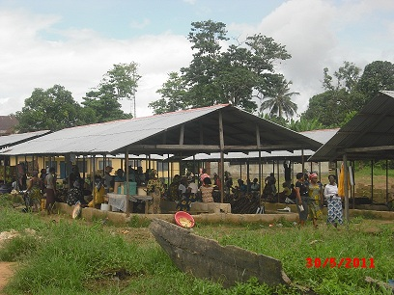
Figure 4.19: Beach Market at Eyo Abasi, Oron

4.13.2 Access Road/ Public Transportation
For the predominantly riverine and marshy sections of the study area watercrafts are utilized as the major means of transportation. Various types of hand and engine propelled boats are utilized either for human or cargo transportation or for fishing activities. Paddle boats may be utilized for short distances in creeks or across minor water arteries. These are however being gradually phased out as a means of public transportation although they are well utilized for private family transportation and fishing expeditions. The common engine boats in the study area include the 9 horse power (HP) engine boat, which is a relatively smaller type of passenger boat and which may also be utilized for minor fishing expeditions. Relatively larger engine boats include, the 40hp, w19 boat, the W23 double 75hp boat; and the “lighter” boat which may be used to traverse distances as far as to Bakassi Peninsular and the Camerouns. There are also the large Ghana type boats which are used for commercial fishing purposes, and may remain off shore for a period of one or two weeks before returning to shore.

It is important to note essentially that land access also exists to these riverine settlements. Inter LGA roads linking Uyo- the state capital- with the headquarters of the LGAs under survey are in fairly good condition. Intra LGA and intra-communal routes in the study area are generally poorly conditioned. Majority of these roads are earthen (very low proportion is gravelly) and which are impassable during the rainy season (Figure 4.20).
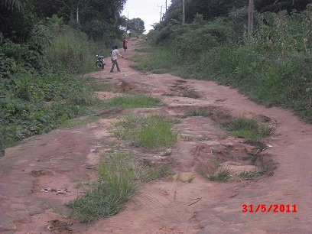
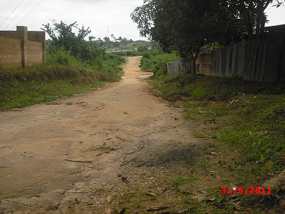

Figure 4.20: Access road to Anakpa and Itu Highway at Ntak Inyang

About 15 communities located along the Ibeno coastline – a long narrow stretch of land, may be accessed by even heavy duty vehicles during low tide. Cognizance must however be taken of the cyclical tide action, to avoid been hemmed-in for long periods of up to 6 hours and above. It is important to note that almost all parts of the study area situated closest to the QIT operational base of the MPNU (Mkpanak, Upenekang, Inua eyet Ikot, Iwuochang etc) are tarred, courtesy of the oil company and are in fairly good condition. In 2007, it was reported (MPNU, 2007) that 95 kms of such roads, extending to adjoining LGAs were rehabilitated, while 35kms of drains were constructed to ease run-off.

Dilapidated trucks and ramshackle passenger/goods vehicles traverse the area. Motorcycle machines, especially, large engine CG 115, 150 and 175 double silencer types predominate. Popular brands include Nanfang, Frajend, Suzuki and Q-link; which are all reported to be strong and hardy enough to traverse the rough, erosion ravaged and poorly maintained road networks. These heavy machines are also conveniently utilized along the marshy Ibeno coastline, during low tide. Bicycles may serve for intra settlements /communities movement. Human porterage on heads/shoulders is also a common activity, especially by the female gender.

4.13.3 Electricity Supply
The major towns in each LGA of the survey area (Table 4.22) are linked to the national grid.

Table 4.22: Electricity Supply to Communities by PHCN
S/No | LGA | No. of Communities
1 | Eket | 68
2 | Esit Eket | 15
3 | Ibeno | 3
4 | Onna | 41
5 | Eastern Obolo | 4
6 | Ikot Abasi | All the clans are linked to the National Grid. However, exact no of communities was NA
7 | Mkpat Enin | 32
8 | Ukana fun | 5*
9 | Oruk-Anam | 4*
10 | Okobo | 16
11 | Oron | NA
12 | Mbo | 3
13 | Ibiono | 27
14 | Itu | 24
15 | Nsit Ubium | 56
16 | Uruan | 32
Source: PHC Offices at the Local Government Level; NA = Not Available During Survey Period

The people are however exposed to the erratic and epileptic characteristics of electricity supplied from the national grid. Communities situated in difficult terrain may not have access to power supply from the national grid. Electricity supply is therefore lacking in the Island settlements and remote villages. Electricity generating plants are utilized by very few relatively well off individuals and by bars and eateries. Bush lamps and candles (rarely) provide illumination in the night. Mkpanak community and its immediate environs are reported to have direct access to Mobil’s electricity supply source. Recent complaints about the near epileptic nature of supply have been attributed to a local contractor, who supplied a refurbished transformer (instead of a brand new one) for power transmission. Community stakeholders are reported to be looking into the issue. Attempts by the state government to improve on the power supply status of the surveyed LGAs has led to the provision of electricity supply to about 88 communities in the past two years (Appendix 4.6c)

4.13.4 Educational Facilities
Primary schools are easily accessed within a 1 – 5 km radius in the incident zone. Secondary schools may not be so easily accessed. The introduction of free and compulsory education in the study area, which has led to an influx of pupils and students, has facilitated the provision and/or upgrading of educational facilities. In 2008, 17 classroom blocks in 13 schools were rehabilitated, while in 2009, 345 classroom blocks were either provided or rehabilitated. These are apart from other investments in assembly halls, staff quarters, students’ hostels, computer and science laboratories and perimeter fences in many schools (Figure 4.21).
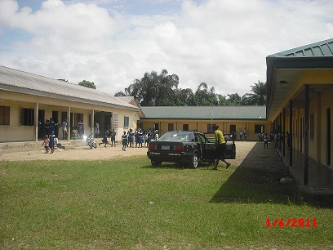
Figure 4.21: Primary School at Upenekang

4.13.5 Postal/Telecommunication Facilities
The major GSM telecommunication providers (MTN, Zain, Glo and Visafone) are generally making in-roads into the area. The capital cities and other m major towns in the survey area are fully covered by one or the other of these networks. It is therefore quite easy to communicate socially and also carry out business transaction within any part of the State. The settlements may not be as effectively covered by the GSM It is however important to note the near absence of postal services – even in the major communities of the survey area.

4.13.6 Recreational Facilities
In the survey area, relaxation activities take the form of visits to acquaintances, drinking in groups (men/youth) and various group discussions. There are also formal recreational facilities, mainly in the major towns of the survey area. A sprinkling of eateries which also serve as drinking parlours and viewing centres may exist in the remote settlements. These structures may also host women of easy virtue who are not native indigenes of the area. Cultural displays (masquerades/dances) may occasionally liven up the drab and dull atmosphere of these areas. Ibeno beach provides an emerging recreational area which is gradually being modernized and which attracts visitors from all over Akwa Ibom State. The beach borders the Ibeno coastline, which is adjudged as one of the longest and most beautiful coastlines in Nigeria and Africa and which can be traversed during low tide. The Tom Shott Island is a scenic area of immense untapped potentials which could be converted into a recreational facility.

4.14 Health Survey
4.14.1 Water Supply/ Sanitation/ Waste Management/ Health Facilities
There are 162 health facilities in the survey area. The population and community locations of health facilities are presented in Appendix 4.7a while Table 4.23 shows the distribution of categories of health facilities in the survey area.

Table 4.23: Health Institutions in the Study Area
S/N | LGA | Health Centre | Health Post | Cottage Hospital | Comp Health Centre | General Hospital | Others | Total
1 | Eastern Obolo | 4 | - | - | - |  | - | 4
2 | Eket | 6 | 4 | - | 1 | 1 | Psychiatric Hospital(1), Dental Centre (1) | 14
3 | Esit Eket | 4 | - | 1 | - | - | - | 5
4 | Ibeno | 5 | 1 | - | - | - | - | 6
5 | Ibiono Ibom | 15 | - | - | - | 1 | - | 16
6 | Ikot Abasi | 8 | - | - | 1 | 1 | - | 10
7 | Itu | 8 | - | - | - | 1 | VVF Hospital | 10
8 | Mbo | 8 | 3 | - | - | - | - | 11
9 | Mkpat Enin | 8 | - | 3 | 1 | - | - | 12
10 | Nsit Ubium | 9 | - | 2 | 1 | - | - | 12
11 | Okobo | 5 | - | - | - | 1 | - | 6
12 | Onna | 10 | - | 1 | 1 |  | - | 12
13 | Oron | 4 | 2 | - | - | 1 | - | 7
14 | Oruk Anam | 11 | 5 | 1 | - | 1 | - | 18
15 | Ukanafun | 5 | 2 | - | 1 | - | Leprosy Clinic | 9
16 | Uruan | 8 | - | - | 1 | 1 | - | 10
 |  | 118 | 17 | 8 | 7 | 8 | 4 | 162
Source: Akwa Ibom State Ministry of Health, Uyo (2009)
The table reveals that Oruk Anam (16) and Ibiono Ibom (15) have the largest number of primary health care facilities (health centres / health posts) in the survey area. Mkpat Enin, with three cottage hospitals and one comprehensive health centre; and Eket, with a general hospital, psychiatric hospital, Dental centre and comprehensive health centre; have the largest concentration of secondary health facilities in the survey area. The state government, between 2008 and 2009 has rehabilitated and installed improved facilities in about 16 health facilities in the survey area. MPNU has been involved in a lot of activities targeted at improved health care delivery in the study area. These include 25% salary subvention to health workers in Ibeno LGA. In 2007, MPNU donated a sum of N500, 000 to the Polyclinic at Upenekang to enable it extend the National Programme on Immunisation (NPI) to remote riverine communities of Ibeno LGA. The company also sponsored an educational awareness campaign on the reduction of tuberculosis burden in Ibeno and surrounding LGAs. Some NGOs have also been providing retraining opportunities to Traditional Birth Attendants in the survey area.

4.14.2 Disease Prevalence
Interactions reveal common diseases in the study area to include malaria, typhoid, cholera, pneumonia, tetanus and whooping cough etc. Various eye ailments have also been reported, arising from the exposure of unprotected eyes to fish processing (especially smoking) activities. Sources of treatment of the various ailments could be traditional, with the aid or herbs, modern – predicated on visits to health centres and hospitals; or spiritual – resort to churches/prayer houses. Essentially, visits to health centres and hospitals for treatment is always the last resort of majority of persons who claim to be discouraged by the cost of treatment and long queues in general hospitals, and by the official documentary procedures and processes that have to be observed in health centres, in order to access medicare. Patent medicine store/itinerant drug vendors are therefore very popular medicare avenues and thus enjoy a lot of patronage, even though the quality of dispensed drugs cannot be ascertained.

Records of disease trend and patients’ attendance at public health facilities in the survey area are presented in Appendix 4.7b. Diseases like dysentary, HIV/AIDS, severe malaria and measles were more prevalent in the health facilities in the surveyed area in 2008, than in 2007. On the other hand, diarrhoea, Hepatitis B and common malaria were less prevalent in 2008 in comparison to reported cases for 2007.

The scenario for 2008 involved common malaria (20,557 cases), severe malaria (4048 cases) and malaria in pregnancy (3781 cases) as the most serious ailments. It may be noted that HIV/AIDS become more prominent in 2008, with 2565 reported cases (as against the number of 1761 cases that were reported in 2007). In essence, HIV/AIDS displaced Diarrhoea (2279 cases) as an endemic disease, to the 4th position of prevalence.

On a disaggregated basis, Mkpat Enin, Oron, Eket and Uruan recorded the highest cases of reported common malaria attacks in 2007, while Okobo, Oron and Eket recorded highest reported cases for 2008. With regard to malaria in pregnancy, Oron women reported the highest cases in 2007 (1413) and in 2008 (917). It is necessary to note the worsening number of reported HIV/AIDS cases in the study area with Oron recording the highest number of cases.

4.14.3 Water Supply in the Study Area
Interactive sessions revealed that potable water supply is lacking in the riverine settlements. Major sources of water supply for consumption and domestic uses are from rain water run-off – collected from thatched/woody/rusty iron sheet roofs. These are invariably unhygienic and particles/germs infested. In the dry season, domestic water supply is from shallow hand-dug wells, the liquid contents of which are separated from the earth surface by rusty iron –wrought containers. Water may also be collected from shallow unhygienic streams which become water logged during the rains and from private and public bore holes. With regard to towns and villages, only a small segment of the population of Eket and Ikot Abasi may lay claims to government supplied, but epileptic potable water sources (Figure 4.22).
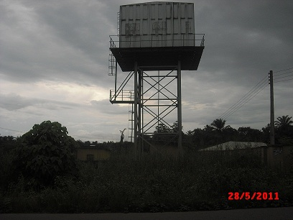
Figure 4.22: Water Project at Okwot, Nsit Ubium LGA

A majority of the residents may however access privately provided boreholes which supply untreated water sources. Relatively well-off individuals from the Island settlements who can withstand high cost of transportation may access such water sources at a rate of about N50.00/20 litre jerry can. In an attempt to improve on the potable water supply situation in the study area, the state government has commissioned 46 water projects in the last 12months in the study area, while MPNU has continued to provide maintenance facilities to about 15 water projects within Ibeno and adjoining LGAs of Esit Eket, Eket and Onna, including those at Okoroutip, Upenekang and Iwuoachang. This is in addition to the revamping of the Mkpanak water distribution system in 2007.

Interactions revealed that solid waste disposal is into running/stagnant water, while human waste is disposed into water channels, resulting in the inevitable breeding and spread of disease pathogens. Inability to build toilet facilities in the study area has been attributed to the high water table.

4.15 Community Concerns and Perception
Community members who were questioned during this study had a positive disposition to the proposed project. A few however, expressed the fear that the project may harm the soil, fishing in the sea and human beings alike. However, the communities were generally not opposed to the project but with the expectations. These expectations, basically development needs, were two fold. The first were infrastructural needs and second, human capital development. Listed below are the concerns and expectations of each LGA.

Mkpat Enin LGA
Odoro Ikot Group of Communities
The Odoro Ikot Communities in Mkpat Enin LGA belong to a political unit recognized as Ward 3, often referred to as Nung Esetang in Ikpa Ibom clan Odoro Ikot is a collective name for the group of 6 Ibibio speaking villages located across the forest area in Mkpat Enin and Ikot Abasi LGA and adjourning the Imo river/Atlantic Ocean. The people are traditionally fishers and farmers.

Concerns/Demands
Water system polluted by spilled oil and lack of response from the oil companies. Coastline erosion from the shore line and flooding of upland areas threaten their social and economic lives. The communities expect the project to bring:
    - Health centre at Ikot Ekpang and reactivation/provision of facilities and personnel’s at the abandoned health centre at Ikot Inyang Okop.
    - Construction of access road to enhance their accessibility and mobility.
    - Construction of two model secondary schools to improve the educational fortunes of the youths.
    - Provision of electricity
    - Provision of potable water supply to all the communities
    - Provision of micro loans to enhance their reintegration into the economic system.
    - Payment of compensation for losses incurred due to incessant oil spills.
    - Recognition of the area by government as a clan on its own.

Eastern Obolo LGA
Iko Community
Iko is a village in Iko clan in Eastern Obolo LGA bound by Ikot Abasi, Mkpat Enin and the Atlantic Ocean. The main occupation of the people is fishing. It has 18 families and village headship is rotational.

Concerns/Demands
    - Employment of youths in ExxonMobil and the State civil service. .
    - Loan facilities to aid their fishing activities.
    - Improved electricity supply.

Environmental Problems:
    - Poor land productivity due to land degradation
    - Water pollution is a threat to fishing activities.

Elekpon Community
Elekpon is a fishing settlement in Eastern Obolo LGA. It is only accessible through the creeks. It lacks all basic infrastructure and social amenities. Only one block house (the rest are thatched). Both the people and the land are directly affected by any activity that impacts on the ocean.

Concerns
Neglect by the government and the oil companies operating in the Eastern Obolo waters.

Onna LGA
Ikwe Village
Main occupation of the people are farming and trading while the youths engage in fishing. The only government project in the village is the electricity project started by OMPADEC and completed by NDDC. There is presently no electricity in the community because the high tension lines supplying power from Ikot Edor axis were destroyed during the construction process of the Ikot Akpatek – Ikwe – Odio road, which was later abandoned by the NDDC.

Concerns/Demands
    - Restoration of electricity supply in the village.
    - Equipping the health centre with staff and medical supplies.
    - Renovation of both secondary and primary schools as well as more teachers
    - Construction of good road

Environmental Problems:
    - Pollution (air and water) due to oil exploration activities,
    - Flooding of the only access road.

Mkpok Village
Concerns/Demands
- Modern daily market
- Financial empowerment for the youths.
- Completion of ongoing NDDC solar water project.
Environmental Problems:
- Roof rust – allegedly caused by gas flares, water pollution, by incessant oil spills,
- Poor fertility of farm land.

Eket LGA
Idung Udo Community
The major occupations of the people are farming and trading, wine tapping and fishing.

Concerns/Demands
- Ongoing gas pipeline construction along the border of the village has affected farming activities.
- Cenopec Construction Company has destroyed shrines and deities in the course of road construction work in the area
- Construction of larger town hall.
- Provision of a technical or vocational school in the community.
- Compensation should be paid for land acquired and money paid to relocate shrines and appease deities.
- Construction of modern market, health centre, roads and secondary school.
Environmental Problems
Flooding, poor road network and house roof corrosion / rusting

Atibe Community
Concerns/Demands
- Potable public water.
Environmental Problems
Major access roads are flooded in the rainy season
Nsit Ubium LGA
Ikot Okwot Village
Concerns/Demands
- Transformer for even distribution of electricity to the entire village.
- Construction of Ikot Okwot/Ikot Oduo/Atang/Edem Idim Okpot/Nnung Obong /Eket-Oron road A Health Centre should be provided
- Youths from the area should be given employment.
- Credit facilities for small businesses
Environmental Problems
Seasonal flooding lack

Ibiomin Village
Concerns/Demands
- Inter and intra access road
- Potable water should be provided
- Mobile telephone network should be improved.
- Credit facilities
- Construction of modern market, town hall, health centre
Environmental Problem:
Flooding and erosion which render access road impassable
Oruk Anam LGA
Ikot Inyang Village Community
The people are basically farmers. Youths engage in palm produce and fishing while women engage in palm oil processing and trading.

Concerns/Demands
- Tarring of the only access road
- Renovation of community secondary school and primary schools
- Credit facility to aid palm processing.
Environmental Problems
Flooding and gully erosion

Ibesit Anwa Udo Community
Most of the facilities are provided by the Local Government, they include:-
- Water Project and a massive town hall-ongoing.
- Health Centre and poor electricity.
- Renovated Primary and Secondary schools.
Concerns/Demands
- Recognition of community by Mobil
- Employment of youths.
- Construction of drainage system
- Tarring of access road to control flood.
- Credit facility to improve economic activities.
Environmental Problem
Flooding and gully erosion.

Oron LGA
Idua Community / Afaha Eduok Village
Demands:
- Building of a perimeter fence for the health centre.
- ExxonMobil should treat Oron as its host community not only Eket and Esit Eket.
- Embankment should be built for their fishing port.
- The market (Afang depot), houses and the access road are threatened by gully erosion.
- Standard market with stalls should be built at the said market and the road tarred.
Environmental Problems:
- Water pollution caused by incessant oil spills,
- Coastal erosion and flood,
- Lack of waste management system.
Eyo Abasi Group of Communities/ Esene Ufot Village
Demands:
- Electricity and intra community roads need to be upgraded
- Construction of a civic centre or town hall
- Mobil and State government should deal directly with the village heads rather than paramount rulers for greater beneficial impacts on the people. Royalty should be paid to community leaders.
Environmental Problems:
Water pollution caused by incessant oil spills, coastal erosion, flood, lack of waste management system. Total neglect by oil companies/non-involvement of indigenes in MPN Training School programme.

Okobo LGA
Ekeya Group of Villages / Edibe Enen-Ekeya Okobo village
Demands:
- Completion of town hall.
- Provision of potable water
- Check on gully erosion
- Employment for youths

Environmental Problems
Flooding and water pollution.

Esit Eket LGA
Etebi Mbakuyo Community
Demands:
- Employment for youths
- Skills acquisition and development centre.
- Treatment of water project by River Basin.
- Credit facility to enhance their economic activities.

Environmental Concerns
Rusty roof tops, soil degradation.

Ebighi Assang Village
Concerns:
- The people have been sidelined concerning Uquo Marginal Field and this should be addressed to curb unrest among the youths.
- Oil spills over the years have caused their waters and land to become unproductive.
- Second phase of electricity project formerly handled by OMPADEC has been re-awarded by the State government through its Inter Ministerial Committee.

Demands:
- Compensation for corroded rooftops and incessant oil spills should be paid.
- Agriculture related industries should be sited here.
- Scholarships should be awarded and slots given to Uquo.
- Repair of collapsed Bailey bridge on Ebighi Assang/Ikot Ubo road.
- Provision of potable water.
Environmental Concerns
- Rusty roof tops, arising from toxic rain, from gas flares,
- Surface and underground water pollution.

Ukanafun LGA
Idung Udom Iso Village
Demands
- Repair of Ikot Akpan Nkwok/Ikot Inyang Abia/Idung Udom Iso road
- Provision of electricity and potable water
- Construction of more blocks of primary school
- Construction of standard market
Environmental Concerns
Land and air pollution by fuming corked well heads and water pollution.

Ikot Ikpe Village
Demands
- Credit facilities for palm processing
- Renovation of primary school.
- Tarring of access road.
- Construction of health centre
- Construction and equipping of a secondary school

Environmental Problems
Erosion and deplorable road.

Ibiono Ibom LGA
Ntan Ekere Community
Concerns/Demands
- Renovation of town hall built by the community.
- Tarring of Oko Ita/Ntan/Mbiabong Edem Idim/Nkwo Ibiono access road
- Construction of health centre.
- Provision of potable water
- Construction of market with stalls

Environmental Problems:
Erosion and flood.

Mbiakpan Atan Community
Concerns/Demands
- Tarred roads.
- Construction of secondary school and renovation of primary school
- Construction and equipping of health centre
- Potable water provided.
Environmental Concerns
Erosion and flooding resulting in gullies along various road networks.

Itu LGA
Ntak Inyang
Concerns/Demands
- Compensation should be paid for land used for Science Park and AKBC.
- Julius Berger should live up to its corporate social responsibility in the community.
- Completion of town hall built by community.
- Supply of electricity
- Construction of primary school and secondary

Environmental Concerns
- Land degradation
- Tse Tse fly infestation because of activities of nomadic herdsmen.

Atai Ibiaku Itam
Concerns
- High tension transmitting line runs through their village causing great danger to the people.
- Youth unemployment
- Destruction of houses as a result of flood along Urua Ekpa road

Demands
- World Bank assisted water Project should be commissioned.
- St Luke Lutheran secondary school in a neighbouring village is shared by 10 villages, one should be built in Atai Ibiaku Itam.
- Roads within the village are too narrow and need expansion.

Environmental Problems
Over population.

Uruan LGA
Anakpa Village
Concerns/Demands
- Provision of patent medicine shop and health centre.
- Construction of access road
- Employment for youths
- Water project is needed as their stream dries up during the dry season.
- Extension of electric project to the whole community.

Environmental Concerns
Erosion and flooding of roads.

Ikot Abasi LGA
Ikpetim Community
Concerns/Demands
- Recommendations of EIA documents should be fully implemented.
- Adequate compensation should be paid for vast land acquired from the village.
- Potable water supply to community.

Ibeno LGA
Upenekang Community
Concerns/Demands
- Adequate compensation by Exxon Mobil for their negative impact on their source of livelihood, being traditionally fishers.
- Upgrade of basic infrastructures( road, school, water supply, electricity, etc) in the villages
- Scholarship and employments opportunities for youths
- Payment of royalties to the community as is applicable in other oil producing areas of the Niger Delta.
Environmental Problems
- Roof rust allegedly caused by gas flares,
- Underground and surface water pollution due to incessant spills,
- Low fertility of farm lands.

