4.5 Socio-economic and Health Condition of the Study Area
This section covers the socio-economic and health assessment of the identified communities within the project’s area of influence. This baseline provides a description of existing conditions which is essential to the identification and assessment of the potential impacts of the proposed project. From the social and health perspective, the assessment covers the pre-project human conditions in the identified community to predict and mitigate any possible adverse future impact of the project on the socio-economic and health conditions of the human inhabitants in the study area.
4.5.1 Demographic Profile and Traditional Governance in Akwa Ibom State
- Community power structure and Traditional Governance
Like most Nigerian communities, the governing system in the affected communities is of two types; formal and traditional.
The people of Akwa Ibom State are believed to have originated from one ancestral Ibibio stock. There is a consensus that the Ibibio is a semi-Bantu tribe, that they travelled through Cameroun, possibly from Central or south-Western Africa, and crossed into the South-Eastern portion of Nigeria settling first in the district now known as Aro-Chukwu. Talbot (1926) estimated that between 1300 and 1400 A.D., the Ibo tribe invaded the Aro-Chukwu district and a portion of them combined with some Ekoi tribes to drive away the Ibibio aborigines who had earlier occupied the area. Present-day Akwa-Ibom is made up of three distinct ethnic groups being Ibibio, Annang and Oron. Ibibio is however spoken and understood among all linguistic groups. In essence, there is a similarity and mutual intelligibility of each other dialects among the various sub-groups mentioned above because language is a crucial element in a people’s culture. The prominent minor ethnic dialects include Ekid, Andoni, Ibeno, Effiat and Enwang, etc.
In Akwa Ibom, the traditional local level of governance consists of three to four tiers of authority. The State is made up of 31 LGAs, and about 2,500 grassroots traditional rulers are recognized, including clan heads and paramount rulers. A clan is usually constituted of a group of villages and a group of clans make up an LGA over which a paramount ruler presides traditionally. A council of clan heads is constituted at the local government level, while paramount rulers at the State level constitute a council of traditional rulers. Hierarchically, therefore, the traditional governance in most communities is structured into hierarchies/levels. These consist of the Clan head and paramount ruler, the Village head and village council, family heads, the Youth Organisation or Movement and the Women Association/Wing respectively. Thus, all the communities/settlements are divided into clans according to lineage with each community head (Obong) deferring to the clan head as the case may be.
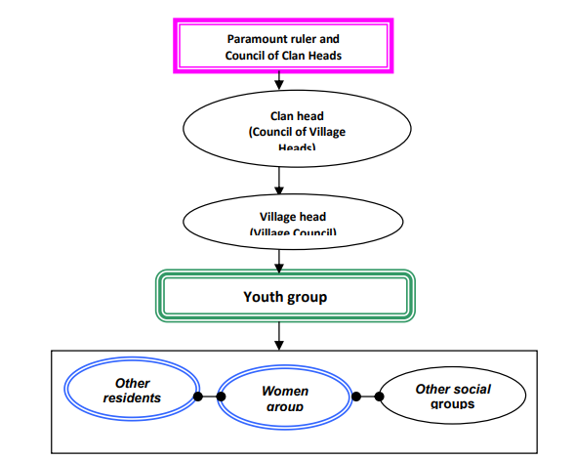
Figure 1: Local Administration Structure of Communities in Akwa Ibom State
- Belief Systems
The people of Akwa Ibom State, like most other African people, are religious. In religious terms the people have a strong and sometimes inexplicable but enduring recognition of a living being, in form of deities; and they are viewed as objects of worship and promotion of social integration, interaction and group solidarity They recognize the existence of Abasi Enyong (Sky god or god of the Heaven) and Abasi Isong (god of the earth). While the sky god is regarded as a single entity, the earth has many gods responsible for the various aspects and features of the physical environment.
Functionally, the nearest entity to the sky god is the spirit of the ancestors who act as intermediaries between the living and the god of the heavens. The earth gods are divided into the benevolent ones called Ndem, and the malevolent ones called Ibok. While these earth gods could be reached and are regarded as taking an active interest in the activities of men, the sky god is regarded as only distantly interested in the affairs of the living. The Ibibio do not, therefore, have shrines for the sky god; neither do they offer specific sacrifices to him.
The earth gods have specific abodes. For instance, certain Ndem lives in water and are known as Ndem mmong while others live on land and are known as Ndem Obot or Ndem isong. Ndem obot may be symbolized by a large stone, a large tree, an ant hill, a sacred grove, etc. Generally, Ndem mmong is regarded to be more powerful than Ndem obot. Thus the Ibibio recognize a sky god who is the creator of all things, as well as the earth gods and the spirits of the ancestors who are all regarded as mere administrators and defenders of creation.
The Ibibios believe that to carry out their duties effectively for the welfare of man, the earth gods must be continuously rewarded by way of sacrifices. The whole act of worship in the Ibibio religion consists of the offering of sacrifices during the planting and harvesting seasons. It may also be performed at any time else by an expectant mother, the parents of a sick child or by anyone who is in any form of difficulty.
Among the Efik sub-group, sacrifices are often offered in a pit whereas, among the mainland Ibibio sub-groups, sacrifices are offered at road junctions, by a hill, riverside or at the foot of a tree. A sacrifice offered on land is regarded as having been accepted if vultures (the messenger bird of the gods) come around to eat up the offering.
The Christian religion came into the former South Eastern state of Nigeria in 1846 when the Reverend Hope Waddell and the Presbyterian Mission came to Calabar. In 1887, Revd Samuel Bill came into present-day Akwa Ibom state and opened the Qua Iboe Mission in 1890. Since the advent of Christianity, it has gained prominence in all communities. Despite strong but waning adherence to the deities, the people have embraced Christianity with its attendant Western civilization. This is evident in the presence of a lot and variety of Orthodox, Pentecostal and spiritual churches dotted all over the state. The church is regarded as a loyalty index and effectively impacts peoples’ psychological attitudes to envisaged projects. The church is also an effective information dissemination organ and may replace the need for separate seminars and workshops because people willingly meet regularly. The influence of Christianity is felt in every area, especially in the naming of schools and newborn babies.

- Community Organization
Concerning community organization, communities in the study area exhibit a high level of cooperative tendency. The people also speak with one voice and bear allegiance to their groupings of affiliation. There is the powerful Ibeno Clan Council. At the local intra-communal level exists the village council, and youth and women councils. The youth are usually incorporated into the executive arm of each village council. The village councils handle traditional and non-criminal issues. Also important are the age-grades, church-based societies and ubiquitous credit and thrift groups (etibe). The pre-cooperatives and etibe groups provide a lot of financial assistance to needy members, at little or no interest, and group members generally offer material, social and financial assistance to needy members and also render moral support during the celebration of members’ joyous occasions. The leadership in various traditional, civic and political settings may be through inheritance, nomination/consensus and/or elective means.
- Social Groupings
The youth group remains the most active pressure group in the study area. This is not different from what obtains in other parts of the State and the Niger Delta, in general. The community has a youth executive, at the apex of who is a youth leader. Choice of youth leadership is either by consensus (village/youth councils) or by fiat (appointment) by the Village Head. The youth are an active, vocal group and (at times) volatile pressure group. Their primary functions pertain to the provision of security, apprehension of culprits and environmental sanitation. The youth group has become an indispensable part of traditional governance in the study area, most especially since the advent of the present political dispensation, and based on examples from other areas of the Niger Delta. The youth have the ability and power to initiate action. They are also primed for energetic action and are always at the forefront of actions targeted at sustained development. A report on the state of youth employment (2004) however reveals that between 47.51 % and 64.61% of Nigerian youths were unemployed in 2003. This was expected to worsen by the year 2010. The unemployment level was however revealed to be highest (83.3 %) for males/females of the 20-24 years age group. The World Youth Report (2003) also revealed that 17.3 million of the estimated 24.7 million Nigerian youth of the 15 - 24 years age range, were living below the poverty line of less than 1 dollar (N130) per day. The situation is far worse now as Nigeria has been classified as the third country in the world with the highest concentration of youths living below the poverty line (UNO, 2005). The problem is more pervasive in Akwa Ibom State which the UNECA (2002) regards as one of the poorest states in the country, with more than 70% income expenditure on food, a situation which has led to much unrest and crises situation
- Household Composition, Marital status and household size
Information on key aspects of the household composition, including the sex of the household head and the size of the household, is presented in Figure 2 below. These characteristics are important because they are associated with household welfare. Female-headed households are, for example, typically poorer than male-headed households. Economic resources are often more limited in larger households. Moreover, where the size of the household is large, crowding also can lead to health problems (NPC and ICF Macro, 2009). Households in Nigeria are predominantly headed by men (81%) and less than one in five (19%) are headed by women. Female-headed households are more common in urban areas (21%) than in rural areas (19%). (NPC and Macro, 2009). There was, however, a slight increase in the proportion of female-headed households from 17 per cent in the 2003 NDHS to 19 per cent in the 2008 NDHS. The three different types of male-headed household structures are traditional (one husband and one spouse), polygamous, and single male (male with no spouse, including widowers and males that have never been married). Traditionally, the male is responsible for all the major household decisions. Several socioeconomic surveys across the Akwa Ibom State human environment have found high marital status among the resident population (Ojile, 2013, 2012, 2006, 2005, 2004, 2002, 2001 and Ojile and Nwaneri, 1998).

- Household size
Earlier socioeconomic studies of some parts of the same environment (Ojile, 2013, Septa Energy, 2012, Ojile, 2012, 2005) also found approximately 31% of the surveyed households to have between 11 -15 members in them. A quarter (25%) of the households also had 5 – 10 members while another one-fifth (20%) had an average household size of 5.1 members was recorded across Akwa Ibom State in a socioeconomic study report (Ministry of Economic Development, Uyo, 2005). According to the last National Population and Housing Census (NPC, 2010, 2009), however, the modal class of households was 8 persons (15.6%), while households with more than 8 persons and above were also significant (14.5%). Size classes of 4-7 persons also constituted over one-half (50.6%) of households in Akwa Ibom State in 2006 (NPC, 2010).
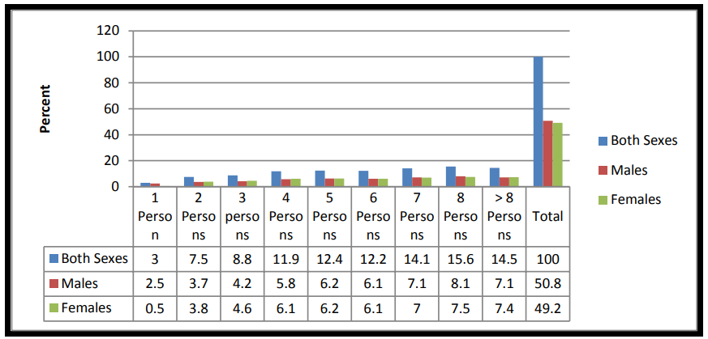
Figure 2: Size class of households and sex in Akwa Ibom State
Source: NPC, 2006

- Population structure (Age/sex Distribution)
The population structure reflects the age and sex composition of a population. Information on age and sex composition is very important, especially for the evaluation of the quality of the enumeration, and for the description and analysis of several types of socioeconomic and demographic data. The population structure is usually characterized by (a) the age-sex distribution and (b) two other key demographic ratios: the sex ratio and the dependency ratio.
Age and sex are important demographic variables and are the primary basis of demographic classification. They are also important variables in the study of mortality, fertility, and nuptiality.
Household age composition conforms to the overall Akwa Ibom and indeed Nigeria’s pyramidal structure. In Akwa Ibom, the population is rather overwhelmingly loaded from the lower age cohorts with over one-third (37.3%) of the population made up of persons below 15 years old, effectively classified as children (NPC 2010).
Decision-making, however, still rests with the adult population as revealed by the participants at the scoping workshops, focus groups discussions (FGDs) and key informants interviews across the project area
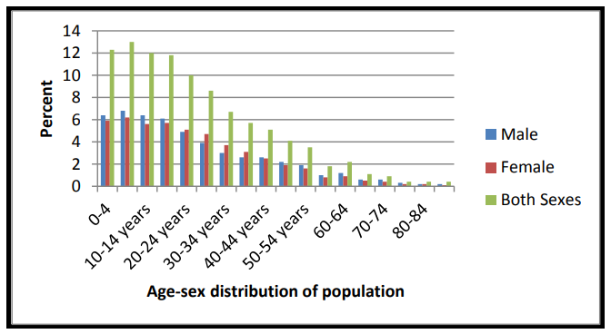
Figure 3: Age-sex distribution of Akwa Ibom State population (2006)
Source: NPC, 2009

The Akwa Ibom State Socioeconomic Study Report, 2005 found a sex ratio of 100 females to 102.9 males for the State. For every 100 females, there are to be found almost 3 more males. Surveys carried out in the course of the Niger Delta Master Plan development process show that there are more males (54%) than females (46%) in the Region.
This is an indication of the socio-cultural norms in most Nigerian rural societies where men’s opinions are considered more important than the female’s. But these days, the participation of women in governance and decision-making has been highly canvassed and more females are now very active in community matters.
- Educational characteristics
Education is a key determinant of the lifestyle and societal status an individual enjoys. Studies have consistently shown that educational attainment has a strong effect on health behaviours and attitudes. A large proportion of the population interacted with appeared to have some formal educational training indicating a sufficiently literate society.
The 2006 Census results indicated that 51.7% of males and 48.3% of females in Akwa Ibom State were literate. Some 83.7% of men and 80.4% of women aged 6 years and above had attained some form of education, putting the state above the national average. Some 10.7% of men and 14.2% of women over the age of six had no formal schooling (never attended) school. Some 16.3% and 19.6% had no educational attainment, while 12.7% and 11.8% of both men and women had finished nursery school. A higher proportion (17.6% and 17.4%) of the males and females finished primary school at the time of the census (NPC, 2010, 2009). The level of formal education was found also to be considerably high in Akwa Ibom State, according to the State’s sponsored Socioeconomic Report (2005). The overall literacy level was reported to be 75 per cent. However, primary and secondary schools constitute the bulk of those with educational qualifications, with over 70 per cent in the State (Ministry of Economic Development, Akwa Ibom State, 2005).
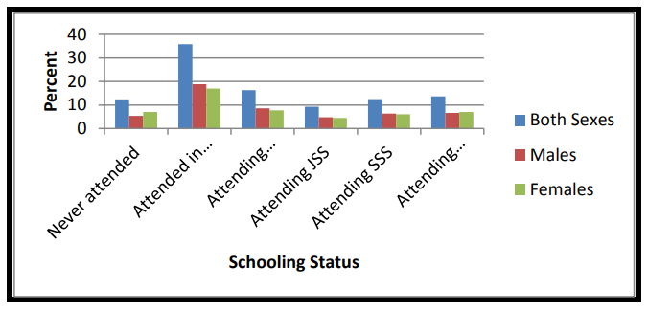
Figure 4: Distribution of population by formal schooling status (Akwa Ibom) State (2006)
Source: NPC, 2009
4.5.2 Study Methodology
The proposed project is situated 60km offshore the coast of Akwa Ibom State, therefore, individuals carring out activities along the shoreline, whose livelihood may be impacted by the proposed project were sampled for the socioeconomic and health assessment. These individuals are recognized as Project Affected Persons (PAP). The socioeconomic and health study was undertaken using a sequential mixed methods research design that integrated both quantitative and qualitative data gathering, analysis, and reporting techniques. Data was triangulated to distinguish perception from reality, and the study was carried out between the 9th and 15th of December 2022 and the 22nd and 23rd of March 2023. The study utilized a questionnaire for the collection of quantitative data and Key Informant Interviews (KII) for the collection of qualitative data.
The data gathering process was strictly limited to individuals who provided their informed consent. This study made use of Computer Assisted Personal Interviewing (CAPI) Software specifically KoBo ToolBox and Zoho Survey, which were accessed via smartphone and facilitated by capable survey enumerators. The questionnaire was to PAPs to gather information on socioeconomic and demographic characteristics of the communities such as; age, sex, marital status, family size, size of household, and major and subsidiary occupations, among others.
A standard 10% non-response rate was included in the sample size, as it was expected that some individuals in the study area may refuse to participate or withdraw from the interview midway. The study involved a sample size of 600 respondents, and 585 complete responses were analyzed for the study. The systematic sampling technique employed ensured a balanced representation of both males and females among the respondents. In addition to the primary data collected through the questionnaire, secondary data sources were also utilized, including previous studies, articles, and research papers. When possible, information sources were used in combination to ensure the reliability and accuracy of the data. Furthermore, visits were made to existing basic facilities such as education and health facilities.
- Analytical Techniques
The collated data were analyzed using a range of analytical techniques, with a particular focus on descriptive statistics. These methods allowed for a comprehensive understanding of the data, through the use of means, percentages, frequency tables, and charts. By utilizing these techniques, valuable insights were gained and informed decisions were made based on the data. Overall, our analytical approach was both thorough and professional, ensuring that the data was carefully examined and interpreted.

4.5.3 Demographic Profile of the Project Areas of Influence (AoI)
- Age Distribution
Population structure affects the age and sex composition of any study area. In terms of age structure and distribution, the general study area exhibits the typical pyramidal structure characteristic of Akwa Ibom and Nigeria, in general. The population is rather loaded for the lower-range cohorts. Analysis of the data obtained indicated that the majority (47.52%) of the respondents were youths aged within the age bracket of 25-35 years (Figure 5), although, an appreciable proportion (23.42%) were also aged between 35-45 years, while those aged 65 years and above are fewest, constituting less than 3%. The Centre for Population and Environmental Development, extrapolated the population of Akwa Ibom State for 2003, as made up of 62.1% in the below 30 years age category and 35.8% in the 30 – 69 years category (CPED, 2005). This implies a young and growing population with a heavy burden on the adult population, a high dependency ratio, as well as a high unemployment ratio.

Figure 5: Age Distribution of the sampled respondents
Source: Richflood field survey, 2022

- Gender Structure
The analysis of the data obtained from the sampled respondents shows that the majority of the respondents representing 70.43% are male, while 29.57% are female. About sex structure, gender statistics for Akwa Ibom State indicate a sex (male: female) ratio of 103.3 (NPC, 2006). This figure is quite close to the national ratio of 103, meaning that the male population is slightly higher than the female population.

Figure 6: Gender Distribution of the Sampled Respondents
Source: Richflood field survey, 2022

4.5.4 Access to economic infrastructure and services
- Livelihood and Micro-Economy
Economic conditions have a vital role to play in people’s experience and perceptions of place. A person or a household’s socioeconomic status influences the range of opportunities and constraints that people face. Socioeconomic status affects almost all aspects of life. It affects nutrition levels and health, geographic mobility, educational attainment, and overall quality of life. In Akwa Ibom, studies have revealed that very high proportions (89.21%) of employed persons were located in the rural areas and rural activities are dominated by the females while the males are dominant in the urban areas (Ministry of Economic Development, Akwa Ibom State, 2005).
- Occupation and Employment
As observed during the field visit, fishing, trading, boat operator, and farming form the major source of livelihood of residents. According to field survey responses, 30.0% of the inhabitants are farmers, 23.0% are artisans/traders, 20.0% are in the fishing business, 13.0 0% are students, 6.0% are Boat Operators, and 3.0% are Company/private firm workers. The category of others which made up about 7.86% of the sampled respondents includes Teachers, Bike riders, Fishing net weaver, Shoe cobbler, Net repairer, Food business, Auto repairer, Jewellery hawking, etc.

Figure 7: Primary occupation of respondents
Source: Richflood field survey, 2022
- Farming
Agricultural production is a very important activity in the study area as the state falls within the tropical zone with dominant vegetation of green foliage of trees, shrubs and oil palm tree belt, which holds the highest density of the cash crop in the world (AKSG, 2001). Land in the study area is the joint property of the extended family system, leading to fragmentation and small sizes of non-contiguous farm holdings. Land acquisition in Akwa Ibom State is by either of four means: outright purchase; leasing (oto-owo); inheritance (Ikot ufok/ekpuk); and pledging (Ubiong ikot) in lieu of loan acquisition, which is returned to original owners after loan payment to creditors. Some conditions may be attached to land acquisition (especially leased or pledged land).
The socioeconomic survey established the traditional economic base in the area to be agricultural. The majority of the people were found engaged in farming, (cultivation of the land at the subsistent level), including the cultivation of palm trees and subsequent harvesting of palm fruits which are processed/milled for palm oil.
Generally, men and women are economically active in various economic endeavours. The principal crops cultivated by the farmers are three-leaf yams, cassava, plantain, cocoyam, banana, potatoes, okra, pepper, maize, beans, melon, pumpkins and other vegetables, garden eggs and pineapples and citrus and related fruits (oranges, pears, guava). Palm oil milling/production is also a major economic activity in the area. Cassava is the most popular crop cultivated in the communities. Cassava, plantain, banana, cocoyam, and maize yield more income to the householders than any other crop. These crops also serve dual purposes; they are the most important food crops (staples) and cash crops.
As is common in most rural areas, mixed farming engagement with the use of crude tools was common, so that any one household can be found engaging in farming, palm fruits cutting and processing, trading, etc, according to favourable times. farm labour is manual and requires physical energy exertion with the matchet and hoe as the main capital items; and while the bulk of labour on compound farms is supplied by the family, the case is different on communal or cooperative land.
On these farmlands, labour is mainly hired, at exorbitant rates, as youths are mainly in school during peak farming seasons, while some may have migrated to towns in search of greener pastures. Work on the farm, therefore, devolves mainly on the husbands and wife/wives who may be too old for any effective energy output. Labour, in this area, is generally regarded as a very restrictive factor of production, based on its high cost. Of all forms of labour, the wedding cost is the most restrictive and attracts the highest cost of labour, because it may be performed a number of times before crop maturity. Consequently, excess produce/harvests from the subsistent farming system are often sold in each of the community’s periodic markets (holds every 4-day intervals) or neighbouring markets to earn incomes.

- Fishing
The continental shelf is the widest in Akwa Ibom State, which possesses about 129 kilometres of coastline and is reputed to have the highest concentration of fisheries in Nigeria. Essentially, the coastal fisheries cover the area between Longitude 7⁰ 35¹E to Longitude 8⁰ 25¹E and Latitude 4⁰ 32¹ to Latitude 3⁰ 55¹N. Fishing activities also occur in the lakes, swamps and brackish waters which occur at the banks of the main rivers and those of big streams. These kinds of fisheries occur in all the local government areas of the state. Private fish ponds exist all over the State. The pond sizes, stock and yields do vary, but generally cultivated species include carp, tilapia, catfish, and Niger perch. The pond generally consists of nursery, transition and production ponds. Only very few have hatcheries.
Fishing is conducted along the surrounding creeks, slots/canals and deep into the Atlantic Ocean. Fish catch is seasonal and depends on tides. The commonest types of fish as obtained from the sampled respondents include Tilapia, Bonga, Crayfish, Crooker, Barracuda, Bonga fish, Catfish, Erure, Cherokee, Cod, Barracuda, Red snapper, Shinose, Tuna, Crooker fish, Plenty, Igborgbor, Crabfish. and periwinkles. However, some of the rare species of fish that can be found in the area include Akpanata, Jellyfish, Jellyfish, Cover pot, London boy, Cuttlefish, Crocker, Akapanta, Igborgbor fish, Gold Fish, Electric Fish, Catfish, and Shark.
In addition, as obtained from the sampled respondents, the average number of fish caught per day is estimated at 2,023. Fishing techniques employed remain largely unchanged from the traditional fishing method and include: cast nets, drag nets, rapture nets, hooks, lines, sweep nets, fish traps and conical baskets. As gathered from the sampled respondents, the month with the highest number of fish caught is December followed by September. However, the month with the lowest number of fish caught is June.

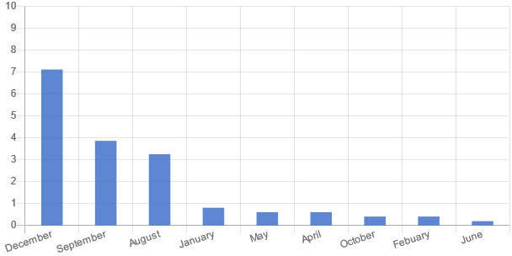
Figure 8: Fish catch per each month of the year
Source: Richflood field survey, 2022

Commercial and Consumption Fishing
The majority (66%) of the fishing activities are both for commercial and consumption purposes, while about 34% of the fishing activities are for only commercial purposes, as obtained from the sampled respondents. However, none of the respondents indicated that fishing is only for consumption purposes.
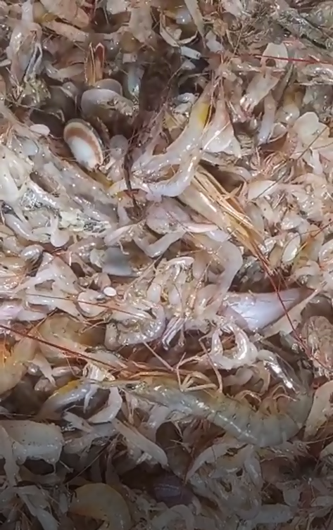 | 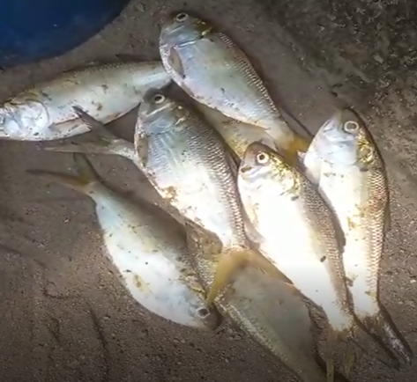
Figure 10: Shrimps and fishes caught in the Project Area of Influence
Source: Richflood field survey, 2022

Transportation Routes
An analysis of the transportation routes obtained from the boat operators indicated that none of the routes is linked with the location of the FLNG. This is because of the distance of the location of the proposed project to the shore. Thus, the FLNG facility will pose minimal or no navigational risks to commercial shipping during its operation. The project area may be traversed on occasion by mariners and fishermen but does not appear to overlap with any known and established sea lanes or fishing grounds
Vessel Types and Movements
As observed during the study, 65.8% of the participants were engaged in the operation of fishing vessels, while 34.1% were involved in cargo vessel operations. Furthermore, the average frequency of daily trips undertaken by these vessels was five.
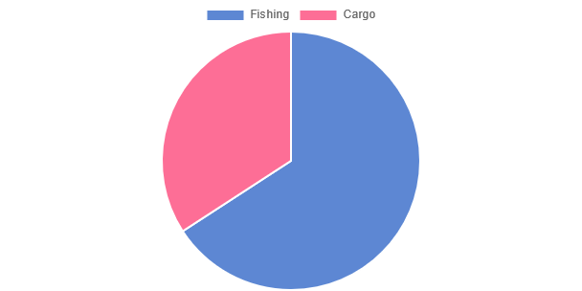
Figure 9: Types of Vessels operated
Source: Richflood field survey, 2022

Association/Cooperative Society
An analysis of the various types of associations and societies reveals that there are different kinds of associations based on occupation, and ethnic groups among others. Some of the associations/cooperative societies as obtained from the sampled respondents include the Nigerian Welders’ Association, Fishermen Association, Yoruba Parapo, Bike Riders Association, Nigeria Tile Union, and Welder Association among others.
- Trading
Aside from the traditional occupation, other income-generating activities identified include petty trading (trading has always been an important economic activity at the shoreline), artisans and those engaged in other skilled-related activities (carpentry, masonry, welding and fabrication, sewing, fashion and design, etc. enhanced by the availability of energy supply, though not regular). The exchange of goods and services is common along the shoreline. This exchange occurs almost on every corner, from the street hawkers to the kiosk and the main market. This activity is not gender specific as both men and women were found selling and buying goods market and around the community. The trading activities range from having a kiosk in front of a house to large-scale buying and selling in designated markets. Trading activities begin in the morning and close in the evening. Some common products found in the markets are palm oil, potatoes, mangoes, meats, peppers, tomatoes and other food supplements, shoes, clothes; and services like tailoring, barbing, and hairdressing salons.
- Income Level of the Sampled Respondents
Income is an important variable that influences the socio-economic status of individuals and its distribution pattern has the potential of influencing other demographic variables. Income distribution is one of the most important indicators of regional welfare. Income level determines the ability to meet basic needs and provide information on the poverty rates in the area. However, information on the income of both the rural and urban householders is very unreliable because many do not keep records, many householders are engaged in several income-generating activities while the level of literacy more often than not acts as a restraint. In most rural areas of the developing world, the household is the basic unit of production and reproduction. Production includes activities that produce tradable (or potentially tradable) goods and services that result in income, and reproduction includes household maintenance functions such as childcare, cooking and cleaning, which are not tradable, but are nevertheless essential for household well-being (Sousan et al., 1999). To survive and prosper in what can often be difficult circumstances, rural agrarian households employ livelihood strategies, which can be defined as “the capabilities, assets (including both material and social resources) and activities required for a means of living” (Carney 1998).
Figure 11 shows the analysis of the monthly income distribution of the sampled respondents. It was revealed that the majority (43.5%) of the sampled respondents’ earnings are in the range of 50,000-100,000 naira monthly, while about 32% earn between 20,000-50,000 naira. However, just one respondent representing 0.2% of the total sampled respondents indicated earnings between 500,000-1,000,000 naira per month.
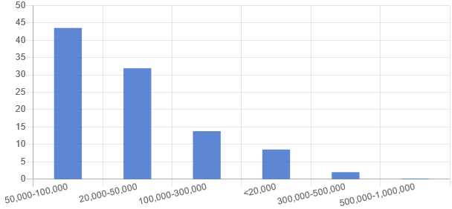
Figure 11: Average Monthly Income Distribution of Sampled Respondents
Source: Richflood field survey, 2022

4.5.7 Access to basic social services and related infrastructure

- Educational Facilities
Also, as part of the educational facilities assessment, two schools (IwoChang Community School and Heritage Polytechnic) were assessed.
IwoChang Community School
IwoChang Community School was established on the 23rd of March, 1962. It has 6 school blocks, 5 offices, an administrative building, 10 teaching staff and 10 non-teaching staff, and 13 classrooms with over 300 students. Other facilities within the school include blackboards, wooden chairs and tables, and pit latrines.
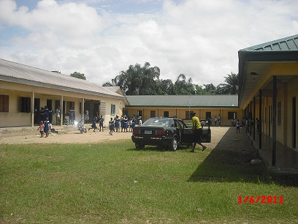
Figure 14: Primary School at Upenekang
Source: Richflood field survey, 2022
Heritage Polytechnic
Heritage Polytechnic, Eket, Akwa Ibom State, is a privately owned polytechnic institute located in Ikot Udota, Eket Local Government Area of Akwa Ibom State, Nigeria. The institution founded by Emmanuel J. Ekott who is a Chemical Engineer took off in 1996 as Christian Continuing Education Centre. By 1999, it metamorphosed into the Christian Institute of Continuing Education. In 2000, the institution became known as Heritage College and it was licenced by the National Board for Technical Education as a Polytechnic in 2010. The institution has four Faculties (Engineering, Environmental Studies, Management Sciences and Science and Technology). Heritage Polytechnic is currently the biggest private polytechnic in Nigeria with over 32 accredited programs and over 4500 students.
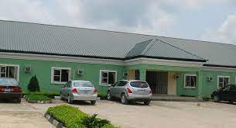
Figure 15: Administrative Building, Heritage Polytechnic, Eket, Akwa Ibom State
Source: https://www.heritagepoly.edu.ng/
- Educational Attainment
An appreciable proportion of the sampled population has received some formal educational training indicating a satisfactory literate society. The modal educational attainment amongst the PAPs is the primary educational level. About 58.13% of the sampled population have Secondary school education and 14.43% have some form of tertiary education (NCE/HND/B.Sc.). However, about 5.69% reported having No Formal Education (NFE).
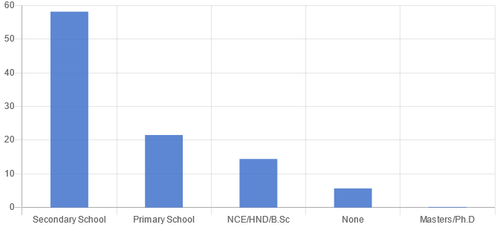
Figure 12: Educational attainment of respondents
Source: Richflood field survey, 2022

- Literacy Level
An advanced level of educational attainment is pivotal to economic liberation and empowerment. Levels of educational attainment by residents within the proposed area are somewhat matched by the level of literacy. The literacy rate in Akwa Ibom State is 75.77%, which is quite higher than the estimated national rate of 68% (AK-BASES 2005; UNDP 2006). This corresponds with the 87% of the surveyed groups which reported that they could read and write as illustrated below.

Figure 15: Literacy Status of the Project Area
Source: Richflood, 2023

- Housing
The provision of good housing is an important aspect of environmental health. It represents a significant part of man’s environment; shelter from the elements; workshop (the kitchen for the housewife, the playroom for the children and tool-shed for the adult males); and home (the residence of the family, where this social institution carries out some of its major functions. Consequently, good housing should minimize physical and biological hazards in the environment, provide a good social environment and promote the health of the inhabitants.
Qualitatively, rural and urban housing in Nigeria falls below minimum standards in all aspects. There are several factors, which may be used in assessing the quality of housing, including liveability, level of comfort afforded, safety, and ease of maintenance. These factors include wall and roofing materials, as well as household facilities. Traditionally, most Nigerians (about 80%) live in their own houses, which are constructed of locally available materials (NEST, 1991; FMAWRRD, 1992). These include mud walls and bamboo and thatch roofs, particularly in the rural areas and cement blocks and corrugated iron sheets/zinc roofs in the urban areas.
According to the field survey, 51.61% of the housing types are Single room bungalows with multiple rooms, 25.81% are Rooms bungalows and 3.23% are Duplex/story buildings.
Field observation reveals the housing condition during the assessment. The majority (41.94%) is made up of Zinc/concrete walls, 35.48% of Zinc/wooden walls, and 12.90% of thatched/mud walls. The category of others (9.68%) includes Zinc/ mud walls.

Figure 16: Housing type within the project area
Source: Richflood field survey, 2022
- Electricity supply
Statistics from the 2006 Population and Housing Census showed that the proportion of the population that had access to electricity as a lighting fuel in Akwa Ibom State amounted to 29.3 per cent. Understandably, the majority of households in the State used kerosene as a lighting fuel in their dwellings (73.5%, 93.9% and 91.9% respectively) (NPC, 2010). Most communities are now connected to the national power grid of the power holding company of Nigeria (PHCN), but the supply of energy is most times the matter for complaints; supply is erratic and epileptic. Step-down transformers were seen strategically located in some of the surveyed communities to improve access to electricity, some donated by the NDDC (Niger Delta Development Commission) to some of the communities.
As observed during the field survey in the project area, 93.77% of respondents within the Project’s AoI have access to electricity and are connected to the National grid. However, there were complaints of irregular supply of power supply in the communities.
- Access Road/Public Transportation
For the predominantly riverine and marshy sections of the study area watercraft are utilized as the major means of transportation. Various types of hand and engine-propelled boats are utilized either for human or cargo transportation or for fishing activities. Paddle boats may be utilized for short distances in creeks or across minor water arteries. These are however being gradually phased out as a means of public transportation although they are well utilized for private family transportation and fishing expeditions. The common engine boats in the study area include the 9 horsepower (HP) engine boat, which is a relatively smaller type of passenger boat and may also be utilized for minor fishing expeditions. There are also large Ghana-type boats which are used for commercial fishing purposes and may remain offshore for a period of one or two weeks before returning to shore.
It is important to note essentially that land access also exists to these riverine settlements. Intra-communal routes in the study area are generally poorly conditioned. The majority of these roads are earthen (a very low proportion is gravelly) and are impassable during the rainy season.
Dilapidated trucks and ramshackle passenger/goods vehicles traverse the area. Motorcycle machines, especially, large engine CG 115, 150 and 175 double silencer types predominate. Popular brands include Nanfang, Frajend, Suzuki and Q-link; which are all reported to be strong and hardy enough to traverse the rough, erosion ravaged and poorly maintained road networks. Bicycles may serve for intra settlements /communities movement. Human porterage on heads/shoulders is also a common activity, especially by the female gender.
- Telecommunication facilities
The prominent GSM telecommunication providers, namely MTN, Zain, Glo, and Visafone, have made significant strides in the region. The capital cities and other major towns in the surveyed area have complete network coverage, enabling individuals to communicate socially and conduct business transactions seamlessly. However, the network coverage is contingent on the subscription, and certain areas within the study environment may be entirely out of reach, resulting in communication blackouts.

Figure 18: Access to facilities in the project area of influence
Source: Richflood survey, 2023
- Recreational Facilities
These are facilities for recreational activities, meetings and dancing sports for members of the project communities. These include town halls/auditoriums, swimming pools and club/ rest houses. The Niger Delta people are generally very social and hospitable. Thus, recreational places/facilities were found during the survey. Communal meetings are organized in town/community halls or Village Squares as the case may be. Public safety and security issues, including fire service and police, are critical issues across the Niger Delta as it has become all over Nigeria.
Within the surveyed area, individuals engage in various forms of leisure activities, including social visits, group drinking sessions (predominantly among men and youths), and group discussions. Furthermore, formal recreational facilities exist primarily in the major towns within the survey area. In isolated settlements, there may be a few eateries that also function as drinking parlors and viewing centers. These establishments may also host non-native women who engage in prostitution. Periodically, cultural events such as masquerades and dances serve to enliven the otherwise monotonous atmosphere of these regions.
- Water Supply in the Area
Interactive sessions revealed that potable water supply is lacking in the riverine settlements. Major sources of water supply for consumption and domestic uses are rainwater run-off collected from thatched/woody/rusty iron sheet roofs. These are invariably unhygienic and particles/germs infested. In the dry season, domestic water supply is from shallow hand-dug wells, the liquid contents of which are separated from the earth's surface by rusty iron–wrought containers. Water may also be collected from shallow unhygienic streams which become waterlogged during the rains and from private and public boreholes.
- Water Sources and Access
Regarding water sources and access, the obtained data from the surveyed respondents, as displayed in Figure 19, indicates that boreholes constitute the most frequently utilized source of drinking water (87.8%). Subsequently, good sources (20.5%) and streams/rivers (6.7%) follow suit, with other sources such as sachet and bottled water representing 2.4%.
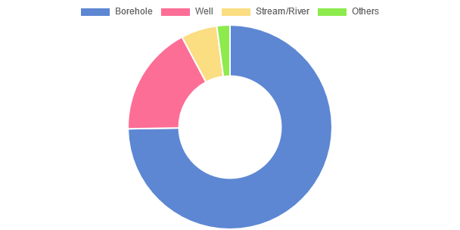
Figure 19: Sources of Drinking Water
Source: Richflood field survey, 2023
4.5.8 Culture and Relgion
- Culture
The cultural festivals observed in the study area are diverse and vary between different communities. Typically, these festivals correspond to seasons, economic activities, and the veneration of particular deities and memorials. Festivals are usually commemorated with festivities, wrestling, masquerade and other dances, and communal feasting. Visitors are often invited to observe and sometimes participate in these celebrations. However, in certain communities, limitations are imposed on movement and participation by visitors and women. In some cases, festival participation is restricted to worshippers of particular deities, and some festivals may involve sacrifices and ritual cleansing of the community.
Despite the differences, all festivals share a common theme of revelry, masquerades, and traditional dances, with the exception of pre-planting season ceremonies, which may involve sacrifices and community cleansing to seek blessings from the land. These annual festivals, which usually coincide with the bountiful harvest season, provide opportunities for family, friends, and well-wishers from distant and neighboring communities to come together in celebration. The festivals are adorned with captivating and enchanting dances, which convey the core values of the community.
- Religious Composition
In terms of religious affiliation, the majority of the project affected persons identified as Christians, accounting for 95.73% of the sampled respondents. Muslim adherents represented 3.86%, while 0.41% claimed adherence to the African Traditional Religion (ATR). This observation was corroborated by the presence of various churches, including orthodox denominations such as Anglican and Catholic, alongside pentecostal churches, serving as worship centers within the study area.

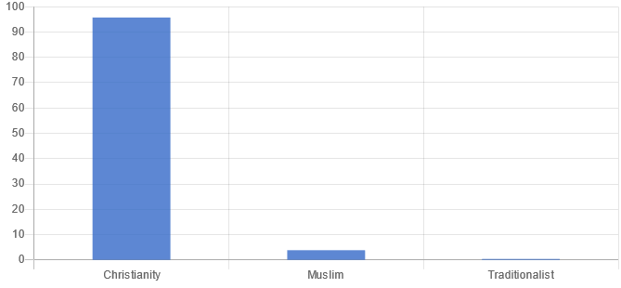
Figure 17: Religion Composition of the Sampled Respondents
Source: Richflood field survey, 2022

4.5.9 Waste Management
- Access to Sanitary facilities
Proper disposal of faecal matter is a crucial factor in determining overall health. Sanitary faecal disposal minimizes the risk of illnesses that are transmitted through faecal-oral means, such as cholera, diarrhoeal diseases, typhoid fever, amoebiasis, and intestinal helminthiasis. Access to proper faecal disposal and sanitation facilities is also a fundamental component of the Sustainable Development Goals. According to data obtained from surveyed respondents, the most commonly used form of sanitary faecal disposal is pit toilets, accounting for 55.89% of the responses. The water system follows closely at 43.09%, with open defecation (30.89%) and defecating in the bush (9.15%) being less commonly used methods.

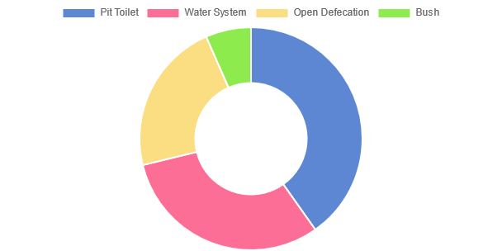
Figure 20: Toilet Systems
Source: Richflood field survey, 2022

- Methods of Solid Waste Disposal
According to the results of the survey, 65.24% and 36.38% of respondents reported utilizing open disposal and dust bins, respectively, as their primary method for solid waste disposal. Burying, burning, and municipal waste collection systems were identified by 26.83%, 1.42%, and 0.61% of respondents, respectively. However, observations within the community suggest that overall, solid waste management in the project area is subpar. Indiscriminate dumping of waste in backyards, drainage systems, and along roadways is frequently observed.
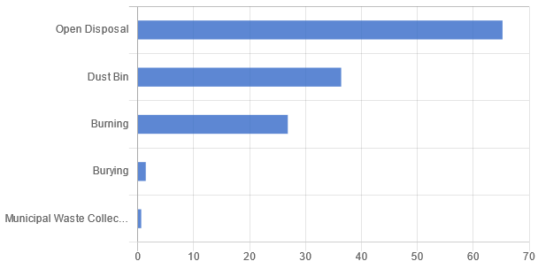
Figure 21: Solid Waste Disposal Method
Source: Richflood field survey, 2022

4.6 Community Health Assessment
- Health Centre, Ntafre
Established in 1991 and managed by the State government, the Health Centre in Ntafre offers basic health care services to the Ntafre community and neighbouring communities. The centre, which operates from 8:00 am to 8:00 pm, has a doctor, a nurse, and one health assistant, as well as one admission bed, furniture, a cooling system, toilet facilities, and several pieces of medical equipment. According to the survey, the centre receives at least five patients weekly, and women (65.58%) visit the centre more than men (34.42%). Children aged between 0-17 years are most affected by environmental issues.
The services provided by the health centre include child health and antenatal services, vaccination, treatment for malaria, typhoid, measles, antibacterial intervention services, and more. Drug supplies come from the state government, private organizations, and non-governmental organizations (NGOs), while some patients obtain drugs from nearby pharmacies.
Genotoxic and pharmaceutical waste, such as urine, vomit, faeces, blood, solvents, used gloves, cotton wool, bandages, needles, and contaminated drugs/vaccines, are the major wastes generated by the medical ward and administrative unit. These wastes are collected using wastebins and disposed of through the waste management authority in the state and incinerator.
The facility is connected to the national grid and has access to a water supply.
- Wisdom Clinic, Upenekang
Established on August 17, 2012, Wisdom Clinic is a private healthcare facility that operates 24 hours daily. The clinic is staffed by 2 doctors, 12 nurses, and 3 laboratory technicians, and equipped with furniture, test kits, and other medical equipment. Its catchment area includes Ukpenekang, IwoChang, and nearby communities. The facility is connected to the national grid and has access to a reliable water supply. The clinic infrastructure comprises 7 admission beds. Drug supplies are obtained from private organizations and non-governmental organizations (NGOs), with some patients purchasing drugs from nearby pharmacies.
The clinic offers various services such as child health and antenatal care, vaccinations, malaria and typhoid treatments, measles treatment, antibacterial interventions, among others. The clinic generates both solid waste (gloves, cottonwool, bandages, needles, blades, scalpel, expired reagents, etc.) and liquid waste (urine, blood, solvents, etc.) from the medical ward, operation theatre/surgical ward, laboratory unit, pharmaceutical/chemical store, and administrative unit. The generated waste is collected in waste bins and disposed of using an incinerator on a daily basis.
- Ukpenekang Operational Base Primary Health Centre
The government established the health centre on August 6th, 1989. It operates 24/7 and receives drug supplies from both the government and NGOs. The facility is connected to the national grid and has access to water supply. It is equipped with one doctor, five nurses, one medical laboratory technician, furniture, toilet facilities, eight admission beds, and other medical equipment.
The health centre offers various services such as child health and antenatal services, vaccination, malaria and typhoid treatment, measles treatment, antibacterial intervention services, among others, and receives at least seven patients weekly. The health centre generates medical wastes such as gloves, cotton wool, bandages, needles, scalpels, expired reagents, etc. from the laboratory, pharmaceutical, and administrative units. The wastes are stored in waste bins and disposed of through the waste management agency and incinerator.
- Primary Health Care, IwoChang
The government established this health centre on July 9th, 1998. It provides basic health care services to IwoChang and neighboring communities, operating from 8:00 am to 8:00 pm daily. The facility has access to electricity and water supply, and comprises of 2 admission beds, furniture, cooling systems, toilet facilities and other medical equipment. The staff consists of 1 nurse, 2 midwives, 1 medical laboratory technician, and 1 health assistant. Drug supply is received from the government and NGOs.
The health centre offers a range of services, including child health and antenatal care, vaccination, treatment for malaria, typhoid, measles, and other antibacterial interventions, with at least 5 patients visiting on a weekly basis. The majority of patients are women and children. Medical waste generated in the facility, such as gloves, cotton wool, bandages, needles, and expired reagents, is appropriately sorted, placed in waste bins, and disposed of through an accredited waste management agency and incinerator.
- Disease Prevalence
The study area has revealed several common diseases, such as malaria, typhoid, cholera, pneumonia, tetanus, and whooping cough. Additionally, various eye ailments have been reported due to unprotected exposure to fish processing activities, particularly smoking. Traditional herbal remedies, modern visits to health centers and hospitals, and spiritual treatments at churches and prayer houses are common sources of treatment for these ailments. However, for many individuals, visits to health centers and hospitals are the last resort due to high costs, long queues, and bureaucratic procedures. As a result, patent medicine stores and itinerant drug vendors are popular sources of medicare, despite concerns about the quality of dispensed drugs.

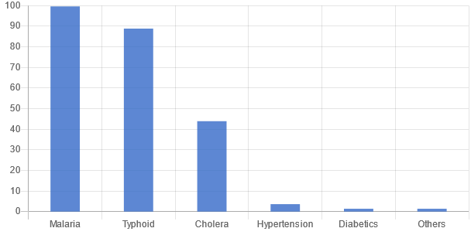
Figure 22: Common Illnesses
Source: Richflood field survey, 2022

4.7 Community Concerns and Perception
During the study, project affected persons were interviewed and most of them expressed a positive attitude towards the proposed project. However, a few individuals expressed concerns that the project may have negative impacts on vessel movement in terms of transportation routes, fishing in the sea, and human health. Despite these concerns, the PAP were generally in favor of the project but had certain expectations related to development needs. These needs were focused on two areas: infrastructure and human capital development. The specific concerns and expectations are listed below..
Concerns/Demands
- Provision of potable water supply
- Provision of micro-loans to enhance their reintegration into the economic system.
- Loan facilities to aid their fishing activities.
- Improved electricity supply.
- Equipping the health facilities with staff and medical supplies.
- Renovation of schools
- Financial empowerment for the youths.
- Skills acquisition and development centre.
Annex 1_Photolog
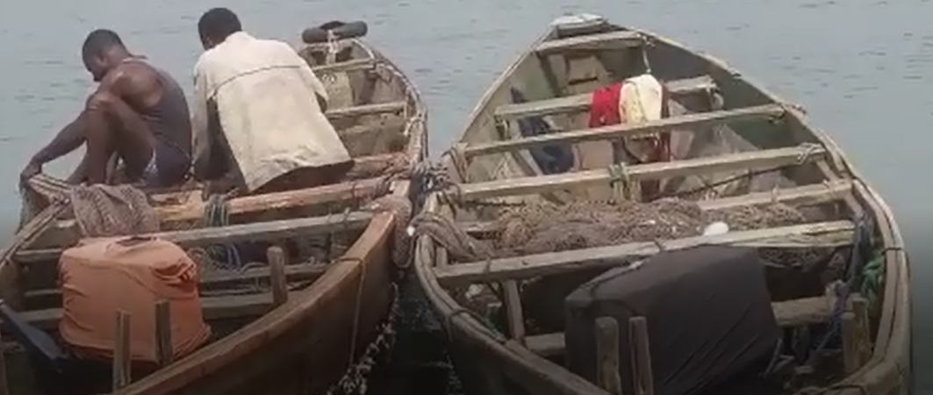 |  | 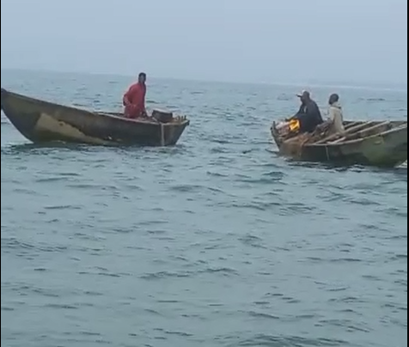
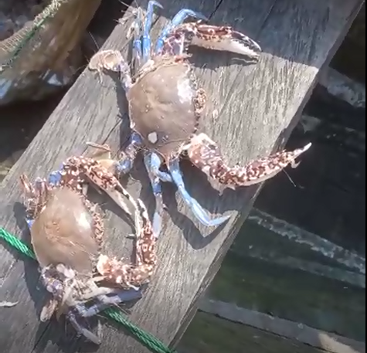
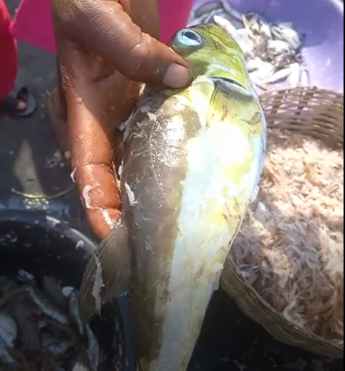 |  | 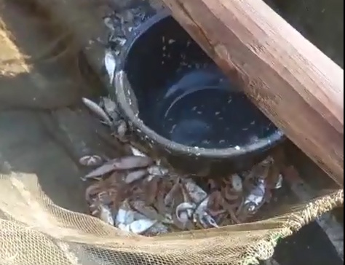
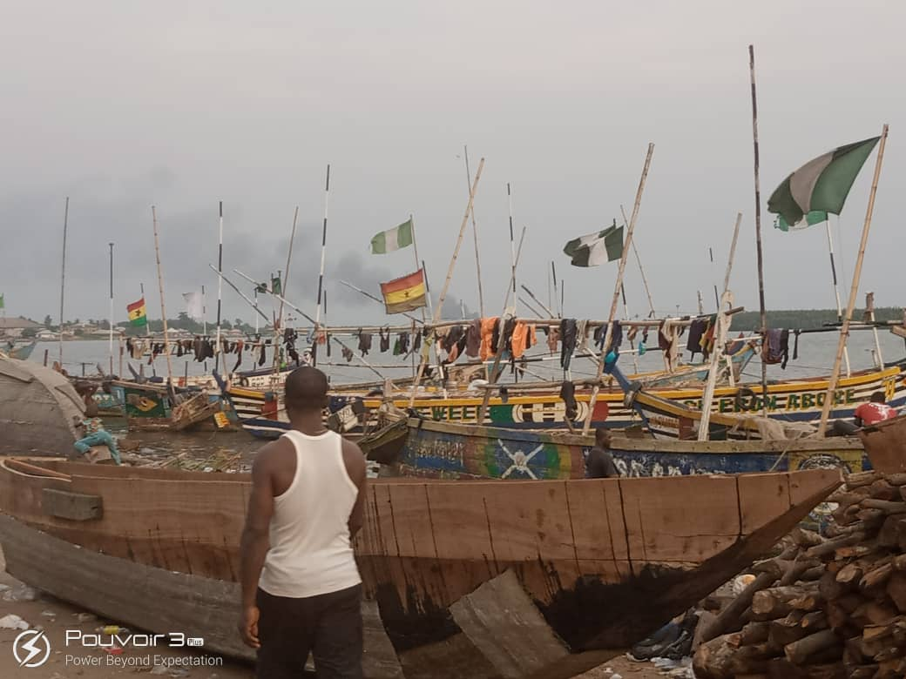 |  | 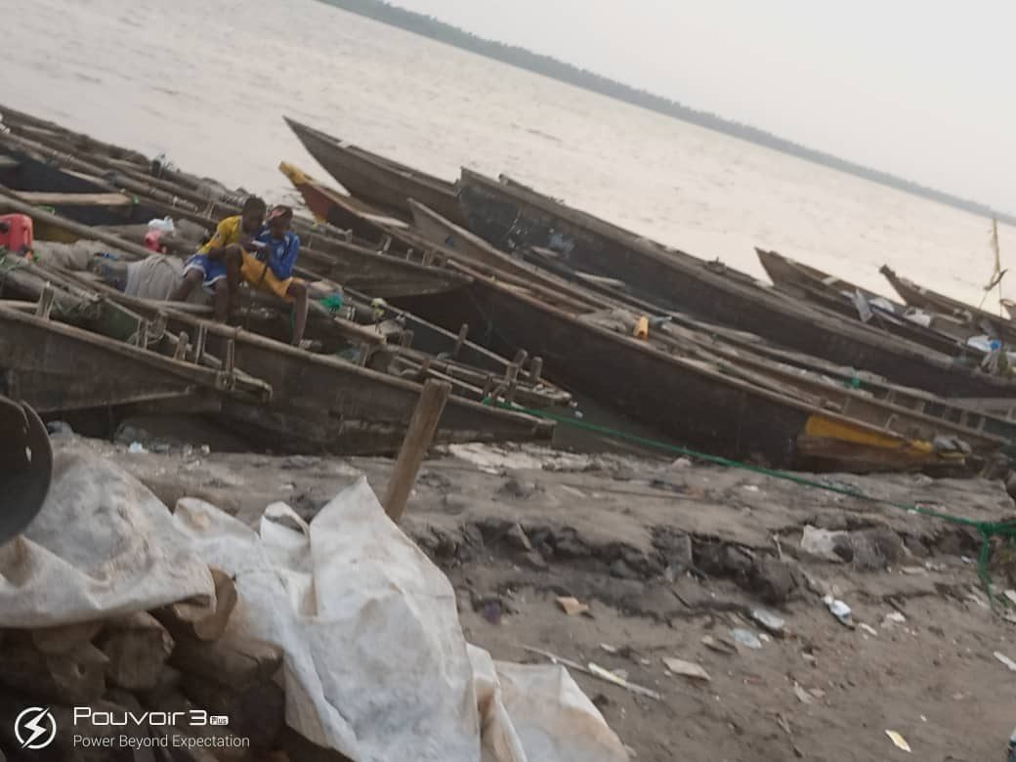
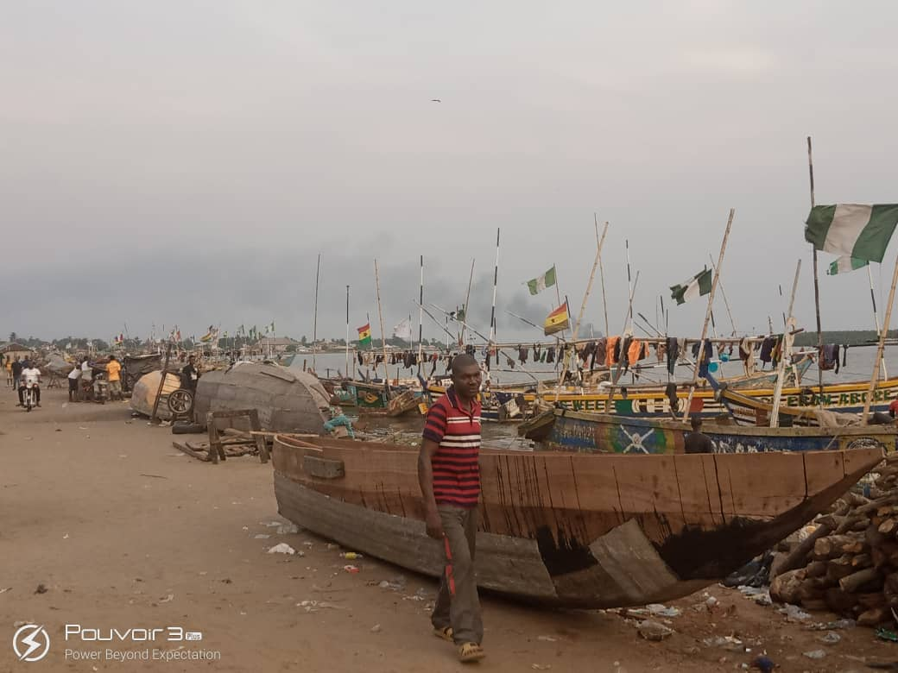 |  | 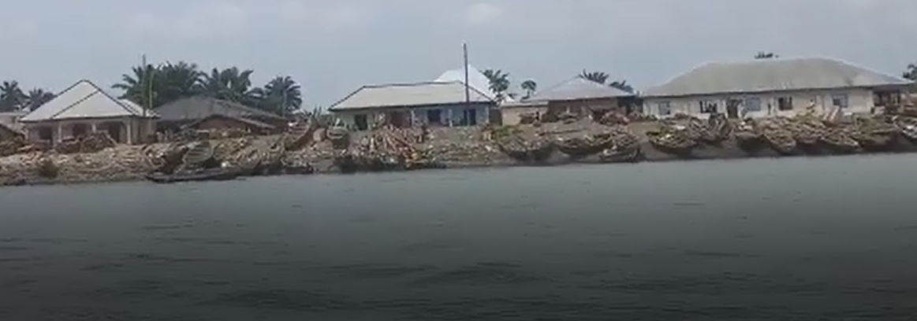
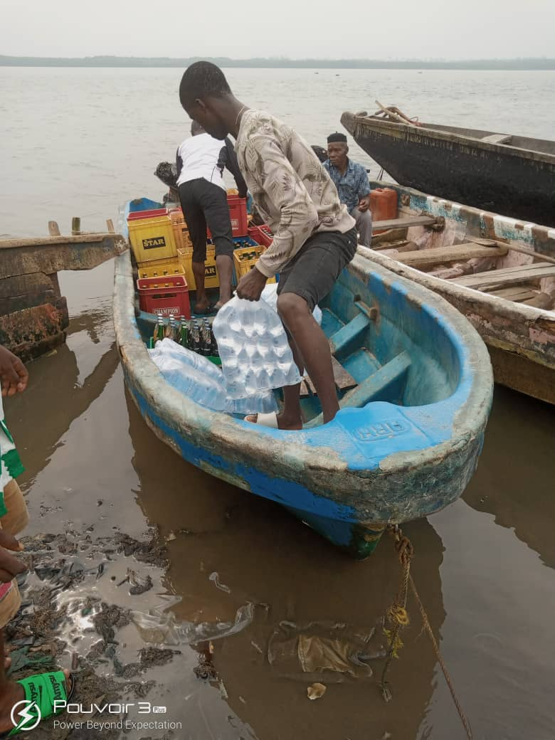 |  | 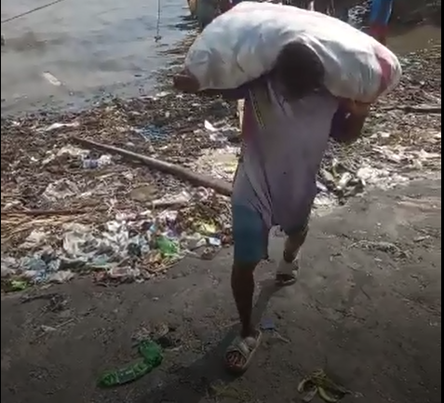
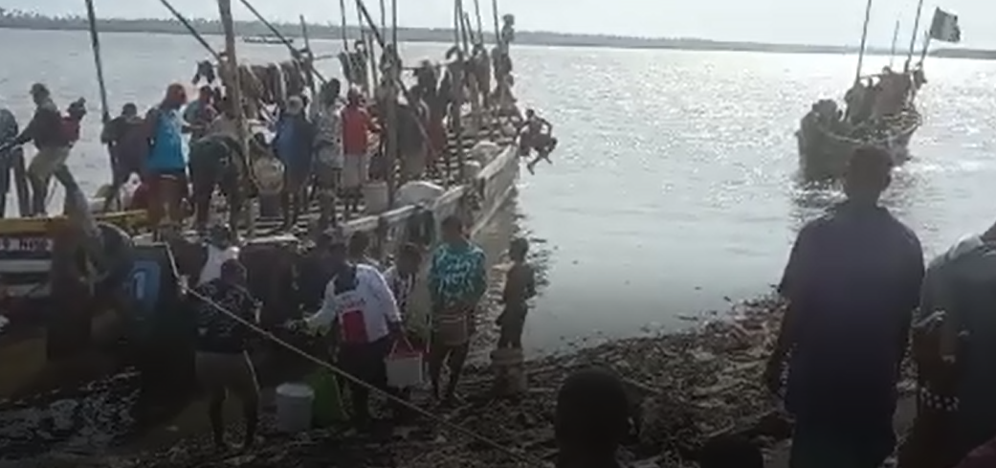 |  | 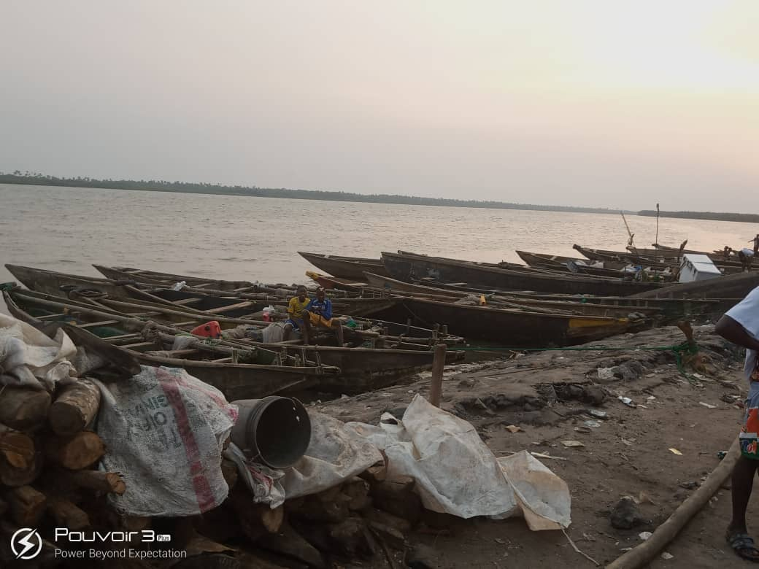
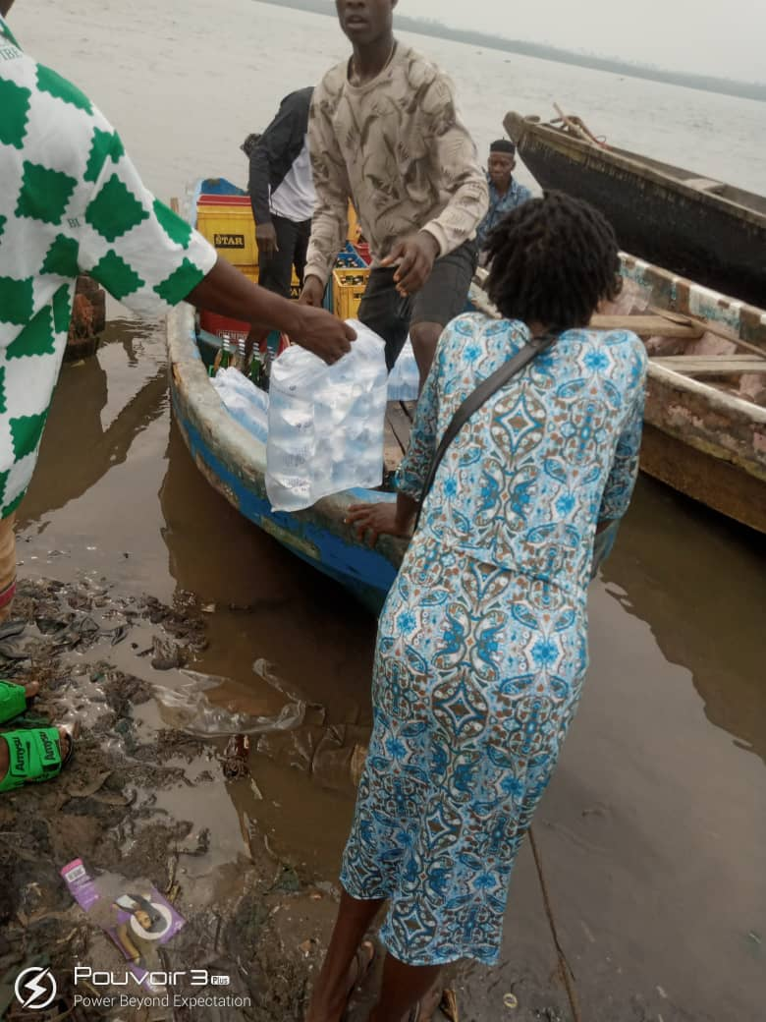 |  | 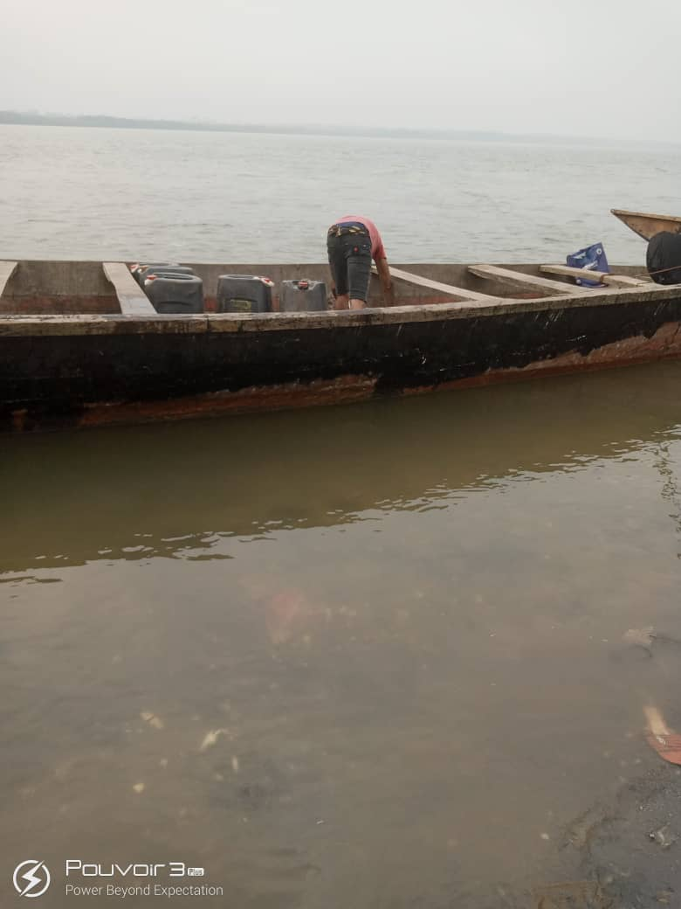
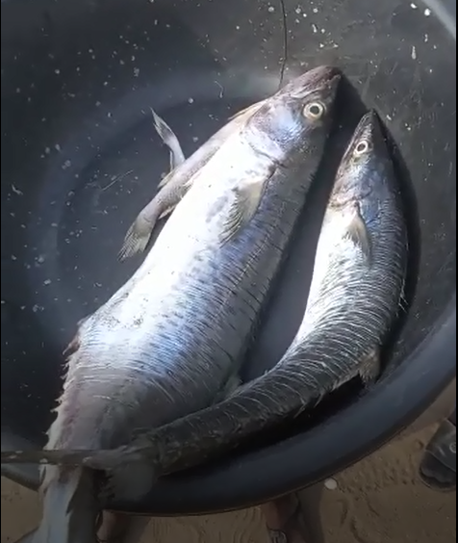 |  | 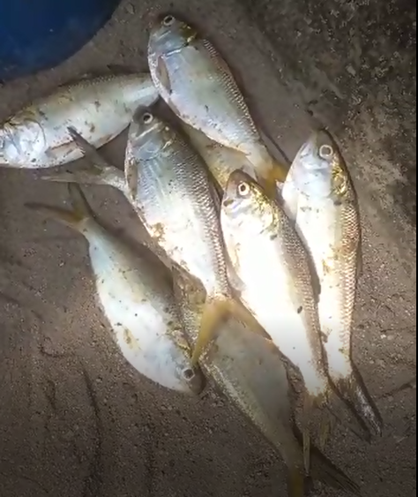
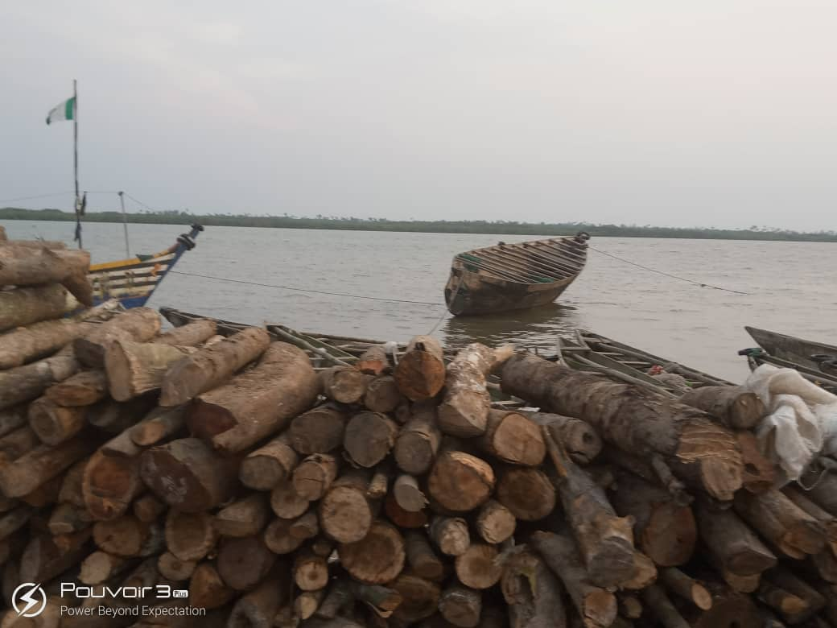 |  | 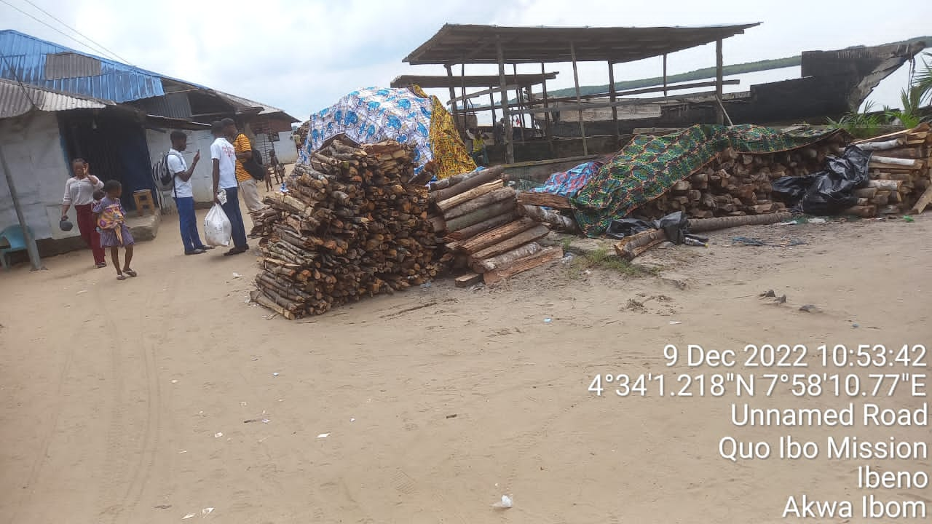
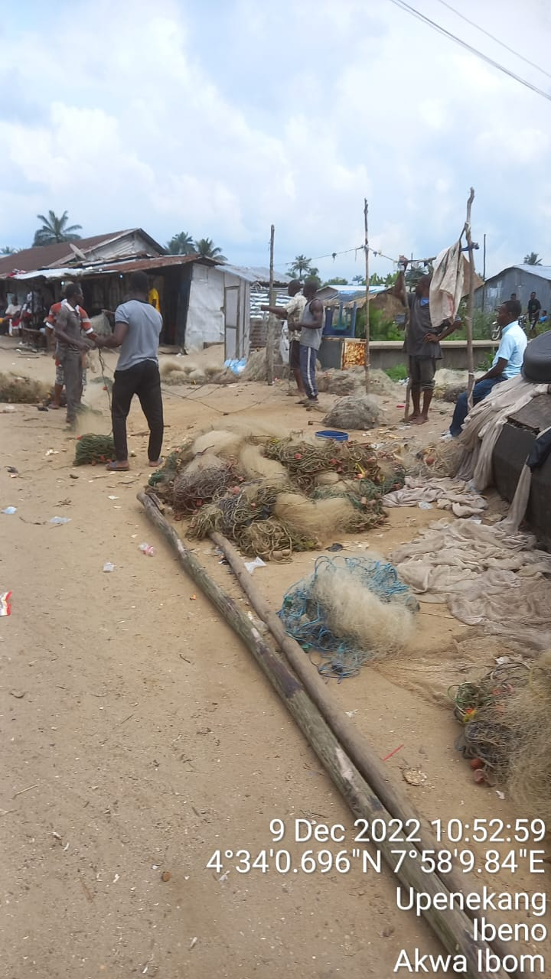 | 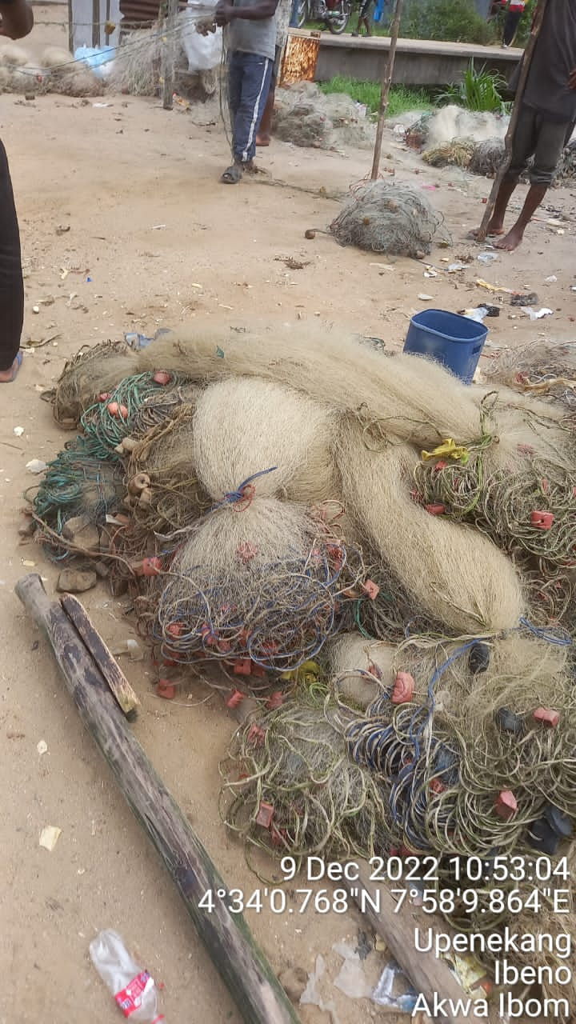 |  | 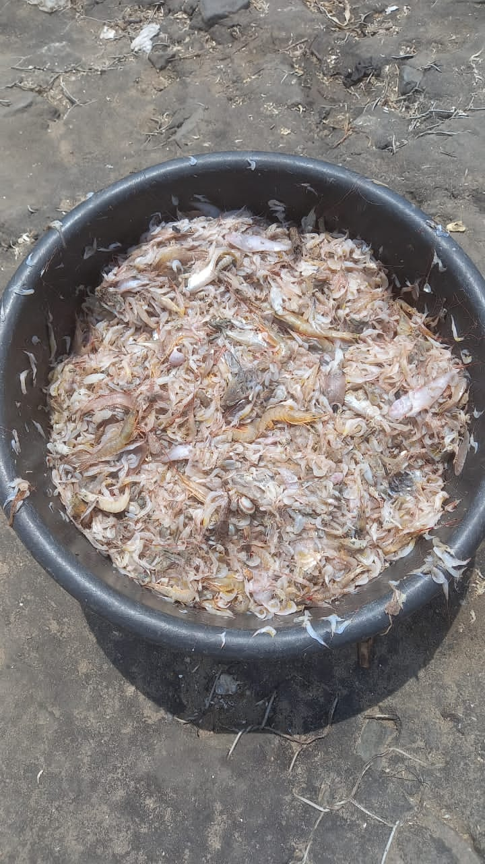
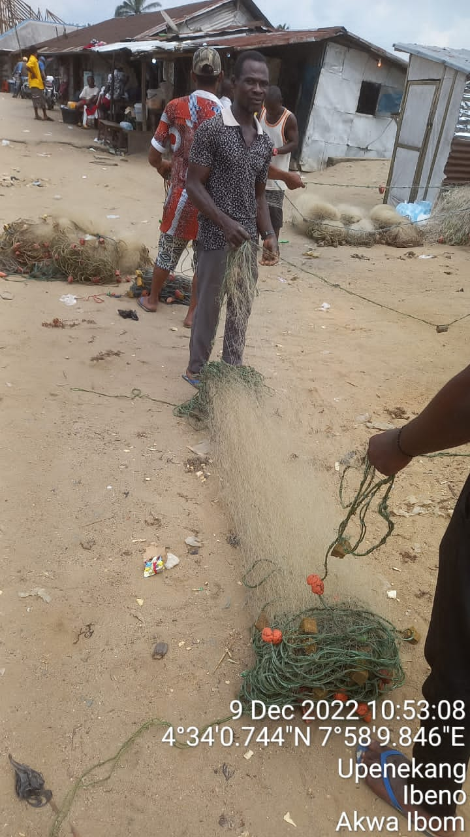 | 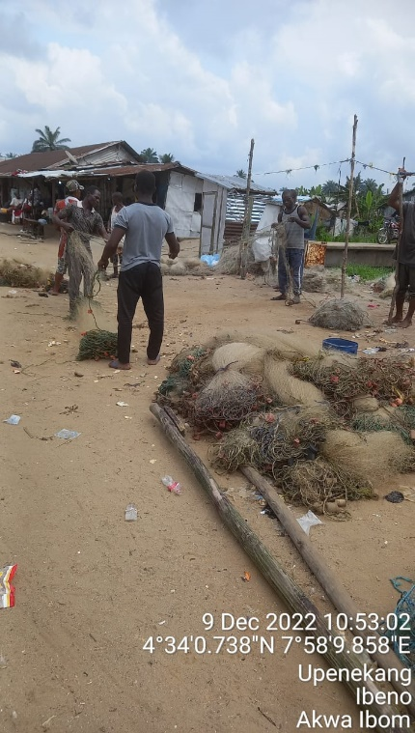 |  | 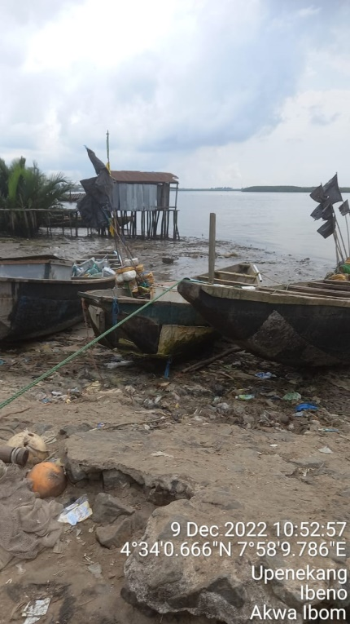

Name of communities visited with GPS locations
SN | Name of Village | Coordinate
 |  | Latitude | Longitude
 | Iwochang | 4.5681007 | 7.9744306
 | Iwochang | 4.5680733 | 7.9749544
 | Iwochang | 4.5681265 | 7.9753506
 | Iwochang | 4.5682857 | 7.9756912
 | Iwochang | 4.5683198 | 7.9762361
 | Iwochang | 4.5682600 | 7.9765150
 | Iwochang | 4.5682594 | 7.9765039
 | Iwochang | 4.5682577 | 7.9764939
 | Iwochang | 4.5682600 | 7.9764917
 | Iwochang | 4.5682640 | 7.9764773
 | Iwochang | 4.5682774 | 7.9765051
 | Iwochang | 4.5682390 | 7.9765304
 | Iwochang | 4.5682565 | 7.9765452
 | Mkpanak | 4.5495418 | 7.9942343
 | Mkpanak | 4.5504519 | 7.9949420
 | Mkpanak | 4.5532250 | 7.9919533
 | Mkpanak | 4.5535198 | 7.9921195
 | Mkpanak | 4.5534133 | 7.9919267
 | Mkpanak | 4.5534078 | 7.9919928
 | Mkpanak | 4.5533948 | 7.9920327
 | Mkpanak | 4.5534024 | 7.9918646
 | Mkpanak | 4.5534910 | 7.9920488
 | Mkpanak | 4.5535324 | 7.9920119
 | Mkpanak | 4.5534515 | 7.9921809
 | Mkpanak | 4.5534500 | 7.9920412
 | Mkpanak | 4.5531600 | 7.9920000
 | Mkpanak | 4.5534150 | 7.9919241
 | Mkpanak | 4.5534335 | 7.9920488
 | Mkpanak | 4.5534638 | 7.9920598
 | Mkpanak | 4.5534156 | 7.9920111
 | Mkpanak | 4.5534153 | 7.9920129
 | Mkpanak | 4.5532133 | 7.9920867
 | Mkpanak | 4.5533209 | 7.9920370
 | Mkpanak | 4.5533433 | 7.9919467
 | Mkpanak | 4.5533457 | 7.9919046
 | Mkpanak | 4.5533909 | 7.9919254
 | Mkpanak | 4.5532458 | 7.9921074
 | Mkpanak | 4.5535001 | 7.9917262
 | Mkpanak | 4.5539496 | 7.9922419
 | Mkpanak | 4.5534292 | 7.9919744
 | Mkpanak | 4.5533592 | 7.9919465
 | Mkpanak | 4.5535117 | 7.9919533
 | Mkpanak | 4.5534398 | 7.9919733
 | Mkpanak | 4.5534544 | 7.9917038
 | Mkpanak | 4.5535017 | 7.9916599
 | Mkpanak | 4.5534233 | 7.9915753
 | Mkpanak | 4.5534385 | 7.9915361
 | Mkpanak | 4.5534751 | 7.9914067
 | Mkpanak | 4.5534104 | 7.9914100
 | Mkpanak | 4.5534492 | 7.9912506
 | Mkpanak | 4.5533680 | 7.9912255
 | Mkpanak | 4.5533873 | 7.9912082
 | Mkpanak | 4.5534328 | 7.9916506
 | Mkpanak | 4.5534233 | 7.9916400
 | Mkpanak | 4.5534382 | 7.9915794
 | Mkpanak | 4.5534393 | 7.9916710
 | Mkpanak | 4.5534243 | 7.9915637
 | Mkpanak | 4.5534346 | 7.9916402
 | Mkpanak | 4.5533960 | 7.9916559
 | Upenekang | 4.5735631 | 7.9902784
 | Upenekang | 4.5735097 | 7.9902853
 | Upenekang | 4.5734744 | 7.9904301
 | Upenekang | 4.5735115 | 7.9903097
 | Upenekang | 4.5735539 | 7.9903776
 | Upenekang | 4.5735623 | 7.9903177
 | Upenekang | 4.5735692 | 7.9903174
 | Upenekang | 4.5735476 | 7.9903318
 | Upenekang | 4.5734777 | 7.9903324
 | Upenekang | 4.5734914 | 7.9901782
 | Upenekang | 4.5735204 | 7.9901934
 | Upenekang | 4.5735333 | 7.9902767
 | Upenekang | 4.5735337 | 7.9902840
 | Upenekang | 4.5735286 | 7.9902937
 | Ibeno | 4.5740230 | 7.9893217
 | Upenekang | 4.5740417 | 7.9892764
 | Upenekang | 4.5740801 | 7.9891553
 | Upenekang | 4.5736533 | 7.9884359
 | Upenekang | 4.5736456 | 7.9884829
 | Upenekang | 4.5736804 | 7.9884911
 | Upenekang | 4.5736652 | 7.9884375
 | Upenekang | 4.5736961 | 7.9884390
 | Upenekang | 4.5740268 | 7.9894544
 | Upenekang | 4.5739964 | 7.9894249
 | Upenekang | 4.5740113 | 7.9894146
 | Upenekang | 4.5740670 | 7.9893856
 | Upenekang | 4.5740254 | 7.9893717
 | Upenekang | 4.5739583 | 7.9893376
 | Upenekang | 4.5740650 | 7.9893826
 | Upenekang | 4.5741238 | 7.9892039
 | Upenekang | 4.5740355 | 7.9892159
 | Upenekang | 4.5740688 | 7.9892396
 | Upenekang | 4.5741144 | 7.9892672
 | Upenekang | 4.5740164 | 7.9892717
 | Iwuoachang | 4.5741661 | 7.9894773
 | Iwuoachang | 4.5674201 | 7.9702206
 | Upenekang | 4.5735385 | 7.9901666
 | Upenekang | 4.5735200 | 7.9902058
 | Upenekang | 4.5735304 | 7.9902233
 | Upenekang | 4.5734958 | 7.9901757
 | Upenekang | 4.5735137 | 7.9901176
 | Upenekang | 4.5735100 | 7.9902570
 | Upenekang | 4.5735681 | 7.9901798
 | Upenekang | 4.5735623 | 7.9902588
 | Upenekang | 4.5735906 | 7.9902022
 | Upenekang | 4.5735761 | 7.9902463
 | Upenekang | 4.5735027 | 7.9902291
 | Upenekang | 4.5735149 | 7.9902455
 | Upenekang | 4.5734904 | 7.9903343
 | Upenekang | 4.5734912 | 7.9903132
 | Upenekang | 4.5735382 | 7.9902084
 | Upenekang | 4.5734452 | 7.9902322
 | Upenekang | 4.5735306 | 7.9902295
 | Upenekang | 4.5734934 | 7.9902193
 | Iwochang | 4.5682624 | 7.9765359
 | Iwochang | 4.5682533 | 7.9765264
 | Iwochang | 4.5676300 | 7.9706717
 | Iwochang | 4.5676300 | 7.9706717
 | Iwochang | 4.5676766 | 7.9706677
 | Iwochang | 4.5685207 | 7.9727390
 | Iwochang | 4.5682500 | 7.9765267
 | Iwochang | 4.5682550 | 7.9764902
 | Iwochang | 4.5682278 | 7.9764536
 | Iwochang | 4.5682520 | 7.9764860
 | Iwochang | 4.5682509 | 7.9765237
 | Iwochang | 4.5682667 | 7.9764900
 | Iwochang | 4.5682601 | 7.9764838
 | Iwochang | 4.5682468 | 7.9764767
 | Iwochang | 4.5682727 | 7.9764757
 | Iwochang | 4.5682657 | 7.9764924
 | Iwochang | 4.5682442 | 7.9764814
 | Obenekan | 4.5683677 | 7.9764739
 | Iwochang | 4.5699113 | 7.9763415
 | Iwochang | 4.5694732 | 7.9774073
 | Iwochang | 4.5689698 | 7.9789344
 | Iwochang | 4.5680017 | 7.9804517
 | Iwochang | 4.5662871 | 7.9800094
 | Iwochang | 4.5663123 | 7.9794171
 | Iwochang | 4.5675179 | 7.9808103
 | Iwochang | 4.5690718 | 7.9786021
 | Iwochang | 4.5681517 | 7.9755717
 | Iwochang | 4.5680691 | 7.9734398
 | Iwochang | 4.5669660 | 7.9694398
 | Iwochang | 4.5669185 | 7.9694127
 | Iwochang | 4.5669416 | 7.9693707
 | Iwochang | 4.5670137 | 7.9693789
 | Iwochang | 4.5693925 | 7.9696357
 | Iwochang | 4.5683767 | 7.9709135
 | Iwochang | 4.5676928 | 7.9714977
 | Iwochang | 4.5677408 | 7.9715082
 | Iwochang | 4.5677326 | 7.971545
 | Iwochang | 4.5677943 | 7.9715137
 | Iwochang | 4.5677899 | 7.9715167
 | Iwochang | 4.5677834 | 7.9715321
 | Iwochang | 4.5662309 | 7.9678872
 | Iwochang | 4.5672447 | 7.9706340
 | Iwochang | 4.5673983 | 7.9707217
 | Iwochang | 4.5674003 | 7.9707214
 | Iwochang | 4.5674465 | 7.9707581
 | Iwochang | 4.5675233 | 7.9707583
 | Iwochang | 4.5657708 | 7.9663832
 | Iwochang | 4.5673431 | 7.9709780
 | Iwochang | 4.5672542 | 7.9708718
 | Iwochang | 4.5673473 | 7.9706562
 | Iwochang | 4.5672832 | 7.9707539
 | Iwochang | 4.5672873 | 7.9706865
 | Iwochang | 4.5672158 | 7.9706966
 | Iwochang | 4.5673749 | 7.9706000
 | Iwochang | 4.5672945 | 7.9707036
 | Iwochang | 4.5823852 | 7.9900329
 | Iwochang | 4.5657344 | 7.9664199
 | Iwochang | 4.5657400 | 7.9664250
 | Iwochang | 4.5677593 | 7.9712550
 | Iwochang | 4.5677557 | 7.9712497
 | Iwochang | 4.5674100 | 7.9710024
 | Iwochang | 4.5657383 | 7.9664217
 | Iwochang | 4.5657854 | 7.9664855
 | Iwochang | 4.5657792 | 7.9664409
 | Iwochang | 4.5671142 | 7.9711685
 | Iwochang | 4.5679168 | 7.9722787
 | Iwochang | 4.5673168 | 7.9708011
 | Iwochang | 4.5672597 | 7.9706197
 | Iwochang | 4.5672730 | 7.9707001
 | Iwochang | 4.5673351 | 7.9707091
 | Iwochang | 4.5673586 | 7.9706831
 | Iwochang | 4.5675405 | 7.9706871
 | Iwochang | 4.5672923 | 7.9706848
 | Iwochang | 4.5674058 | 7.9708092
 | Iwochang | 4.5673246 | 7.9707123
 | Iwochang | 4.5673536 | 7.9707643
 | Iwochang | 4.5671396 | 7.9714837
 | Iwochang | 4.5683286 | 7.9709942
 | Iwochang | 4.5672848 | 7.9708167
 | Iwochang | 4.5674796 | 7.9706401
 | Iwochang | 4.5674440 | 7.9705850
 | Iwochang | 4.5674540 | 7.9705890
 | Iwochang | 4.5674335 | 7.9704683
 | Iwochang | 4.5674950 | 7.9706185
 | Iwochang | 4.5674964 | 7.9706550
 | Iwochang | 4.5674451 | 7.9705969
 | Iwochang | 4.5674498 | 7.9706148
 | Iwochang | 4.5674693 | 7.9706660
 | Iwochang | 4.5674999 | 7.9706084
 | Iwochang | 4.5675001 | 7.9706115
 | Iwochang | 4.5674943 | 7.9706363
 | Iwochang | 4.5675769 | 7.9706359
 | Iwochang | 4.5675359 | 7.9706865
 | Iwochang | 4.5674755 | 7.9706682
 | Iwochang | 4.5674816 | 7.9707010
 | Iwochang | 4.5674768 | 7.9706564
 | Iwochang | 4.5674475 | 7.9706669
 | Iwochang | 4.5673995 | 7.9706969
 | Iwochang | 4.5674094 | 7.9706621
 | Iwochang | 4.5674559 | 7.9706964
 | Iwochang | 4.5673564 | 7.9705160
 | Iwochang | 4.5674008 | 7.9706706
 | Iwochang | 4.5673553 | 7.9706470
 | Iwochang | 4.5674533 | 7.9706800
 | Iwochang | 4.5674451 | 7.9706725
 | Iwochang | 4.5674730 | 7.9706837
 | Iwochang | 4.5674598 | 7.9706479
 | Iwochang | 4.5674750 | 7.9707467
 | Iwochang | 4.5674812 | 7.9707590
 | Iwochang | 4.5672565 | 7.9702898
 | Iwochang | 4.5674470 | 7.9708049
 | Iwochang | 4.5674089 | 7.9706491
 | Iwochang | 4.5674032 | 7.9706882
 | Iwochang | 4.5680848 | 7.9714036
 | Iwochang | 4.5673051 | 7.9707259
 | Iwochang | 4.5673133 | 7.9707763
 | Iwochang | 4.5673204 | 7.9707768
 | Iwochang | 4.5672950 | 7.9707583
 | Iwochang | 4.5670283 | 7.9709700
 | Iwochang | 4.5673432 | 7.9706394
 | Iwochang | 4.5673714 | 7.9706221
 | Iwochang | 4.5673892 | 7.9706108
 | Iwochang | 4.5673604 | 7.9706250
 | Iwochang | 4.5673518 | 7.9706643
 | Iwochang | 4.5673006 | 7.9706411
 | Iwochang | 4.5673979 | 7.9707352
 | Iwochang | 4.5673371 | 7.9706635
 | Iwochang | 4.5673395 | 7.9706633
 | Iwochang | 4.5673118 | 7.9707404
 | Iwochang | 4.5673283 | 7.9706653
 | Iwochang | 4.5673333 | 7.9706283
 | Iwochang | 4.5673142 | 7.9706218
 | Iwochang | 4.5673152 | 7.9707948
 | Iwochang | 4.5673417 | 7.9705755
 | Iwochang | 4.5673776 | 7.9706237
 | Iwuo-okpom | 4.5673710 | 7.9706263
 | Iwuo-okpom | 4.5336393 | 7.9114842
 | Iwuo-okpom | 4.5336296 | 7.9114665
 | Iwuo-okpom | 4.5336602 | 7.9114637
 | Iwuo-okpom | 4.5336601 | 7.9114716
 | Iwuo-okpom | 4.5336496 | 7.9115177
 | Iwuo-okpom | 4.5337208 | 7.9114742
 | Iwuo-okpom | 4.5337400 | 7.9115117
 | Iwuo-okpom | 4.5336496 | 7.9115211
 | Ibeno | 4.5326518 | 7.9128000
 | Eastern obolo | 4.5327592 | 7.9146999
 | Iwuo-okpom | 4.5436548 | 7.9293852
 | Iwuoachang | 4.5673035 | 7.9707600
 | Iwuoachang | 4.5673152 | 7.9707737
 | Ibeno | 4.5673094 | 7.9707940
 | Iwuoachang | 4.5673718 | 7.9708324
 | Iwuoachang | 4.5673237 | 7.9707417
 | Iwuoachang | 4.5672178 | 7.9706389
 | Iwuoachang | 4.5672418 | 7.9707461
 | Iwuoachang | 4.5671949 | 7.9707258
 | Iwuoachang | 4.5672185 | 7.9707710
 | Iwuoachang | 4.5672352 | 7.9707216
 | Iwuoachang | 4.5672182 | 7.9707014
 | Iwuoachang | 4.5672170 | 7.9706606
 | Iwuoachang | 4.5671969 | 7.9706425
 | Iwuoachang | 4.5672233 | 7.9706330
 | Iwuoachang | 4.5672308 | 7.9707359
 | Iwuokpom | 4.5434896 | 7.9293930
 | Iwuokpom | 4.5421528 | 7.9292108
 | Iwuokpom | 4.5338640 | 7.9139309
 | Iwuokpom | 4.5338751 | 7.9140089
 | Iwuokpom | 4.5338569 | 7.9139803
 | Iwuokpom | 4.5338767 | 7.9139483
 | Akata | 4.5296880 | 7.8787954
 | Akata | 4.5293997 | 7.8780303
 | Akata | 4.5293443 | 7.8768466
 | Akata | 4.5292705 | 7.8764723
 | Akata | 4.5295052 | 7.8763969
 | Akata | 4.5296122 | 7.8764556
 | Akata | 4.5296511 | 7.8764349
 | Akata | 4.5293617 | 7.8764233
 | Akata | 4.5295038 | 7.8768179
 | Akata | 4.5294678 | 7.8770200
 | Akata | 4.5294936 | 7.8769262
 | Akata | 4.5293703 | 7.8769311
 | Akata | 4.5294176 | 7.8775844
 | Akata | 4.5293981 | 7.8775981
 | Akata | 4.5295610 | 7.8781202
 | Akata | 4.5294184 | 7.8780634
 | Akata | 4.5293140 | 7.8780972
 | Akata | 4.5295365 | 7.8787917
 | Akata | 4.5297890 | 7.8791710
 | Akata | 4.5298801 | 7.8799423
 | Akata | 4.5297837 | 7.8805560
 | Akata | 4.5296377 | 7.8805231
 | Akata | 4.5297918 | 7.8803584
 | Akata | 4.5297441 | 7.8804522
 | Iwuo okpom | 4.5329177 | 7.9164923
 | Ibeno | 4.5332700 | 7.9191219
 | Iwuokpom | 4.5339777 | 7.9198422
 | Iwuokpom opolom | 4.5337391 | 7.9179088
 | Iwuokpom | 4.5337067 | 7.9168333
 | Iwuokpom opolom | 4.5336530 | 7.9157737
 | Oron | 4.5336684 | 7.9157116
 | Iwuokpom | 4.5334486 | 7.9146337
 | Iwuoachang | 4.5435278 | 7.9297590
 | Iwuoachang | 4.5672477 | 7.9708578
 | Upenekang | 4.5729652 | 7.9862548
 | Upenekang | 4.5728509 | 7.9863118
 | Upenekang | 4.5727927 | 7.9862766
 | Upenekang | 4.5740590 | 7.9871323
 | Upenekang | 4.5740232 | 7.9870550
 | Upenekang | 4.5750465 | 7.9887227
 | Upenekang | 4.5749254 | 7.9897794
 | Upenekang | 4.5755593 | 7.9885842
 | Upenekang | 4.5755707 | 7.9885977
 | Upenekang | 4.5740942 | 7.9891158
 | Upenekang | 4.5738944 | 7.9890769
 | Upenekang | 4.5740240 | 7.9892297
 | Upenekang | 4.5740631 | 7.9892880
 | Upenekang | 4.5739733 | 7.9893343
 | Upenekang | 4.5738551 | 7.9896135
 | Upenekang | 4.5740611 | 7.9894695
 | Upenekang | 4.5741027 | 7.9890640
 | Upenekang | 4.5740605 | 7.9890769
 | Upenekang | 4.5740888 | 7.9890367
 | Upenekang | 4.5736898 | 7.9890625
 | Upenekang | 4.5736223 | 7.9889736
 | Upenekang | 4.5735822 | 7.9890202
 | Upenekang | 4.573701 | 7.9891958
 | Upenekang | 4.5737535 | 7.9892054
 | Upenekang | 4.5740353 | 7.9893060
 | Upenekang | 4.5742403 | 7.9893347
 | Upenekang | 4.5772899 | 7.9917857
 | Upenekang | 4.5784007 | 7.9938942
 | Upenekang | 4.5784101 | 7.9938543
 | Upenekang | 4.5787880 | 7.9937457
 | Upenekang | 4.5790140 | 7.9936872
 | Upenekang | 4.5789825 | 7.9937140
 | Upenekang | 4.5682813 | 7.9764975
 | Upenekang | 4.5682022 | 7.9764404
 | Upenekang | 4.5682371 | 7.9763930
 | Iwuoachang | 4.5672929 | 7.9725449
 | Iwuoachang | 4.5672813 | 7.9725437
 | Iwuoachang | 4.5674286 | 7.9724890
 | Iwuoachang | 4.5672725 | 7.9707727
 | Upenekang | 4.5691230 | 7.9707556
 | Iwochang | 4.5682737 | 7.9707787
 | Iwochang | 4.5681233 | 7.9708890
 | Iwochang | 4.5683021 | 7.9707980
 | Iwochang | 4.5683234 | 7.9709002
 | Iwochang | 4.5682718 | 7.9707483
 | Iwochang | 4.5683192 | 7.9708391
 | Iwochang | 4.5682728 | 7.9707839
 | Iwochang | 4.5682775 | 7.9708247
 | Iwochang | 4.5683051 | 7.9707838
 | Iwochang | 4.5683312 | 7.9706336
 | Upenekang | 4.5701510 | 7.9795827
 | Upenekang | 4.570959 | 7.9793980
 | Mkpanak | 4.5722991 | 7.9793836
 | Upenekang | 4.5723625 | 7.9793847
 | Upenekang | 4.5708750 | 7.9693517
 | Iwochang | 4.5710855 | 7.9693044
 | Iwochang | 4.5708900 | 7.9693039
 | Iwochang | 4.5704066 | 7.9695406
 | Iwochang | 4.5703691 | 7.9696602
 | Iwochang | 4.5701670 | 7.9697254
 | Iwochang | 4.5697850 | 7.9699367
 | Iwochang | 4.5695669 | 7.9656519
 | Iwochang | 4.5690455 | 7.9687718
 | Iwochang | 4.5681539 | 7.9688593
 | Iwochang | 4.5676794 | 7.9707515
 | Iwochang | 4.5675726 | 7.9705455
 | Iwochang | 4.5676938 | 7.9716244
 | Iwochang | 4.5672307 | 7.9708002
 | Iwochang | 4.5673230 | 7.9706165
 | Iwochang | 4.5669333 | 7.9808999
 | Iwochang | 4.5664183 | 7.9799228
 | Iwochang | 4.5667592 | 7.9805592
 | Iwochang | 4.5689330 | 7.9790485
 | Iwochang | 4.5698485 | 7.9760378
 | Iwochang | 4.5681081 | 7.9742044
 | Iwochang | 4.5695018 | 7.9694983
 | Iwochang | 4.5681873 | 7.9713620
 | Iwochang | 4.5678654 | 7.9713634
 | Iwochang | 4.5677465 | 7.9713985
 | Iwochang | 4.5677023 | 7.9714990
 | Iwochang | 4.5677117 | 7.9714551
 | Iwochang | 4.5657810 | 7.9664188
 | Iwochang | 4.5656523 | 7.966489
 | Iwochang | 4.5656000 | 7.9664567
 | Iwochang | 4.5656146 | 7.9663915
 | Iwochang | 4.5656775 | 7.9664420
 | Iwochang | 4.5661754 | 7.9677332
 | Iwochang | 4.5667476 | 7.9689692
 | Iwochang | 4.5670901 | 7.9706490
 | Iwochang | 4.5673032 | 7.9707084
 | Iwochang | 4.5672371 | 7.9707116
 | Iwochang | 4.5672886 | 7.9707281
 | Iwochang | 4.5670352 | 7.9708103
 | Iwochang | 4.5672723 | 7.9707885
 | Iwochang | 4.5673350 | 7.9706533
 | Iwochang | 4.5672417 | 7.9707351
 | Iwochang | 4.5671718 | 7.9716490
 | Iwochang | 4.5670952 | 7.9711108
 | Iwochang | 4.5677783 | 7.9711466
 | Iwochang | 4.5673297 | 7.9707512
 | Upenekang | 4.5683452 | 7.9764411
 | Upenekang | 4.5681875 | 7.9764926
 | Upenekang | 4.5682198 | 7.9765217
 | Upenekang | 4.5681781 | 7.9764615
 | Upenekang | 4.5681137 | 7.9762897
 | Iwochang | 4.5680649 | 7.9763732
 | Iwochang | 4.5673336 | 7.9730574
 | Iwochang | 4.5672771 | 7.9724610
 | Iwochang | 4.5672595 | 7.9724293
 | Iwochang | 4.5672603 | 7.9724353
 | Iwochang | 4.5673644 | 7.9724796
 | Iwochang | 4.5673661 | 7.9725071
 | Iwochang | 4.5673453 | 7.9725257
 | Iwochang | 4.5673067 | 7.9725200
 | Iwochang | 4.5673435 | 7.9725756
 | Iwochang | 4.5678987 | 7.9707358
 | Iwochang | 4.5679048 | 7.9707462
 | Iwochang | 4.5689392 | 7.9708260
 | Iwochang | 4.5683435 | 7.9710462
 | Iwochang | 4.5683125 | 7.9707757
 | Iwochang | 4.5683178 | 7.9707666
 | Iwochang | 4.5683374 | 7.9707991
 | Iwochang | 4.5682775 | 7.9708042
 | Iwochang | 4.5682820 | 7.9708414
 | Iwochang | 4.5682850 | 7.9707983
 | Iwochang | 4.5682511 | 7.9707478
 | Iwochang | 4.5682997 | 7.9708582
 | Iwochang | 4.5682765 | 7.9707816
 | Iwochang | 4.5682113 | 7.9707676
 | Iwochang | 4.5672685 | 7.9707654
 | Iwochang | 4.5711914 | 7.9692817
 | Iwochang | 4.5712786 | 7.9693767
 | Iwochang | 4.5672611 | 7.9707900
 | Iwochang | 4.5672496 | 7.9707632
 | Etim Ekpo | 4.5672583 | 7.9707937
 | Nsit Ibium | 4.5696059 | 7.9699306
 | Iwochang | 4.5687409 | 7.9685959
 | Iwochang | 4.5681596 | 7.9688893
 | Iwochang | 4.5673735 | 7.9724955
 | Iwochang | 4.5674025 | 7.9725014
 | Iwochang | 4.5673243 | 7.9724779
 | Iwochang | 4.5673132 | 7.9724596
 | Iwochang | 4.5672934 | 7.9723886
 | Iwochang | 4.5672305 | 7.9723848
 | Iwochang | 4.5672472 | 7.9723647
 | Iwochang | 4.5672246 | 7.9724118
 | Iwochang | 4.5672221 | 7.9724283
 | Iwochang | 4.5671150 | 7.9715417
 | Iwochang | 4.5670884 | 7.9712956
 | Iwochang | 4.5671281 | 7.9713235
 | Iwochang | 4.5670862 | 7.9713385
 | Iwochang | 4.5670947 | 7.9712323
 | Iwochang | 4.5670750 | 7.9712617
 | Iwochang | 4.5671017 | 7.9712437
 | Iwochang | 4.5670767 | 7.9712317
 | Iwochang | 4.5670795 | 7.9712098
 | Iwochang | 4.5670803 | 7.9712121
 | Iwochang | 4.5670506 | 7.9712491
 | Iwochang | 4.5670683 | 7.9712117
 | Iwochang | 4.5670350 | 7.9712583
 | Iwochang | 4.5680974 | 7.9739203
 | Iwochang | 4.5680450 | 7.9752200
 | Iwochang | 4.5680450 | 7.9752200
 | Iwochang | 4.5681250 | 7.9752100
 | Iwochang | 4.5673107 | 7.9706297
 | Iwochang | 4.5672917 | 7.9706883
 | Iwochang | 4.5673383 | 7.9707119
 | Iwochang | 4.5673066 | 7.9707532
 | Iwochang | 4.5673466 | 7.9707081
 | Iwochang | 4.5673392 | 7.9707593
 | Iwochang | 4.5673095 | 7.9707308
 | Iwochang | 4.5663800 | 7.9714574
 | Iwochang | 4.5246728 | 8.0102458
 | Iwochang | 4.5157782 | 8.0372689
 | Iwochang | 4.5670389 | 7.9711730
 | Iwochang | 4.5672605 | 7.9707475
 | Iwochang | 4.5672448 | 7.9707475

