SOCIO-ECONOMIC STUDIES

1.0 Study Approach and Methodology
This document provides details of the socio-economic and health assessment of the proposed UTM FLNG Project Affected Persons (PAPs). The Project Affected Persons (PAPs) are the people whose livelihood activities may be directly or indirectly affected by the proposed Project. Such people include fishermen, boat operators, traders etc. who occupy the shores and navigate the sea where the proposed project will be situated. This baseline assessment provides a description of existing conditions which is essential to the identification and assessment of the potential impacts of the proposed project. The assessment covers the pre-project human conditions of people at the shoreline with a view to predicting and mitigating any possible adverse future impact of the project on their socio-economic and health conditions.
The project site is located 60km offshore, hence, the target population consisted of people at the shoreline whose livelihood may likely be affected by the project. The study employed sequential mixed methods research design including quantitative and qualitative methods of data gathering, analysis and reporting. Information collected during the study was triangulated to separate perception from reality. The study was carried out from 9th to 15th December, 2022. The study made use of a questionnaire for quantitative data gathering, while Key Informant Interviews (KII) was adopted for the qualitative data gathering.
During data gathering, only the population who gave informed consent were studied, this study made use of Computer Assisted Personal Interviewing (CAPI) Software using a smartphone and assisted by competent survey enumerators. A 10% non-response rate was added as a standard practice with the speculation that some respondents within the study area may refuse to participate or some may withdraw in the middle of the interview, thus, the sample size was 500 respondents, out of which 492 responses were complete and analysed for the study. The systematic sampling technique employed ensures a fair representation of both males and females among the respondents.
The Key Informant Interview (KII) sessions revealed that most PAPs are artisans such as plumbers, welders, hairstylists, mechanics etc., and those that engage in trading activities such as selling of fish, crayfish, seafood, firewood, petroleum and engine oil, provisions etc. as their means of livelihood. As gathered from the respondents during the survey, the major challenges facing them include lack of public conveniences, lack of educational facilities, lack of potable water, flooding, lack of good health care facilities, etc.

1.1 Age Group and Gender Distribution
Age Structure of sampled respondents
Analysis of the data obtained indicated that the majority (43.5%) of the respondents were youths aged within the age bracket of 25-35 years (Figure 1), although, an appreciable proportion (27.85%) were also aged between 35-45 years, while those aged 65 years and above are fewest, constituting less than 2%.
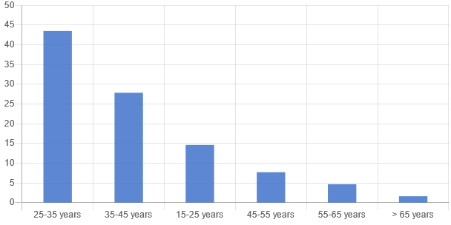
Figure 1: Age Distribution of the sampled respondents
Source: Richflood field survey, 2022

Gender
The analysis of the data obtained from the sampled respondents shows that majority of the respondents representing 68.9% are male, while 31.11% are female.
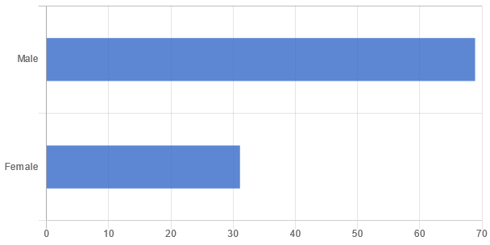
Figure 2: Gender Distribution of the Sampled Respondents
Source: Richflood field survey, 2022

1.2 Educational Attainment/ Literacy Level
An appreciable proportion of the sampled population has received some formal educational training indicating a satisfactory literate society. The modal educational attainment amongst the PAPs is the primary educational level. About 58.13% of the sampled population have Secondary school education and 14.43% have some form of tertiary education (NCE/HND/B.Sc.). However, about 5.69% reported having No Formal Education (NFE) (Figure 3).
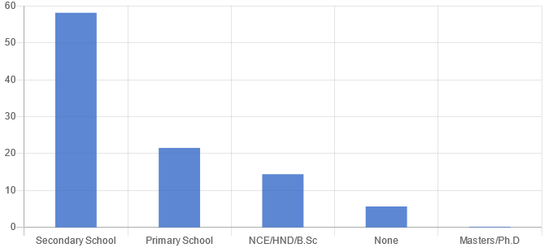
Figure 3: Educational attainment of respondents
Source: Richflood field survey, 2022

1.3 Religion Composition
There is an overwhelming affiliation (95.73%) to Christianity by the sampled respondents of the project area. Out of the remaining 4.27%, 3.86% are Muslims while 0.41% laid claim to the practice of the African Traditional Religion (ATR).
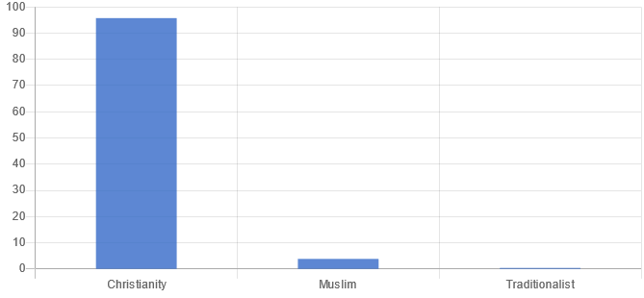
Figure 4: Religion Composition of the sampled Respondents
Source: Richflood field survey, 2022

1.4 Livelihood and Micro-Economy
1.4.1 Occupation and Employment
The occupational distribution of the sampled respondents reveals that the majority (53.46%) are traders/artisans, about 17.48% are into fishing, about 13% are students, and 2.85% are Company/Private firm workers. The category of others which made up about 6.3% of the sampled respondents includes Teachers, Bike riders etc.

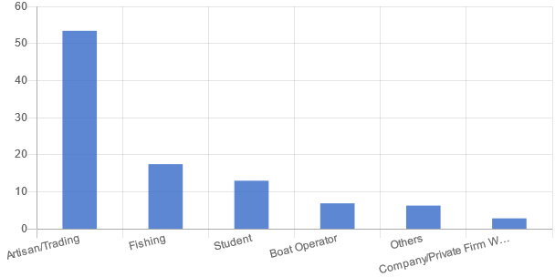
Figure 5: Primary occupation of respondents
Source: Richflood field survey, 2022

1.4.1.1 Fishing
Fishing is conducted along the surrounding creeks, slots/canals and deep into the Atlantic Ocean. Fish catch is seasonal and depends on tides. The commonest types of fish as obtained from the sampled respondents include Tilapia, Bonga, Crayfish, Crooker, Barracuda, Bonga fish, Catfish, Erure, Cherokee, Cod, Barracuda, Red snapper, Shinose, Tuna, Crooker fish, Plenty, Igborgbor, Crabfish. and periwinkles. However, some of the rare species of fish that can be found in the area include Akpanata, Jellyfish, Jellyfish, Cover pot, London boy, Cuttlefish, Crocker, Akapanta, Igborgbor fish, Gold Fish, Electric Fish, Catfish, and Shark.
In addition, as obtained from the sampled respondents, the average number of fish caught per day is estimated at 2,023. Fishing techniques employed remain largely unchanged from the traditional fishing method and include: hooks, lines, cast nets, drag nets, rapture nets, sweep nets, fish traps and conical baskets. As gathered from the sampled respondents, the month with the highest number of fish caught is December followed by September. However, the month with the lowest number of fish caught is June.
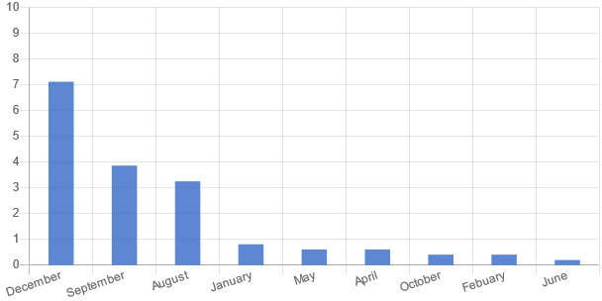
Figure 6: Fish catch per each month of the year
Source: Richflood field survey, 2022

Commercial and Consumption Fishing
The majority (66%) of the fishing activities are both for commercial and consumption purposes, while about 34% of the fishing activities are for only commercial purposes, as obtained from the sampled respondents. However, none of the respondents indicated that the fishing is only for consumption purposes.
1.4.1.2 Transportation Routes
An analysis of the transportation routes obtained from the boat operators indicated that none of the routes is linked with the location of the FLNG. This is because of the distance of the location of the proposed project to the shore. Thus, the FLNG facility will pose minimal or no navigational risks to commercial shipping during its operation. The project area may be traversed on occasion by mariners and fishermen but does not appear to overlap with any known and established sea lanes or fishing grounds

1.4.1.3 Vessel Types and Movements
Out of the 41 boat operators sampled, 27 respondents (65.8%) operate fishing vessels, while 14 respondents (34.1%) operate cargo vessels. In addition, the average number of trips they make per day is 5 trips.
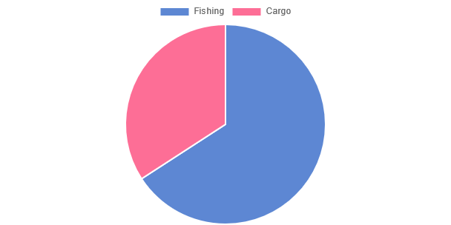
Figure 7: Types of Vessels operated
Source: Richflood field survey, 2022

1.5 Association/Cooperative Society
An analysis of the various types of associations and societies reveals that there are different kinds of associations based on occupation, and ethnic groups among others. Some of the associations/cooperative societies as obtained from the sampled respondents include the Nigerian welders’ association, Fishermen Association, Yoruba Parapo, and Bike Riders Association among others.

1.6 Income Level of the Sampled Respondents
Income is an important variable that influences the socioeconomic status of individuals, and its distribution pattern has the potential of influencing other demographic variables. However, the personal income levels of self-employed persons are always difficult to assess because many local people do not keep records and are therefore uncertain of the gross or net amount earned from self-endeavours.
Figure 8 shows the analysis of the monthly income distribution of the sampled respondents. It was revealed that the majority (43.5%) of the sampled respondents’ earnings are in the range of 50,000-100,000 naira monthly, while about 32% earn between 20,000-50,000 naira. However, just one respondent representing 0.2% of the total sampled respondents indicated earnings between 500,000-1,000,000 naira per month.
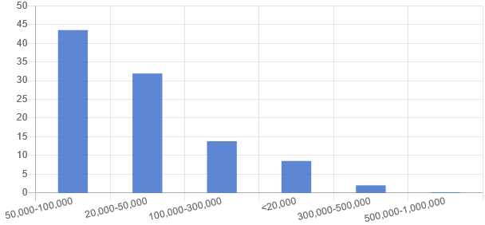
Figure 8: Average Monthly Income Distribution of Sampled Respondents
Source: Richflood field survey, 2022

1.7 Water Sources and Access
Access to potable water is an important determinant of health and one of the Sustainable Development Goals (SDGs). The sources of drinking water obtained from the sampled respondents are shown in Figure 9. Borehole was shown to be the most common source of drinking water (87.8%), followed by well sources (20.5%) and then stream/river (6.7%), while others (including sachet and bottled water sources) represent 2.4%.

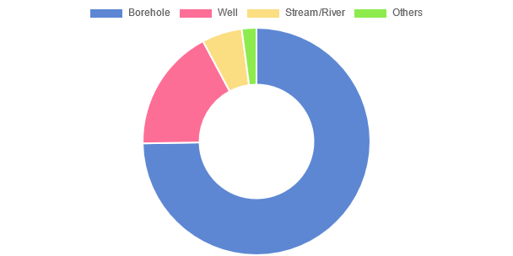
Figure 9: Sources of Drinking Water
Source: Richflood field survey, 2022

1.8 Access to Sanitary Faecal Disposal
Sanitary disposal of faeces is another important determinant of health. Sanitary disposal of faeces reduces the risk of faecal-orally transmitted infections like cholera and other diarrhoeal diseases, typhoid, amoebiasis and intestinal helminthiasis. Access to sanitary faecal disposal/sanitation facilities is another Sustainable Development Goal. The commonest form of Sanitary Faecal Disposal as obtained from the sampled respondents is Pit Toilet (55.89%), followed by water system (43.09%), Open defaecation (30.89%) and through Bush (9.15%).

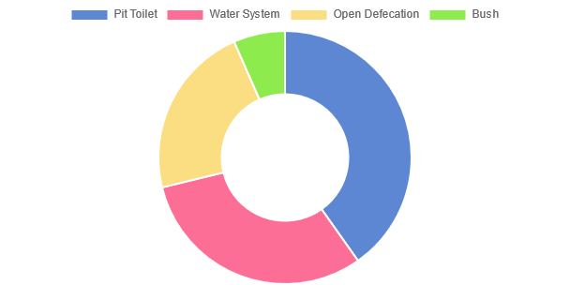
Figure 10: Toilet Systems
Source: Richflood field survey, 2022

1.9 Methods of Solid Waste Disposal
Out of the 492 sampled respondents, 65.24% and 36.38% indicated that the method of solid waste disposal is open disposal and dust bin respectively, while 26.83%, 1.42% and 0.61% of the respondents indicated Burying, Burning and Municipal waste collection systems respectively as the method of solid waste disposal.
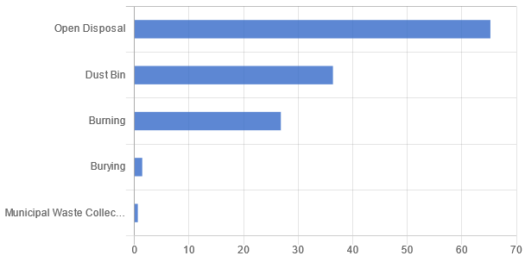
Figure 11: Solid Waste Disposal Method
Source: Richflood field survey, 2022
1.10 Common Illnesses
The common illnesses in the area as obtained from the sampled respondents include Malaria, Typhoid, Cholera, Hypertension, Diabetics, Heat, and Stroke as shown in figure 12 below.
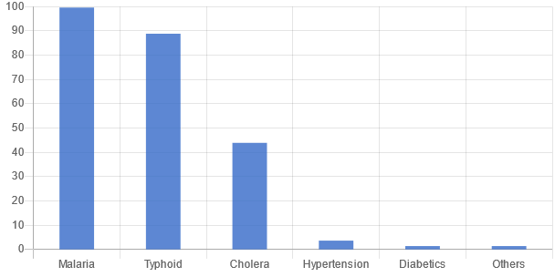
Figure 12: Common Illnesses
Source: Richflood field survey, 2022

Annex 1_Photolog
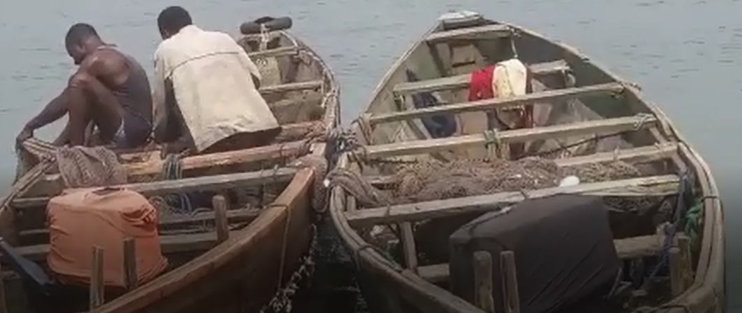 |  | 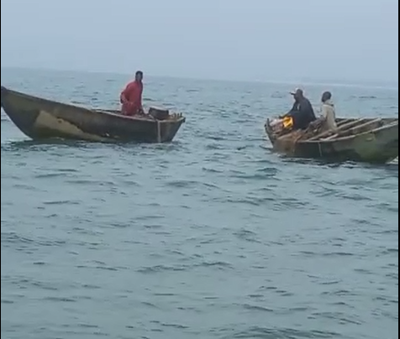
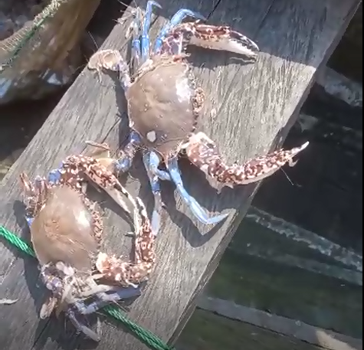 |  | 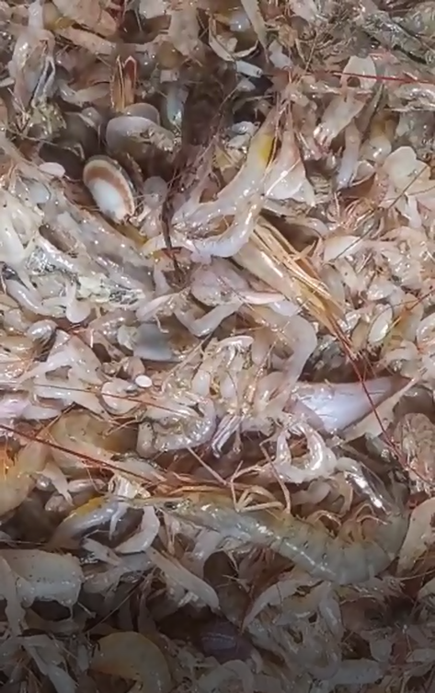
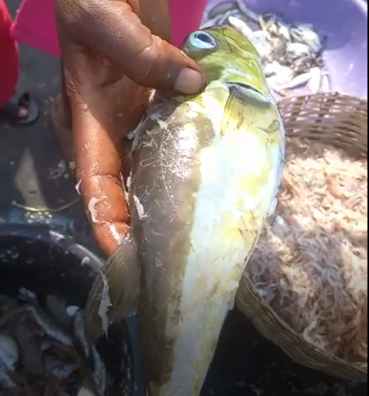 |  | 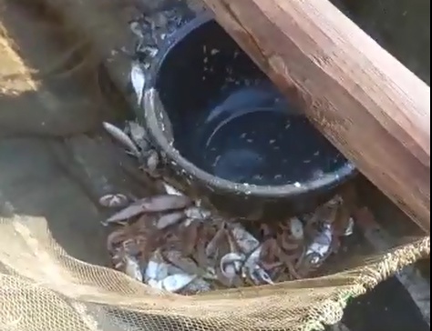
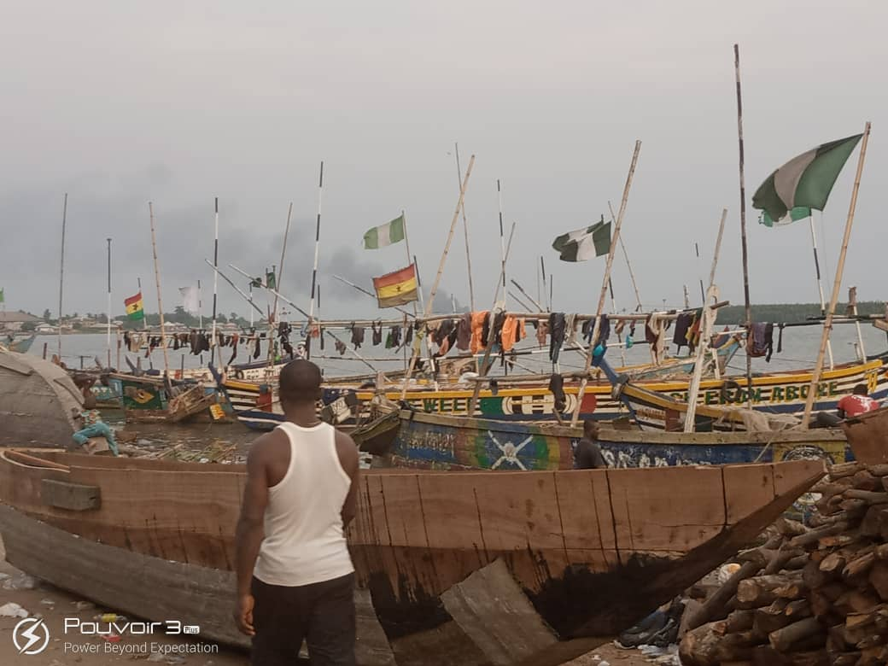 |  | 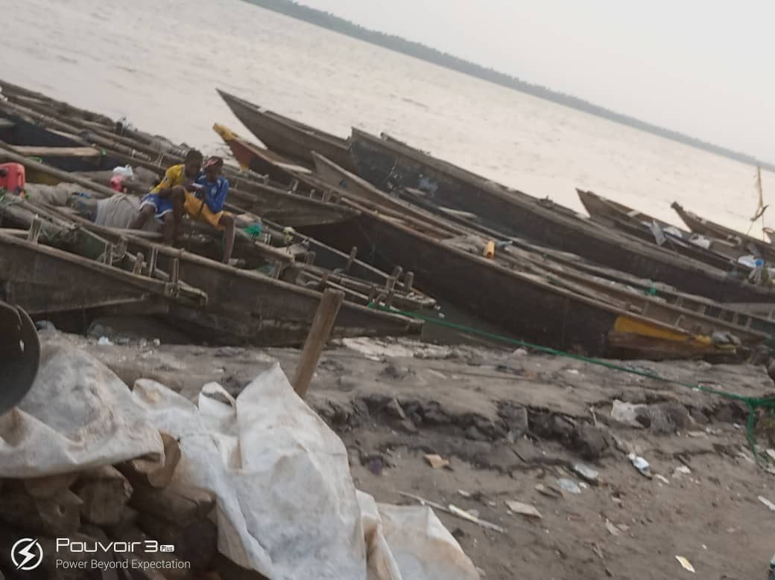
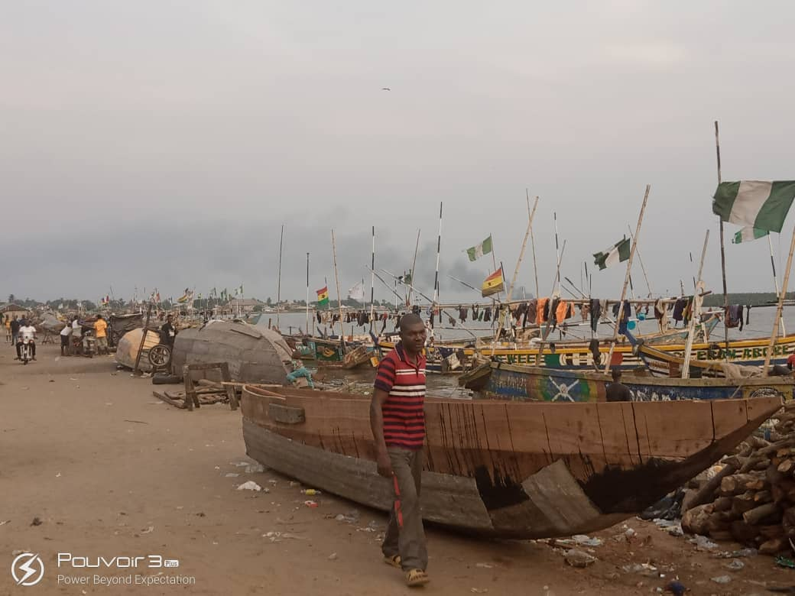 |  | 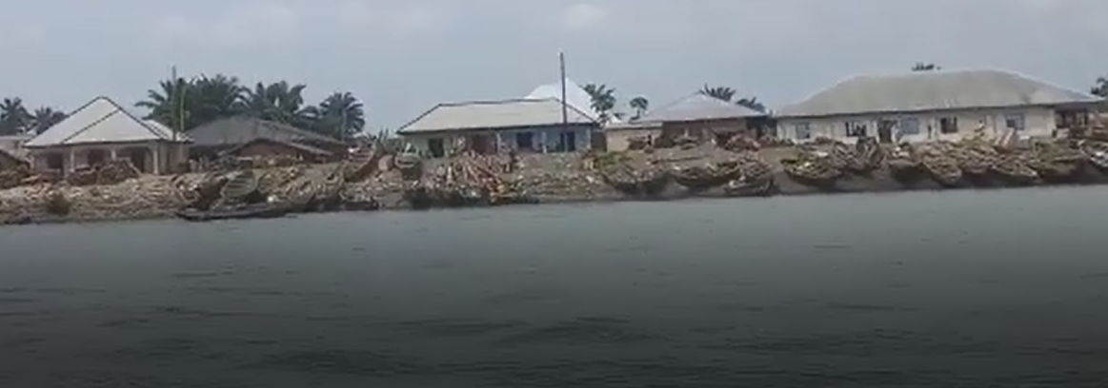
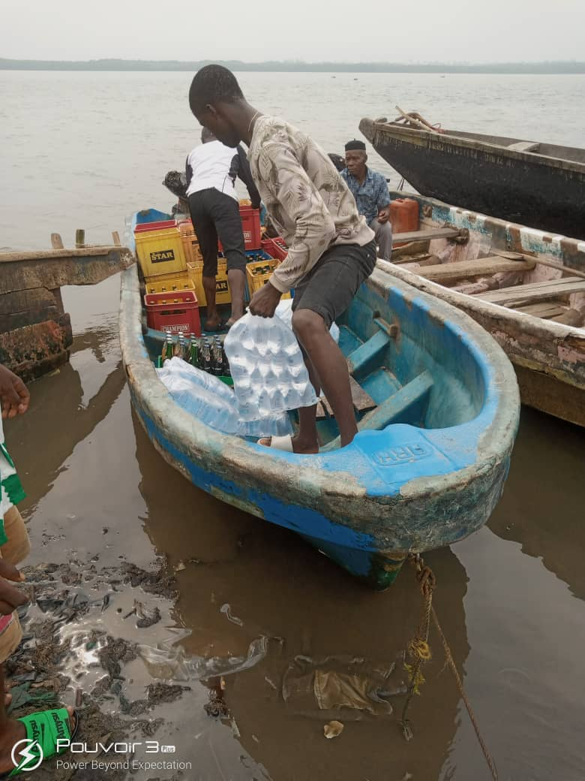 |  | 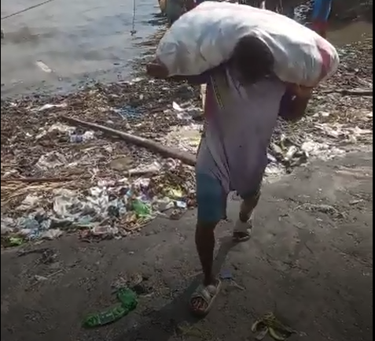
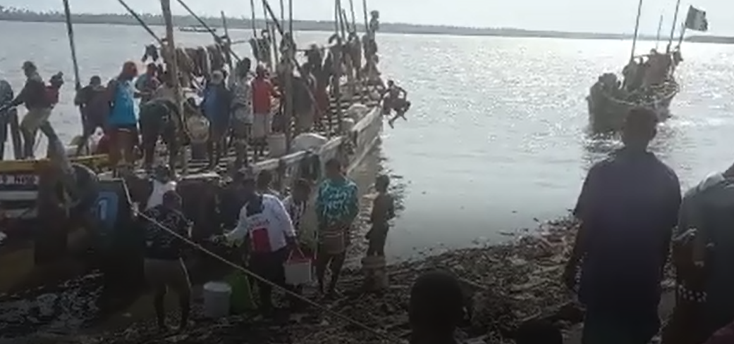 |  | 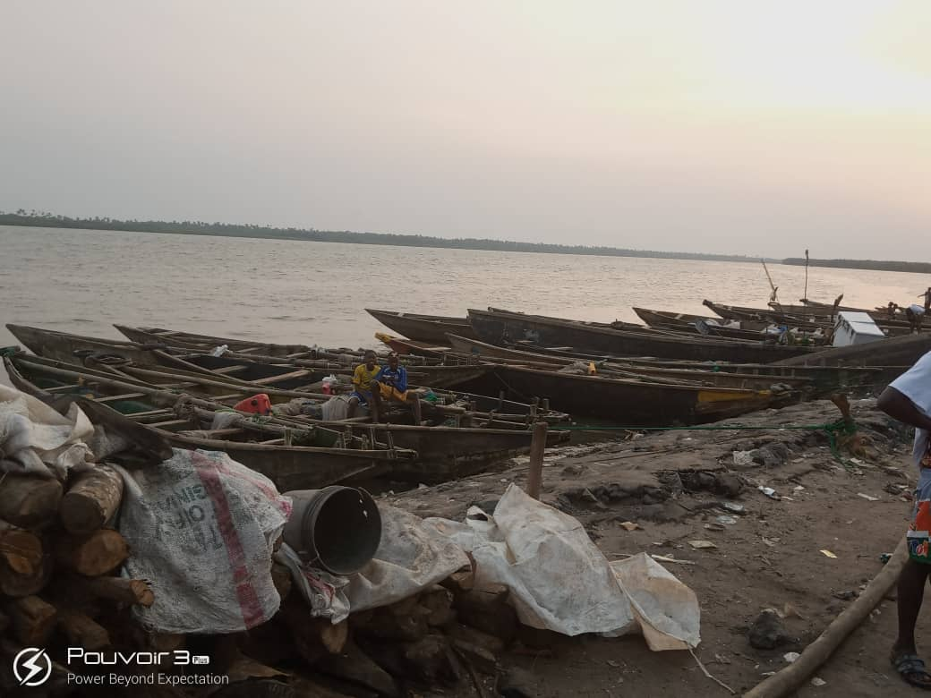
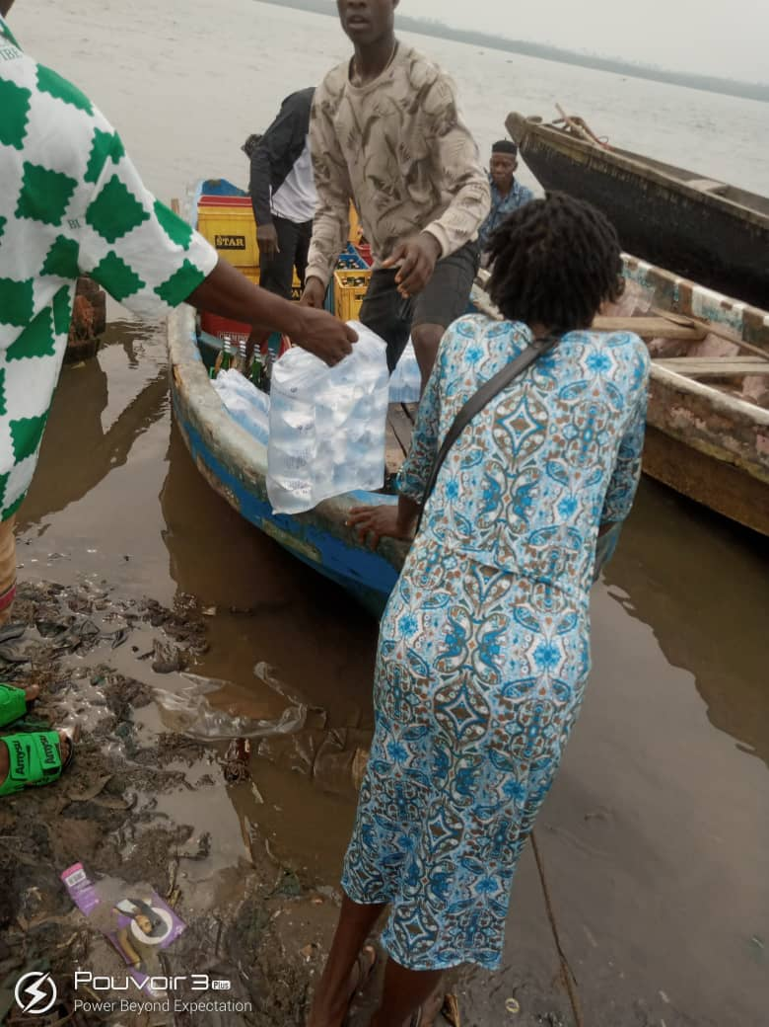 |  | 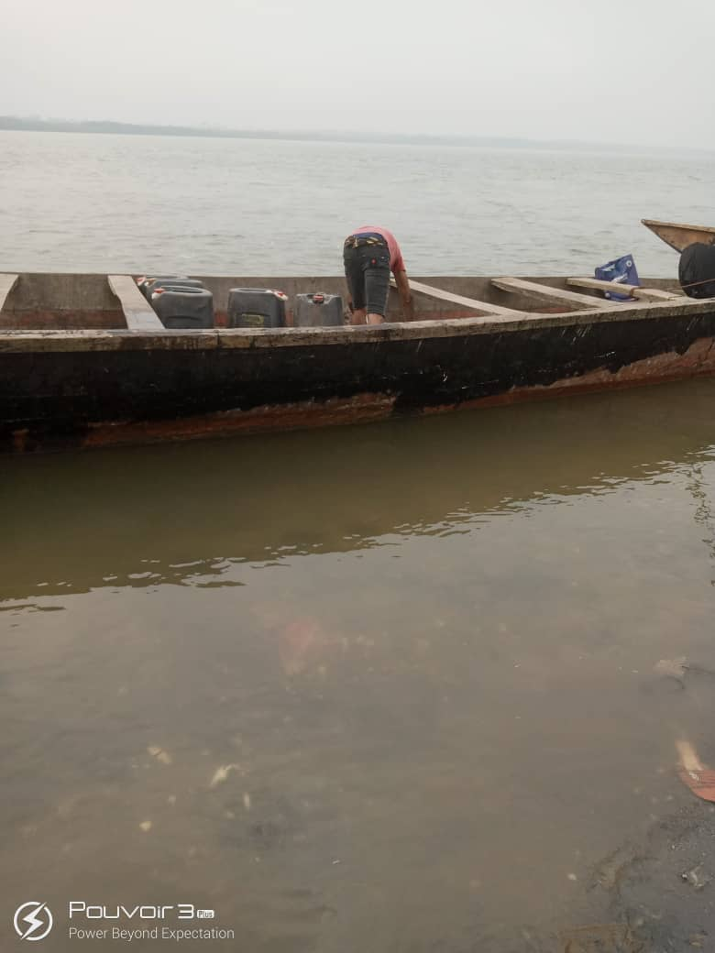
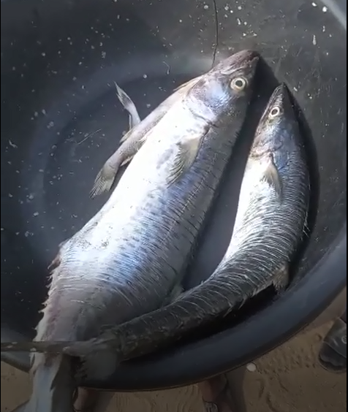 |  | 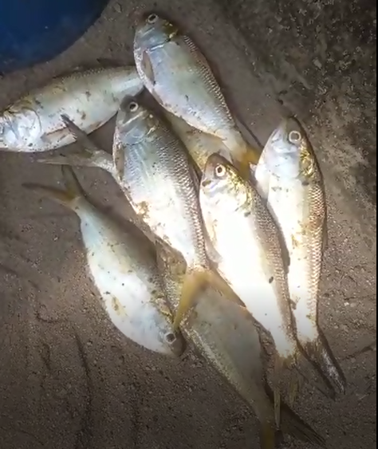
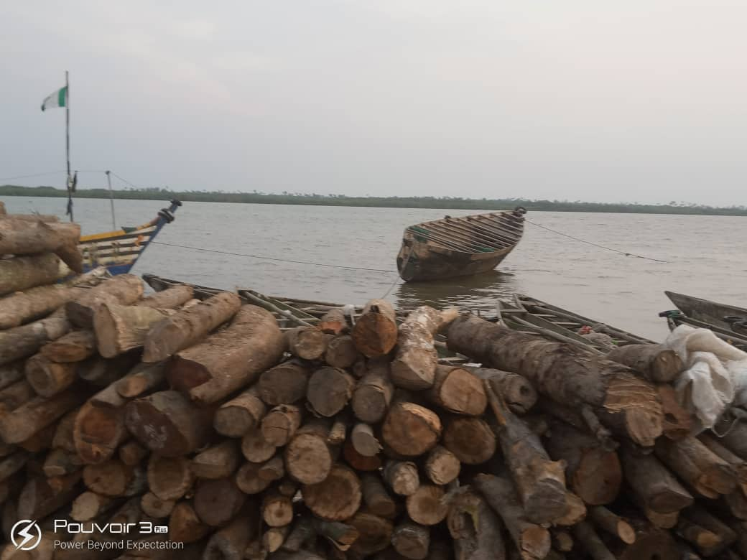 |  | 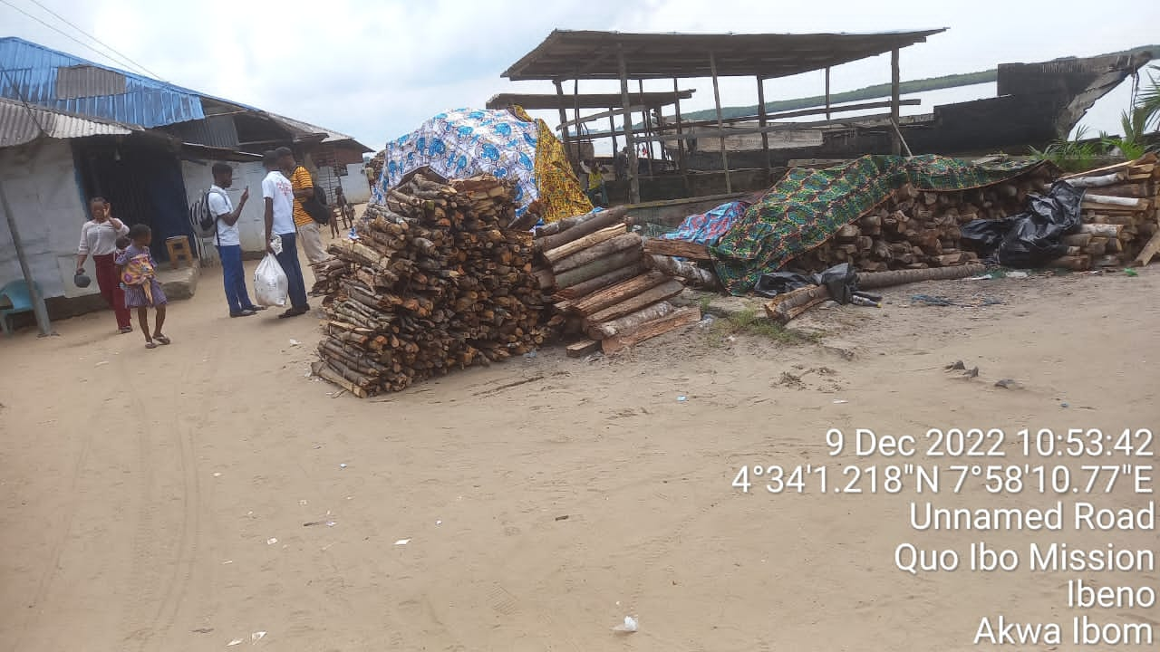
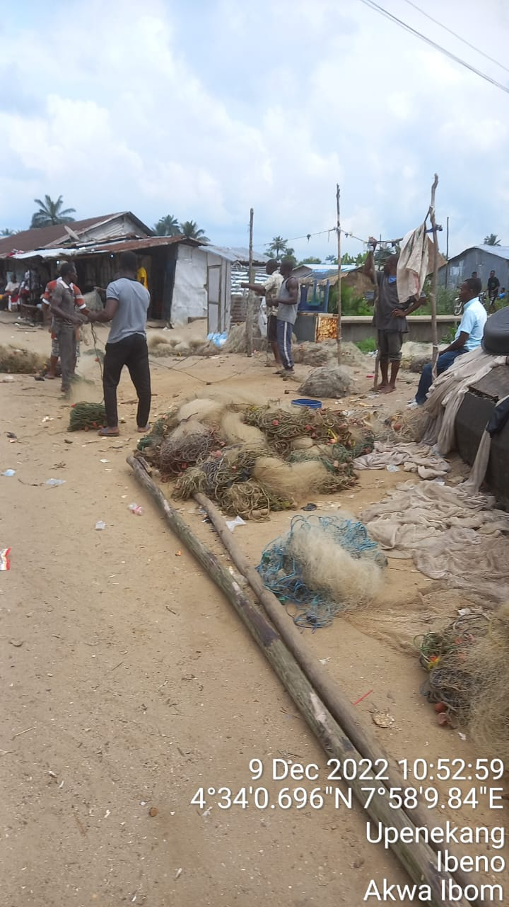 | 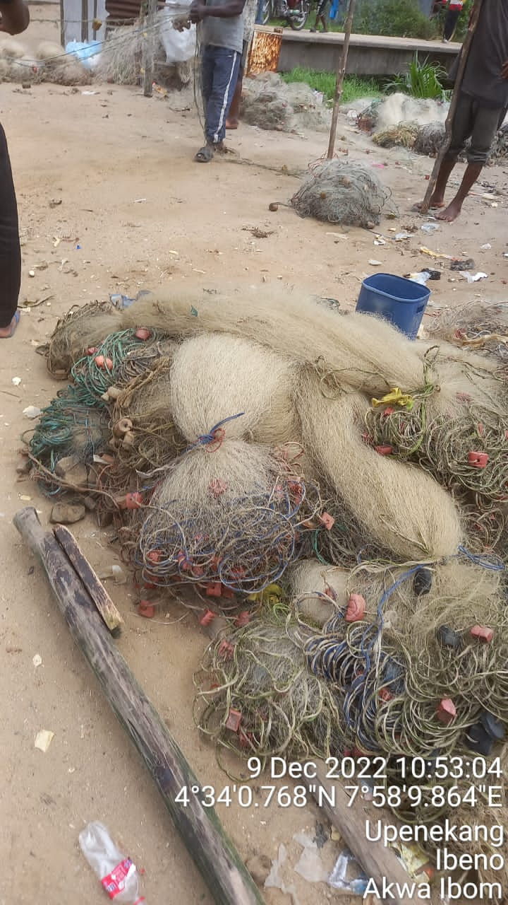 |  | 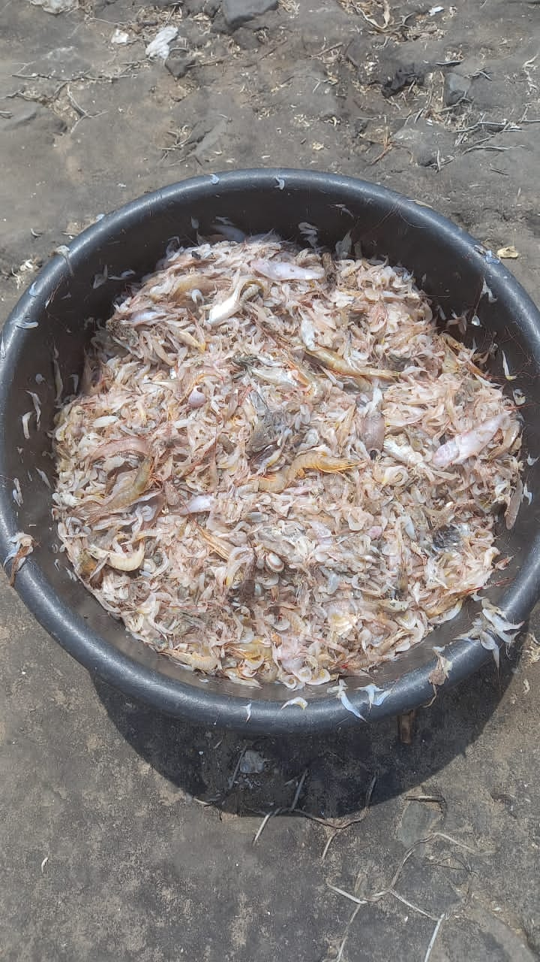
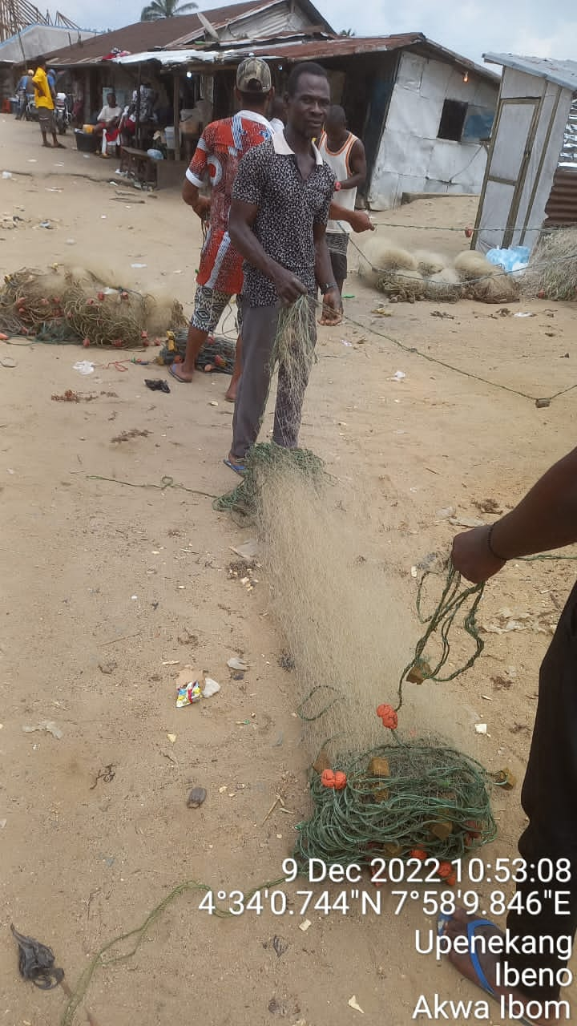 | 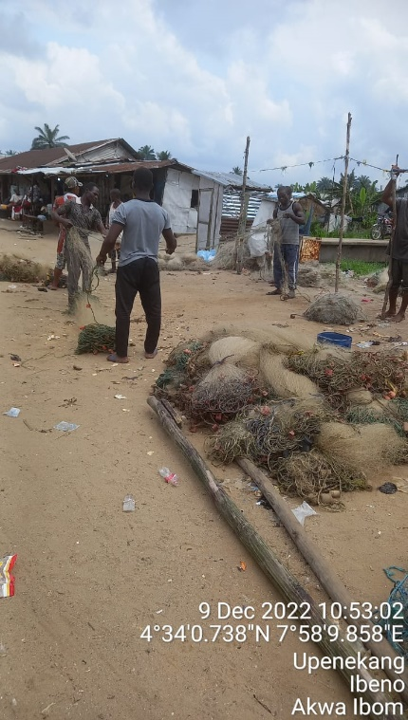 |  | 